GEF-6 REQUEST FOR PROJECT ENDORSEMENT/APPROVAL
Project Type:
Type of Trust Fund:
For more information about GEF, visit TheGEF.org


part i: project information
Project Title: Systemic, institutional and individual capacity for the implementation of the Rio Conventions in the Republic of South Sudan
Country(ies): | South Sudan | GEF Project ID: |  | 9815
GEF Agency(ies): |  | GEF Agency Project ID: |  | 01566
Other Executing Partner(s): | Ministry of Environment and Forestry with execution support from UNEP | Submission Date: |  | 07 November 2018
GEF Focal Area (s): |  | Project Duration (Months) |  | 36
Integrated Approach Pilot | IAP-Cities IAP-Commodities IAP-Food Security |  | Corporate Program: SGP
Name of Parent Program |  | Agency Fee ($) |  | 95,000

- Focal Area Strategy Framework and Other Program Strategies
Focal Area Objectives/Programs | Focal Area Outcomes | Trust Fund | (in $)
Focal Area Objectives/Programs | Focal Area Outcomes | Trust Fund | GEF Project Financing | Co-financing
 | Integrating global environmental needs into management information systems |  | 354,900 | 500,000
 | Strengthening consultative and management structures and mechanisms |  | 376,600 | 450,000
 | Integrating Multilateral Environmental Agreements’ provisions within national policy, legislative, and regulatory frameworks |  | 268,500 | 500,000
Total project costs |  |  | 1,000,000 | 1,450,000

- Project description summary
Project Objective: To strengthen systemic, institutional and individual capacity for effective implementation of the Rio Conventions in South Sudan
Project Components/  Programs | Financing Type | Project Outcomes | Project Outputs | Trust Fund | (in $)
 |  |  |  |  | GEF Project Financing | Confirmed Co-financing
Component 1:  Development of a coordinated environmental knowledge and information management system. |  | Outcome 1:  Enhanced management of environmental information and knowledge for use in decision-making, planning and reporting. | Output 1.1:  Analysis of the current environmental information systems, data flows, environmental statistics and reporting mechanisms related to the Rio Conventions and other MEAs utilized by line ministries and other relevant agencies conducted.  Output 1.2:  Priority environmental indicators identified and agreed upon based on MEAs, SDGs, SoEOR, draft Vision 2040 and other sources for use in reporting, monitoring and assessment processes (including gender-disaggregated indicators where relevant).  Output 1.3:  Training provided to national and state level data custodian agencies (including Rio Convention focal points) on data collection and management methodologies, including use of the Environment Live knowledge platform.  Output 1.4:  Shared environmental information system developed and implemented to manage and access environmental data, building on the existing CBD national Clearing House Mechanism. |  | 324,900 | 460,000
Component 2:  Strengthening of coordination mechanisms and stakeholder engagement for the Rio Conventions and relevant SDGs. |  | Outcome 2:  Enhanced coordination mechanisms and stakeholder engagement for the sustained implementation of Rio Conventions and relevant SDGs. | Output 2.1:  MEA Network established and other mechanisms implemented to support enhanced coordination in support of the implementation of the Rio Conventions, other relevant MEAs and related SDGs.  Output 2.2:  Activities for awareness and capacity building implemented (e.g., disseminating best practices and fact sheets, organising events, roundtables for decision-makers, and training) to support the implementation of the Rio Conventions and the relevant SDGs.  Output 2.3:  Practical guidelines on community participation and engagement in mainstreaming and implementation of the Rio Conventions developed. |  | 346,600 | 406,000
Component 3:  Integration of key provisions of Rio Conventions in national policies and legislation. |  | Outcome 3:  National policies include provisions for mainstreaming biodiversity conservation, climate change adaptation and mitigation, and sustainable land and forest management. | Output 3.1:  At least 2 sectoral policies, laws or strategies finalized during the project duration and submitted for enactment clearly make provisions for mainstreaming Rio Convention principles.  Output 3.2:  Sustainable financing strategy for Rio Conventions and the environmental dimension of SDGs developed. |  | 238,500 | 454,000
Subtotal |  |  |  |  | 910,000 | 1,320,000
Project Management Cost (PMC) |  |  |  |  | 90,000 | 130,000
Total project costs |  |  |  |  | 1,000,000 | 1,450,000

- confirmed sources of Co-financing for the project by name and by type
Please include evidence for co-financing for the project with this form.
Sources of Co-financing | Name of Co-financier | Type of Cofinancing | Amount ($)
GEF Agency | UNEP | In-kind | 300,000
Recipient Government | Ministry of Environment and Forestry | In-kind | 550,000
Recipient Government | Ministry of Agriculture and Food Security | In-kind | 250,000
Recipient Government | Ministry of Wildlife Conservation and Tourism | In-kind | 250,000
Recipient Government | National Bureau of Statistics | In-kind | 100,000
Total Co-financing |  |  | 1,450,000
- Trust Fund Resources Requested by Agency(ies), Country(ies), Focal Area and the Programming of Funds
GEF Agency | Trust Fund | Country  Name/Global | Focal Area | Programming of Funds | (in $)
 |  |  |  |  | GEF Project Financing (a) | Agency Fee ^{a)} (b)² | Total  (c)=a+b
 |  | South Sudan |  |  | 1,000,000 | 95,000 | 1,095,000
Total Grant Resources |  |  |  |  | 1,000,000 | 95,000 | 1,095,000

a) Refer to the Fee Policy for GEF Partner Agencies
- Project’s Target Contributions to Global Environmental Benefits
Provide the expected project targets as appropriate.
Corporate Results | Replenishment Targets | Project Targets
Enhance capacity of countries to implement MEAs (multilateral environmental agreements) and mainstream into national and sub-national policy, planning financial and legal frameworks | Development and sectoral planning frameworks integrate measurable targets drawn from the MEAs in at least 10 countries | Number of Countries: 1
 | Functional environmental information systems are established to support decision-making in at least 10 countries | Number of Countries: 1
- Does the project include a “non-grant” instrument?
(If non-grant instruments are used, provide an indicative calendar of expected reflows to your Agency and to the GEF/LDCF/SCCF/CBIT Trust Fund) in Annex D.

Table of Contents

part i: project information 1
part ii: project justification 6
A. describe any changes in alignment with the project design with the original pif 6
A.1. Project Description. 6
1) Global environmental and/or adaptation problems, root causes and barriers that need to be addressed 6
2) Baseline scenario or any associated baseline projects 9
3) Proposed alternative scenario 20
5) Global environmental benefits 28
6) Innovativeness, sustainability and potential for scaling up 28
A.2. Child Project? 29
B. Stakeholders. 29
A.4. Gender Equality and Women’s Empowerment. 36
A.5 Risk. 38
A.6. Institutional Arrangement and Coordination. 39
A.7 Benefits. 41
A.8 Knowledge Management. 41
B. Description of the consistency of the project with: 42
B.1 Consistency with National Priorities. 42
C. Describe the budgeted m&e plan 44
PART iII: certification by gef partner agency(ies) 46
LIST OF ANNEXES 47
Annex A: Project Results Framework 48
Annex B: Responses to Project Reviews 50
Annex C: Status of Implementation of Project Preparation Activities and the Use of Funds 54
Annex D: Calendar of Expected Reflows 55
Annex E: Consultants to be Hired for the Project Using GEF/LDCF/SCCF Resources 56
Annex F-1: Detailed GEF Budget 56
Annex F-2: Detailed Co-finance Budget 56
Annex G: Monitoring and Evaluation Budget and Workplan 56
Annex H: Project Implementation Arrangements 57
Annex I: Key Deliverables and Benchmarks + Work Plan 60
Annex J: Capacity Development Scorecard 64
Annex K: OFP Endorsement Letter 70
Annex L: Co-finance Letters 71
Annex M: UNEP Environmental, Social and Economic Review Note (ESERN) 77
Annex N: Acronyms and Abbreviations 83
Appendix 5: Supervision plan 85
Appendix 6: Procurement plan 85
Appendix 7: Terms of Reference of key personnel 86

part ii: project justification

A. describe any changes in alignment with the project design with the original pif
A.1. Project Description. Elaborate on: 1) the global environmental and/or adaptation problems, root causes and barriers that need to be addressed; 2) the baseline scenario or any associated baseline projects, 3) the proposed alternative scenario, GEF focal area strategies, with a brief description of expected outcomes and components of the project, 4) incremental/additional cost reasoning and expected contributions from the baseline, the GEFTF, LDCF, SCCF, CBIT and co-financing; 5) global environmental benefits (GEFTF) and/or adaptation benefits (LDCF/SCCF); and 6) innovativeness, sustainability and potential for scaling up.

Additional information has been gathered on the baseline projects and has been added to the sections below. The project components and outputs have been refined based on consultations with key stakeholders during the project design phase. The changes are explained in section 3) Proposed alternative scenario. These changes will not, however, affect the project outcomes or objective. The co-financing amounts have been adjusted to reflect the current realistic level of co-financing. Total co-financing is reduced from USD 2.25 million to USD 1.45 million. Two additional agencies have been added under the co-financing partners, namely the Ministry of Wildlife Conservation and Tourism and the National Bureau of Statistics.

1) Global environmental and/or adaptation problems, root causes and barriers that need to be addressed

Covering an area of 619,745 km², South Sudan is the youngest country in Eastern Africa, having attained independence in 2011. The landlocked country has a total population of just over 12 million people (World Bank, 2016). More than 80% of the population lives in rural areas with livelihoods dependent on natural resources; primarily agriculture and livestock rearing for food and prestige and marriage especially among the pastoral communities, wood and charcoal for energy as well as rivers for water. The country has one of the most underdeveloped economies in the world. Industrial development is negligible, primarily due to negative impacts of prolonged war of independence (pre 2011) and civil war (post 2013), which has resulted in serious neglect to development, lack of infrastructure and major destruction and displacement of populations (including internal displacement). This is exacerbated by having the highest maternal mortality and female illiteracy rates in the world as of 2011. The country, however, contains many natural resources such as petroleum, iron ore, copper, chromium ore, zinc, gold, diamonds, silver, hardwoods (it exports timber), limestone and hydropower. Oil generates 98% of government revenues – making South Sudan the most oil dependent country in the world, while the local economy is fundamentally subsistence in nature. South Sudan used to be a net exporter of food but is now a net importer, importing 50% of its needs from Kenya and Uganda. There is great potential to increase agricultural production, as only 4.5% of South Sudan’s potential arable land is cultivated.

South Sudan is inhabited by a number of different ethnic groups, the largest of which is the Dinka, a traditionally pastoralist people that makes up 36% of the population. It is followed by the Nuer, who constitute about one-fifth. Other groups include the Zande, the Bari, the Shiluk and the Anywa (Anyuak). In total there are 64 ethnic groups in South Sudan. There is also a small Arab population in South Sudan. With less than 13 people per square kilometre, population density in the country is one of the lowest in Africa. Livelihoods in the northern dry areas are dominated by seasonal agriculture, pastoralism, fishing and hunting. The country is divided into three regions (the former historic provinces): Bahr el Ghazal in the northwest, Equatoria in the south and Greater Upper Nile in the northeast. There used to be ten states in South Sudan, which are now divided into 32 states. (SoEOR, 2018)

Many environmental issues in South Sudan are international in nature, as the country has multiple international borders and hosts globally significant ecosystems and biodiversity: for example, the Nimule and Boma National Parks bordering Uganda and Ethiopia, respectively; and the transboundary Nile River and the Sudd wetlands (97.5% of South Sudan lies in the Nile Basin, and the White Nile passes through Juba). The country is covered by tropical forests, swamps, and grasslands with important habitats being high-altitude plateaus and escarpments, wooded and grassy savannas, floodplains, and wetlands. The Boma-Jonglei Landscape, East Africa’s largest savannah ecosystem, encompasses Boma National Park, broad pasturelands and floodplains, Bandingilo National Park, and the Sudd, a vast area of swamp and seasonally flooded grasslands arguably the largest wetland in Africa. South Sudan’s grasslands are part of the Sudanian Savannahs, which are deemed to be in a critical or endangered state (SoEOR, 2018).

South Sudan is home to several globally threatened mammal species, such as the critically endangered Rhinoceros (Diceros bicornis), the endangered wild dog (Lycaon pictus) and Eastern Chimpanzee (Pan troglodytes schweinfurthii), and the vulnerable cheetah (Acinonyx jubatus), lion (Panthera leo), leopard (Panthera pardus), African elephant (Loxodonta africana), Nubian giraffe (Giraffa camelopardalis camelopardalis), Kordofan giraffe (Giraffa camelopardalis antiquorum), and Hippopotamus (Hippopotamus amphibious) (SoEOR, 2018). South Sudan has 12 Important Bird Areas (IBAs) identified by BirdLife International, and 19 globally threatened bird species, including the vulnerable Black-Crowned Crane (Balearica pavonina) and the Shoebill Stork (Balaeniceps rex). South Sudan is home to the world’s second largest animal migration after the great Serengeti-Maasai Mara wildebeest migration. As highlighted in the SoEOR (2018), this epic migration of antelopes (white-eared kob, tiang and mongalla gazelle) offers opportunity for the development of ecotourism.

These globally significant species and ecosystems of South Sudan are faced with numerous environmental problems including deforestation and forest degradation, loss of biodiversity due to habitat loss, inadequate protection and overharvesting, land degradation, soil erosion and loss of soil fertility, air and water pollution and siltation of rivers and water bodies. The Fifth National Report to the Convention on Biological Diversity (UNEP/GRSS, 2015) confirmed that although there is very limited data on the extent of loss of important biodiversity and ecosystems, the key threats to biodiversity include:
- Wildlife poaching and trafficking;
- Deforestation;
- Livestock and agricultural expansion (frequently leading to conflicts between farmers and traditional pastoralists);
- Habitat fragmentation caused by road network expansion and the expansion of extractive industries;
- Adverse climate change impacts including increasing desertification;
- Human-wildlife conflicts.

Indirect threats to ecosystems and biodiversity include:
- Past and continuing armed conflicts, the resulting displacement of people internally, and proliferation of firearms, which facilitates crimes against wildlife;
- High levels of poverty with high dependence on natural resources;
- Emerging threats including oil exploration and production, spread of invasive species, and genetically modified organisms (GMOs), without commensurate institutional capacities to ensure that these activities mainstream biodiversity and ecosystem management;
- Insufficient data with a majority of the environment management institutions reporting significant lack of data to guide planning and management of natural resources.

South Sudan is highly vulnerable to the impacts of rising temperatures and increased rainfall variability due to climate change. Between the 1970s and the 2000s, the country experienced an increase in temperatures of 2°C on average, with the central and southern regions registering an increase of as much as 0.4°C per decade – one of the highest increases in the world. In the same period, average precipitation declined between 10 and 20%, while the variability in the amount and timing of rainfall from year to year increased. By 2060, South Sudan overall is expected to get warmer by about 1°C over and above 2020 values, and average rainfall is expected to decline by 10-20% for any observed warming of more than 1°C. Consequently, the country is one of the five countries in the world most vulnerable to the impacts of climate change (SoEOR, 2018). A report by the Sudd Institute has found that conflicts often occur after floods or droughts, implying that climate change has been contributing to conflicts in South Sudan.

Fuelwood and charcoal account for over 90% of all wood used in South Sudan, with an annual deforestation rate estimated at between 1.5 and 2%. South Sudan has a forest cover of about 207,422 km² or 33% of the total land area and is among the top eleven most forested countries in Africa. There are no reliable data on the extent of forests, however, since a detailed forest survey and inventory has never been carried out (SoEOR, 2018).

Despite these challenges, the Republic of South Sudan has an enormous opportunity to mainstream ecosystems and biodiversity management, sustainable land and forest management, and climate change adaptation and mitigation into the national development and resource planning and utilization, given its early stage of economic development.

South Sudan has been signatory to the Rio Conventions since only 2014 and has since had to deal with frequent interruption of work imposed by armed conflicts and general insecurity. South Sudan is also party to the Ramsar Convention since 2013 and is in the process of signing the Nagoya Protocol. It is signatory to the Paris Agreement and party to the Montreal Protocol, the Vienna Convention on Substances that Deplete the Ozone Layer, and the International Plant Protection Convention (IPPC). Although there has been some progress in activities under the UNFCCC, partly due to the availability of funding for climate change adaptation and mitigation, generally initiatives pertaining to the conventions are thin on the ground. Nonetheless, the country has managed to produce a good number of legislation and strategic plans and would therefore be ready to move on to actual implementation as soon as circumstances allow.

The country is struggling to fulfil many of the objectives set forth in the Rio Conventions due to the following barriers:
- Weak policies and legislation, exacerbated by inadequate institutional coordination and collaboration.
- Inadequate training, education and public awareness, exacerbated by poor information and data availability.
- Weak local governance and stakeholder participation, exacerbated by inadequate funding and unsustainable financing.

The National Capacity Self-Assessment (NCSA, 2017) report concludes that there are capacity gaps at all three important levels:
- At the systemic level: There is weak inter-institutional coordination across levels of government (vertical coordination), across government institutions (horizontal coordination), and between government and other stakeholders; and a weak policy and legal framework for addressing multilateral environmental agreements (MEAs).
- At the institutional level: There is low awareness of MEA issues, lack of data and information, inadequate technical capacity to implement the MEAs, weak capacity of MEA focal points, inadequate monitoring and evaluation mechanisms, inadequate funding, limited research, and poor infrastructure;
- At the individual level: There is low levels of awareness of MEA issues, insufficient numbers of staff with adequate skills, know-how and access to technologies (computers, smart phones, internet, etc.).

As shown in the table below, the data needs for the three Rio Conventions are largely overlapping.

Table 1: Illustrative comparison of data needs across the three conventions (from NCSA, 2017)
Core Data Set Needs | Biodiversity | Climate Change | Desertification/ Land Degradation
Land use (by type) | x | x | x
Vegetation (by type) | x | x | x
Forests (by type, condition, density) | x | x
Forest tenure/land tenure | x |  | x
Soils (by type) | x | x | x
Agriculture (by type) | x | x | x
Livestock census | x | x | x
Wetlands | x | x | x
Climate (temperature, precipitation, etc.) | x | x | x
Flora and fauna (species type and density information) | x
Human settlements | x | x | x
Population (count and density) | x | x | x
Roads | x | x | x
Other infrastructure (transmission lines, etc.) | x | x | x
Industrial activities | x | x | x

2) Baseline scenario or any associated baseline projects

Government baseline in support of the Rio Conventions

South Sudan has prepared a number of laws and policies that incorporate environmental matters. However, several of these laws and policies remain in draft form or are awaiting approval by the legislative assembly. The following table summarises the status of the main environmental policies and laws in South Sudan (sources: SoEOR, 2018 and NCSA, 2017).

Policy or legal framework | Status | Objectives
Transitional Constitution of South Sudan | Approved and functional | - Articles 41 & 46 provide that every person shall have the obligation to protect the environment and the right to have the environment protected for the benefit of present and future generations.
South Sudan Vision 2040 | Draft | - To ensure that by 2040 South Sudan is a united and peaceful new nation, building strong foundations for good governance, economic prosperity and enhanced quality of life for all.  - The Vision foresees the government initiating and investing in agriculture to achieve food security; advancing the role of women; and promoting partnerships between local and foreign investors, which invest in development that substantially increases resource ownership and management by citizens. The Vision also envisages that the government will adopt appropriate measures to limit pollution that may result from rapid industrialisation and to foster sustainable environmental management.
South Sudan Development Plan 2011-2013 (extended to 2018) | Approved and functional | - In addition to mainstreaming environmental protection within multiple sectors, the Development Plan 2011-2013 also specifically calls for natural resources to be protected from significant adverse environmental impacts.
National Environment Protection and Sustainable Development Policy, 2014-2024 | Approved and functional | - To provide guidance and direction on the effective management of the environment to all stakeholders: government agencies, the private sector, NGOs, CBOs and the general public.
Environment Protection Bill, 2014 | Draft | - Empowers the Ministry of Environment and Forestry to supervise and coordinate all matters relating to the environment and to be the principal instrument of government in the implementation of all policies relating to the environment, including biodiversity.  - Provides for the preparation of a National Environmental Action Plan; and designation of Environmentally Sensitive Areas (ESAs) for the actual or prospective habitat of any environmentally sensitive species required to be protected for the purpose of meeting the government’s international obligations under any of the MEAs.  - Provides for freedom to access environmental information and this will facilitate education and public awareness on biodiversity.  - Addresses pollution prevention, control and waste management, currently a major source of biodiversity loss and ecosystem degradation particularly by the oil and extractive industries.
National Environmental Policy 2013 | Approved and functional | - Sets guidelines and regulations on the sustainable management of the environment as well as the prudent utilization of natural resources.  - Calls for the development and implementation of a National Strategy and Biodiversity Action Plan for South Sudan. It also urges for:  - Promoting coordination, cooperation and participation of all relevant stakeholders in conservation and sustainable use of biodiversity across all sectors of the economy;  - Encouraging a Green economy initiative to enhance low carbon and resource efficient economy as well as promoting carbon sequestration;  - Promoting national integrated approaches for conservation and sustainable use of biodiversity and protection of aquatic ecosystems and life;  - Implementing the MEAs related to biodiversity;  - Supporting communication, education and public awareness programmes on the importance and benefits of conserving the biodiversity to the citizens and their livelihoods;  - Sharing the benefits of biodiversity conservation and sustainable use with local communities and stakeholders;  - Discouraging introduction of invasive and alien species and where such species are available manage and control properly to avoid adverse impacts on local environment;  - Promoting ex-situ conservation of biodiversity; and  - Encouraging conservation and cultivation of herbal, medicinal and economic plants.  - Provides for the establishment of an autonomous South Sudan National Environmental Management Authority (NEMA) to act as the watchdog on all public institutions, private companies and individuals defaulting against the stipulated environmental laws and regulations.  - Calls for developing a national strategy and mechanisms for climate change adaptation and mitigation; and formulating a climate change policy for South Sudan.
Agriculture Sector Policy Framework for 2012-2017 | Approved and passed by the cabinet. | - Aims at enhancing measures to mitigate the adverse effects and impacts from climate change in the medium and long-term. It also provides for the protection of plants, seed management, and development of plant genetic resources conservation programme and a biosafety framework.
Comprehensive Agricultural Development Master Plan (CAMP) | Approved by the cabinet, presented to the legislature | - Proposed in 2015, considered as a “road map” for the future of agriculture in South Sudan.  - The CAMP identifies the potential of different products across the country, priority programmes/projects and the resources required to implement them. During the formulation of the CAMP, a mechanism was established to ensure a harmonized and coordinated framework for effective and efficient management of activities and resources for formulation.
National Policy on Food Security 2012 | Pending | - National policy to support food security. Includes policy measures and strategies meant to mitigate the adverse effects and impacts from climate change in the medium and long term. These include the development of community adaptive capacity for climate change through the development of crops that can resist droughts and floods.
Ministry of Animal Resources and Fisheries Policy Framework and Strategic Plans 2012-2016 | Policy not yet passed but strategic plan passed by the council of ministers. | - To take charge of protecting, promoting, exploiting and developing, on a sustainable basis, the livestock and fisheries resources, for the socio-economic prosperity of the people of South Sudan.
Fisheries Policy for South Sudan | In process | - Provides for a framework to manage fisheries resources of the country so as to maximize production and avoid overfishing and to prevent destruction of wetlands and promote their conservation. One specific objective of the policy is to maintain a healthy environment and ecosystems by adopting measures to prevent environmental damage to aquatic systems through pollution and environmental degradation.
Forest Policy Framework 2007 | Approved and functional | - The policy aims at ensuring a sufficient and sustained forest resource base and flow of forest goods and services to support livelihoods and socio-economic development for the present and future generations. Ensuring inter-generation equity in its potentially rich forest endowment is a key plank of this policy.
Forestry Bill 2009 | Draft | - The purpose of this Bill is to cover all matters concerned with all forests and woodlands on national forest reserves, provincial forest reserves, and protection forests under custody of the Government of the Republic of South Sudan, state government, communities and individuals.
Forest Policy Harmonized 2015 | Approved by the legislative assembly, pending approval of the president | - The policy aims at ensuring a sufficient and sustained forest resource base and flow of forest goods and services to support livelihoods and socio-economic development for the present generation without compromising this endowment for future generations.  - The policy addresses important tenure issues around the country’s forests and articulates forest ownership and institutional management boundaries. The policy designates previous Central Forest Reserves as National Forest Reserves to be managed by central government, State Forest Reserves to be overseen by state governments, and allows for formalizing tenure and co-management arrangements for communities for forests on community lands.
Policy on Wildlife Conservation and Protected Areas 2012 | Draft | - To guide on the sustainable management and utilization of wildlife resources including land, water, fauna and flora for the benefit of the people of South Sudan.  - To protect, conserve and propagate the wildlife species and their habitats in a manner that supports the development needs of South Sudan and the cultural, economic and social well-being of its people.  - Recognizes climate change as a global reality with serious implications for natural ecosystems and wildlife resources. The policy calls for designing coping strategies to address the impacts of climate change on habitats and populations of wildlife species.
Wildlife Conservation and Protected Areas Bill 2015 | Pending in the legislative assembly | - Covers all matters concerned with wildlife conservation, the establishment and management of protected areas (PAs) and the sustainable management and conservation of South Sudan’s natural heritage and wildlife for the benefit of its citizens.  - Allows local communities around PAs to manage wildlife in collaboration with the South Sudan Wildlife Service (SSWS) and permits other organizations to manage any PA on behalf of the Government.  - Grants SSWS Officers similar enforcement and prosecutorial powers as the police officers under the Code of Criminal Procedure Act 2008 – arrest, inspection, seizure and forfeiture.  - Increases the number of wildlife offences as well as explicitly provides for the crime of wildlife trafficking. These include illegal hunting, capture and trafficking of protected animals.  - Provides for the protection of wetlands.
Disaster Management Policy and its accompanying Master Plan 2015-2030 | In process | - Provides for capacity building for disaster (local conflicts, civil wars, drought and floods) risk reduction in South Sudan.
Water Bill Final Draft 2015 | In process | - To promote effective management of the quantity, quality and reliability of available water resources in order to maximize social and economic benefits while ensuring long-term environmental sustainability.
Water Resources Policy 2007 | Approved and functional | - The document addresses specific issues in relation to three main sub-areas of water policy, i.e. Water Resources Management (WRM), Rural Water Supply and Sanitation (RWSS), and Urban Water Supply and Sanitation (UWSS) and establishes guiding principles and objectives in relation to each.
Petroleum Act 2012 | Approved and functional | - This act provides a regulatory framework for the development and management of petroleum activities and other ancillary matters related to petroleum activities in the Republic in conformity with the Transitional Constitution.  - Provides that a Social and Environmental Impact Assessment (SEIA) to be undertaken by the oil contractor or licensee in compliance with international standards to determine any present environmental and social damage, establish the costs of repair and compensation and determine any other areas of concern.
Mining Policy 2013 | Approved and functional | - Recognizes the need to ensure that mining operations are conducted in a socially and environmentally responsible manner by minimizing harmful impacts of mining and that the interests of local communities are fully considered and protected.
Mining Act 2012 | Approved and functional | - Provides a framework for the management of the mining sector consistent with international standards, including licensing, environmental protection guidelines and the use of technology to ensure as much mineral resources as possible are recovered from the ground. It also provides for Community Development Agreements for Mining Licenses and environment and social provisions.
South Sudan Tourism Policy 2012 | Draft | - Recognizes that tourism developments in national parks and game reserves shall adhere to the provisions of the General Management Plans developed according to the Wildlife Conservation and Protected Area Policy and related legislation, regulations and guidelines.
Land Act 2009 | Approved and functional | - The Land Act prescribes that land may be acquired, held and transferred through customary, freehold and leasehold tenure. All citizens hold freehold titles to their lands. Non-citizens may acquire leasehold for specific periods but may not possess land in freehold.  - Addresses land tenure security, transparency and accountability, resource-based conflicts, and gender bias and discrimination. It also addresses the need for social and environmental impact assessment for planned projects  - The Land Act does not completely align with the Transitional Constitution in the area of land ownership.
Land Policy | Under preparation | - Addresses issues such as displacements due to civil war, natural disasters, land right conflicts and conflicts over pastures and water points.
Plant Protection Bill | Draft | - Protect South Sudan’s plants against destructive diseases, pests and weeds and prevent the introduction and spread of harmful organisms that may adversely affect the country’s agriculture.

In the baseline, the Government of the Republic of South Sudan has, therefore, taken significant steps towards the translation of the Rio Convention provisions into relevant national laws and policies. Nevertheless, more efforts are needed towards the adoption and implementation of these laws and policies. Reasons for the lack of enactment and implementation include the ongoing conflict and civil war, as well as a lack of funding and institutional capacity.

Climate change is mentioned in the Policy on Food Security, the Fisheries Policy, the Forestry Policy and the Policy on Wildlife Conservation and Protected Areas. However, the National Environmental Policy is currently the only policy that adequately addresses the issues of climate change (NCSA, 2017). A report by the Sudd Institute further finds that:

The 2009 Land Act has clauses intended to promote climate resilience. For example, customary land tenure permits communal land rights, customary seasonal access rights and access through social relationships, which allow climate change resilience. In addition, the Act enhances land tenure security through survey, demarcation, and registration. However, these articles have barely been implemented. Only about one-quarter of the urban areas has been surveyed and registered. In addition, these resilience features are undermined by decreases in social capital linked to large-scale rural-urban migration, abject poverty, and communal conflicts that erode inter-communal relationships that serve to accommodate displaced persons during disasters.

Wetlands conservation has been mainstreamed in the National Environmental Policy and in the Environment Protection Bill of South Sudan (NCSA, 2017). With regard to protected areas, South Sudan currently has seven National Parks and 12 Game Reserves, one Ramsar Site (the Sudd), three National Conservation Areas, and several Forest Reserves (SoEOR, 2018). The Protected Area (PA) system of South Sudan covers about 10.4% of the terrestrial areas of the country, which is higher than the African average estimated at 9%.

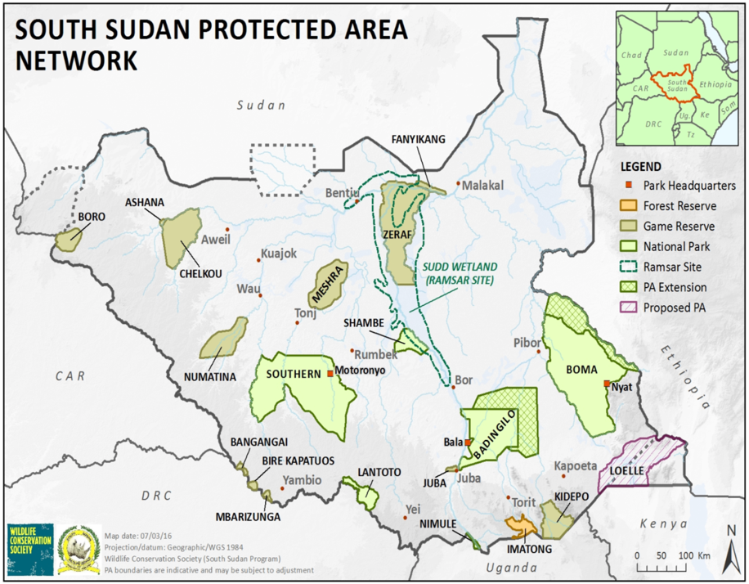
Figure 1: Protected area network of South Sudan (WCS, 2016)

In the baseline, South Sudan, with funding support from international donors, has also made significant progress in the preparation of national plans, strategies and programmes in support of the Rio Conventions. UN Environment, with funding from GEF, has supported South Sudan to develop a National Adaptation Programme of Action (NAPA) under the UNFCCC, focusing on the most immediate needs to adapt to climate change. It has also supported South Sudan to develop an Initial National Communication (INC) to the UNFCCC, as well as the Fifth National Report and a National Biodiversity Strategy and Action Plan (NBSAP) under the CBD. Furthermore, the country plans to prepare a National Action Plan (NAP) under the UNCCD. An overview of completed, ongoing and planned projects in support of the Rio Convention implementation is provided below.

Ongoing and recently completed projects
 | Project | Partners | Donor | Status
1 | National Adaptation Programme of Action (NAPA) | MoEF and UNEP | GEF | Completed
2 | Fifth National Report to the CBD and National Biodiversity Strategy and Action Plan (NBSAP) | MoEF and UNEP | GEF | Completed
3 | National Capacity Self-Assessment (NCSA) | MoEF and UNEP | GEF | Completed
4 | Initial National Communication (INC) | MoEF and UNEP | GEF | Near completion
5 | State of Environment and Outlook Report (SoEOR) | MoEF and UNEP | DFID via Concern Worldwide | Completed
6 | South Sudan Green Climate Fund’s Readiness project | MoEF and UNEP | GCF | Ongoing

Projects in preparation
 | Project | Partners | Donor | Status
1 | Systemic, institutional and individual capacity for the implementation of the Rio Conventions in the Republic of South Sudan (Cross-Cutting Capacity Development, or CCCD) | MoEF and UNEP | GEF | PPG approved, in preparation
2 | Capacity Development in Reducing Illegal Wildlife Trade and Improving Protected Area Management Effectiveness in South Sudan | MoEF, MWCT, UNEP, WCS, AWF | GEF 6-STAR | PPG approved, in preparation
3 | Strengthening the Capacity of Government and Communities in South Sudan to Adapt to Climate Change | MoEF, UNEP, FAO, etc. | GEF-LDCF | PPG approved, in preparation
4 | First Biennial Update Report (BUR1) to INC | MoEF and UNEP | GEF | Approved and work to start in Q3 2018
5 | South Sudan GCF National Adaptation Plan (NAP) Project (for medium- and long-term climate adaptation planning) | MoEF and UNEP | GCF | Project proposal in preparation
6 | South Sudan Project Preparation Funding Application (PPFA) | MoEF and UNEP | GCF | Work underway
7 | UNCCD 2018 National Reporting Process and National Action Plan (NAP) | MoEF, MoAFS and UNEP | GEF | In planning phase
8 | Sixth National Report to the CBD | MoEF and UNEP | GEF | In planning phase

A CBD Clearing House Mechanism (including for the Nagoya and Cartagena Protocols) and a website for the Ministry of Environment and Forestry were also initiated with GEF funding, and are expected to be launched in 2018. In addition, the Ministry of Environment and Forestry, in collaboration with the Ministry of Wildlife Conservation and Tourism is in the process of developing a National Biodiversity Database through the support of the Inter-Governmental Authority on Development (IGAD)’s Biodiversity Management Programme and the Global Biodiversity Information Facility (GBIF). Biodiversity Information Units have been set up in both ministries, with servers for the biodiversity database and trained staff to manage the database. The aim of the database is to mobilise biodiversity data and information for easy access by decision makers. Under the project, an agreement has been reached with the National Museum of Kenya to digitise the East African herbarium data for South Sudan. An inventory of biodiversity data, data holders and users is being developed. Training and awareness raising workshops are also planned to encourage data sharing. The project will end in March 2019.

A National Environmental Information Center (NEIC) with a physical and digital library had been established at the Ministry of Environment and Forestry with support from UN Environment. This center, if strengthened, could be the unit hosting the environment information system to be developed under this project.

Focal points for the UNFCCC, Ramsar and the CBD have been designated with the Ministry of Environment and Forestry. In terms of coordination mechanisms, a ministerial order is planned to be issued by the Ministry of Environment and Forestry to form an inter-ministerial committee on the implementation of environmental projects. A National Designated Authority (NDA) has further been designated for Green Climate Fund (GCF) projects.

The Ministry of Environment and Forestry with the Ministry of Energy and UNDP are currently developing a project on hybrid solar power generation.

The National Bureau of Statistics (NBS) is leading the implementation of a Statistical Capacity Building Project for South Sudan, with a USD 9 million loan from the World Bank. The goal of this project is to strengthen the capacity of statistics producers in South Sudan to produce and disseminate official statistics. The project is being implemented from 2015 to 2020, and it also involves capacity building for the relevant line ministries and agencies that are producing data. The Ministry of Environment and Forestry and the Ministry of Agriculture and Food Security are among the priority data producing ministries for which the project is providing training and some equipment. The NBS also has offices at the state level, working closely with other government agencies on data collection at the local level (e.g., for household surveys). A National Strategy for the Development of Statistics (2014-2020) and a Five Year Strategic Plan (2015-2020) for the NBS were produced. Environmental statistics are not explicitly mentioned in these strategy documents; however, relevant sectors such as the extractive industry and agriculture are well represented. Nevertheless, South Sudan has not yet carried out any comprehensive agriculture or environmental surveys.

The NBS hosts a National Directorate for GIS, Remote Sensing and Cartography, which includes a GIS unit with servers. The directorate is the main government agency in South Sudan with GIS capacity, and it supports mapping tasks for the different line ministries. It supports the collection, compilation and dissemination of all geospatial information in South Sudan through the National Spatial Data Infrastructure (NSDI), as well as the integration of geospatial information with statistical information. Among others, the directorate has data on natural resources, such as land use/land cover, hydrology, lithology, and soil types.

The Ministry of Humanitarian Affairs and Disaster Management, in collaboration with other ministries, is leading the implementation of the Sendai Framework for Disaster Risk Reduction. With support from WFP, UNDP, and the Norwegian Refugee Council, it has developed a draft Disaster Risk Management (DRM) policy document which is currently being finalized. This policy captures climate change issues under the Sendai Framework and the Paris Agreement. There is a need for further strengthening the main DRM institutions in the country for roll-out and implementation of this policy, including by establishing or strengthening community committees at the local level. The Ministry of Humanitarian Affairs and Disaster Management in collaboration with the South Sudan Relief and Rehabilitation Commission, WFP and other partners issues a quarterly early warning bulletin and organizes regular working group meetings. A climate outlook is also produced quarterly in collaboration with IGAD and FAO, and disseminated to the local level.

With support from JICA, the Ministry of Agriculture and Food Security and the Ministry of Water Resources and Irrigation have developed a Comprehensive Agricultural Development Master Plan (CAMP) and an Irrigation Development Master Plan (IDMP). The Ministry of Agriculture and Food Security is also collaborating with IGAD on its climate change initiative. The Ministry hosts the focal point for the UNCCD. It also hosts the focal point for the Comprehensive Africa Agriculture Development Programme (CAADP). The ministry is working on developing strategies to improve crop production, dryland farming, and dryland conservation in low-rain areas. It has developed a draft seed policy, which sets out strategies for resilience in the seed production for agriculture. There is an ongoing collaboration with the Consultative Group on International Agricultural Research (CGIAR) to develop higher-yield and drought-resistant crops. Furthermore, a South Sudan Country Programme Paper to End Drought Emergencies was prepared in 2014 under IGAD’s Drought Disaster Resilience and Sustainability Initiative (IDDRSI). The Ministry of Agriculture and Food Security also collaborates with the African Initiative for Combating Desertification in the Horn of Africa to i) collect, document and validate indigenous knowledge/good practices on combating desertification and share with others, and to ii) introduce and adapt exotic good practices/knowledge for socio-economic and environmental benefits.

The Ministry of Wildlife Conservation and Tourism, in collaboration with the Wildlife Conservation Society (WCS), has conducted wildlife surveys since 2009, with support from GEF, UNDP and USAID. However, due to a lack of specialised technical equipment and a lack of funding, surveys are not yet carried out on a regular basis. The ministry has also developed a wildlife conservation and protected areas policy and bill, which have not yet been adopted. There are ongoing activities in protected areas management and law enforcement in collaboration with WCS, Fauna and Flora International (FFI) and the African Wildlife Foundation (AWF). The ministry has also worked on addressing illegal wildlife trade with support from WCS and USAID. It has developed a management plan for Nimule National Park in collaboration with the African Wildlife Foundation. The ministry has also implemented capacity building for park rangers in collaboration with Kenya Wildlife Service.

Additionally, South Sudan has taken important steps for implementing environmental education and awareness raising. The Ministry of Environment and Forestry has established a Directorate of Environmental Information and Education, while the Ministry of Wildlife Conservation and Tourism has a Wildlife Education Unit. Both units need to be strengthened in terms of their financial and technical capacity. The Ministry of Wildlife Conservation and Tourism has initiated a conservation awareness programme with WCS, under which awareness materials such as CDs, posters, calendars and news bulletins have been produced. Furthermore, environmental education has recently been incorporated into the curriculum of the Ministry of General Education and Instruction.

With support from the UN-REDD programme, the Government of the Republic of South Sudan has undertaken a REDD+ Stakeholder Mapping and Capacity Needs Assessment (2015) and a REDD+ Country Needs Assessment (2016). The assessments conclude that although there is political willingness to start a REDD+ process, the necessary institutional capacity and policies are yet to be developed. Capacity of civil society groups to facilitate community participation also needs to be developed. The reports further recommend that roles and responsibilities of e.g. County Land Authorities and district-level Payam Land Councils over the governance of community lands be clarified, and that women’s participation in decision-making processes and women’s access and ownership to land be ensured.

The South Sudan Meteorological Service (SSMS) under the Ministry of Transport, with support from the BRACED project and UN Environment, has developed a Strategic Plan (2018-2023) that is currently being finalised. This Strategic Plan provides the strategic directions for the implementation of key national policies relating to SSMS’ mandate of ensuring safety of life and property and promoting adaptation to climate change by reducing weather and climate-related losses through improved meteorological services in the country.

Baseline projects by Donor Partners and Civil Society Organisations

A number of national and international projects by donor partners and civil society organisations also support the implementation of the Rio Conventions.

The European Union, the UK’s Department for International Development (DFID), the Canadian Development Cooperation, the Swiss Development Cooperation, the Government of Germany and the Japan International Cooperation Agency (JICA), among other donors, are funding several livelihood, food security and resilience building initiatives in South Sudan. These initiatives include aspects on natural resources management and climate change adaptation, although there is some potential to strengthen these aspects. Implementing partners on the ground include UN agencies such as FAO and WFP, as well as international and national NGOs.

Existing mechanisms that have been established by the donor and NGO community can be used for awareness building and the dissemination of information, best practices and policies in South Sudan. These mechanisms include, among others:
    - The Resilience Exchange Network under the NGO Forum. The NGO Forum is a voluntary, independent networking body of currently 203 national and 95 international NGOs that supports its members to effectively respond to the humanitarian and development needs in South Sudan. This forum provides a channel to reach the practitioners working on the ground.
    - The Food Security and Livelihoods (FSL) Cluster (http://fscluster.org/south-sudan-rep).
    - The Partnership for Recovery and Resilience, which brings together UN agencies and donor countries.
    - The South Sudan Rural Development Group.
    - The Agriculture and Livelihoods Donor Group.
    - The Conflict Sensitivity Resource Facility (CSRF). The CSRF delivers a range of services such as 1) the development of common guidelines and principles on conflict sensitive engagements in South Sudan; 2) ongoing research and analysis to advise donors and their implementing partners on conflict sensitivity issues and best practice; 3) capacity development and training; and 4) promoting a culture of ongoing learning and critical self-reflection on conflict sensitivity. The CSRF has partnered with the South Sudan Peace Portal to establish a searchable research repository where policymakers and practitioners can easily access recent research and analysis to inform programming design and decisions.

Existing databases and information systems established by donor partners include:
- The Agriculture and Food Security Information System (AFIS) managed by FAO. AFIS is a tool to collect, analyse and share information on productivity, agro-ecology, markets and pastoral systems for informed action and policy enhancement.
- The Integrated Food Security Phase Classification (IPC) is a set of standardized tools for classifying the severity and magnitude of food insecurity. Information related to environmental indicators (e.g., mapping of climate shocks) could be incorporated into this platform. The platform is used to take decisions regarding, for instance, the delivery of agricultural inputs.
- The South Sudan Crop and Livestock Market Information System (CLiMIS). The National Bureau of Statistics and the Ministry of Agriculture and Food Security are involved in the monitoring of the food security and nutrition situation in South Sudan by collecting and analysing information on food security indicators (e.g. Food Consumption Score, Household Dietary Diversity Score, Household Hunger Score etc.), crop production data, market data, livestock data, rainfall data etc. (http://climis-southsudan.org)
- The European Union is currently developing a project geo-mapping tool that provides a database of initiatives implemented in South Sudan.
- The South Sudan country page of the Famine Early Warning Systems Network (FEWS NET) (http://fews.net/east-africa/south-sudan). FEWS NET is a leading provider of early warning and analysis on food insecurity. Created by USAID in 1985 to help decision-makers plan for humanitarian crises, FEWS NET provides evidence-based analysis on some 34 countries.

The CCCD project also builds on the outcomes of BRACED, a DFID-funded project implemented by a consortium of Concern Worldwide, ACTED, FAO, UN Environment and the Sudd Institute. ‘BRACED’ stands for Building Resilience and Adaptation to Climate Extremes and Disasters and the consortium is implementing multiple streams of climate change adaptation projects that seek the improvement in the well-being of extremely poor and marginalized people in South Sudan. BRACED works directly with communities, focusing on improving farming techniques, access to climate smart agriculture training, microfinance, and natural resource management governance training among other programming streams. The project is ending in June 2018.

The Weather and Climate Information Services for Africa (WISER) programme (2015-2020), also funded by DFID, is aimed at empowering local communities and decision-makers through a better understanding of weather and climate. It also aims to improve the quality and relevance of weather and climate information.

The European Union’s South Sudan Rural Development Programme (SORUDEV) is aimed at contributing to increased food security, reduced vulnerability and enhanced livelihoods of rural households in South Sudan. It aims to increase agricultural production and income of smallholder farmers in Western Bahr El Ghazal, Northern Bahr El Ghazal, Warrap and Lakes. The project ended in 2018.

JICA is supporting a United Nations Institute for Training and Research (UNITAR) Fellowship Programme for South Sudan. This annual, six-month-long training programme focuses on project implementation and development, aiming to build the knowledge, skills and attitudes needed for effective project management and leadership of professionals from public sector, civil society organizations, private sector and academic institutions in South Sudan.

The Critical Ecosystem Partnership Fund (CEPF) is currently investing USD 12 million in the Afromontane Biodiversity Hotspot (2012-2019), funding projects in 11 countries from the hotspot. This includes two Key Biodiversity Areas (KBAs) located in South Sudan (Kidepo plains and Imatong mountains, although Kidepo is contested to mainly belong to a much lower elevation in relation to the rest of the Afromontane hotspot). CEPF has provided some support for capacity building for civil society organisations active in and around these two KBAs. According to the CEPF Ecosystem Profile, Imatong Mountains “is relatively unknown but is likely to have extremely high biodiversity. Further, it could be an important site to help support the emergence of civil society in South Sudan.”

Private Sector

Private sector initiatives relevant to the Rio Conventions primarily include the oil and gas and mining sectors. Some companies are implementing corporate social responsibility (CSR) projects in the geographic areas where they operate.

Gaps

The gaps in the baseline investment are primarily linked to (i) the absence of a comprehensive and coordinated environment information management system allowing to monitor the implementation of national policies and plans with regard to the Rio Conventions and the relevant SDGs; (ii) limited coordination mechanisms among ministries and agencies involved in environmental management; (iii) limited investment in building awareness and capacity in public institutions on the Rio Conventions and their link with sustainable development; and (iv) the lack of enactment and the poor implementation of laws and policies.

Linkages with other GEF and non-GEF interventions

As mentioned above, the CCCD project directly builds on several GEF Enabling Activities, including the Preparation of the National Adaptation Plan of Action (NAPA), the National Capacity Self-Assessment (NCSA), the National Biodiversity Planning to Support the Implementation of the CBD 2011-2020 Strategic Plan in South Sudan by Development of the first National Biodiversity Strategy and Action Plan (NBSAP), as well as the Initial National Communication to the UNFCCC.

The project will complement two other planned national GEF projects led by UN Environment: the USD 9 million ‘Strengthening the Capacity of Government and Communities in South Sudan to Adapt to Climate Change’, to be executed in collaboration with the Ministry of Environment and Forestry, and the USD 5.3 million ‘Capacity Development in Reducing Illegal Wildlife Trade and Improving Protected Area Management Effectiveness in South Sudan’, executed by the Ministry of Wildlife Conservation and Tourism in conjunction with the African Wildlife Foundation and the Wildlife Conservation Society.

The climate change adaptation project is divided into three outcomes: 1) Institutional capacity for adaptation to climate change developed; 2) Ecosystem-based adaptation strategies transferred to communities as part of an agreed land‐use plan structured to reduce people’s vulnerability to climate change; and 3) Strengthened knowledge base and transfer of knowledge on climate change effects and adaptation benefits. The CCCD project will coordinate closely with this project, in particular with regard to the hydro‐meteorological network and the graduate level and short-term courses on climate change that this project aims to establish.

The wildlife and protected areas project is divided into three components, which are directly relevant to the CCCD project: 1) National frameworks and coordination mechanisms for wildlife protection; 2) Improved wildlife conservation demonstrated through strengthened management of Nimule National Park; and 3) Wildlife Protection Initiative in the Sudd Ecosystem. The CCCD project will collaborate closely with this project, in particular for the revision and harmonization of laws and policies, capacity development, coordination and awareness for wildlife protection, and best practices on community-based conservation and sustainable livelihoods.

Additionally, UN Environment’s Africa Office is supporting the implementation, monitoring and reporting of the country’s Hydrochlorofluorocarbons (HCFC) Phase-out Management Plan under the Montreal Protocol. The CCCD project will coordinate with this project with regard to the data generated under this activity.

The project will also seek coordination with the Africa Environment Information Network (AEIN), a multi-stakeholder capacity building process that aims to harness and enhance access to information and knowledge to support the management of Africa’s environmental resources as assets for sustainable development. Its goal is to strengthen the capacity of African countries to use good quality information on environmental assets to make informed investment choices at sub-national and national levels, and manage these assets on a sustainable basis. South Sudan is currently an observer to this network.

The Government of Norway has been funding the IGAD Regional Initiative for Capacity Enhancement in South Sudan, implemented with technical support by the United Nations Development Programme (UNDP). Since 2011, through bilateral agreements, the IGAD regional countries of Ethiopia, Kenya, and Uganda have been seconding experienced civil servant support officers (CSSOs) to South Sudan where they are paired with counterparts to develop core government capacity at the national and subnational levels in a coaching and mentoring scheme. The CCCD project will seek to incorporate lessons learned from this project.

3) Proposed alternative scenario, GEF focal area strategies, with a brief description of expected outcomes and components of the project

The proposed CCCD project targets a set of systemic, institutional and individual capacities to advance South Sudan on a path towards environment-friendly and sustainable development. The objective of the project is to strengthen systemic, institutional and individual capacity for the effective implementation of the Rio Conventions in South Sudan. In the long term, it is expected that this will lead to enhanced national capacities to deliver and sustain global environmental benefits within the framework of sustainable development priorities and, thus, to enhanced biodiversity conservation, climate change adaptation and mitigation and sustainable land and forest management in the country.

The project objective will be achieved via three components addressing the barriers identified in the foregoing analysis:
- Development of a coordinated environmental knowledge and information management system, leading to enhanced management of environmental information and knowledge for use in decision-making, planning and reporting.
- Strengthening of coordination mechanisms and stakeholder engagement for the Rio Conventions and relevant SDGs, leading to enhanced consultation and coordination for the sustained implementation of the Rio Conventions and relevant SDGs.
- Integration of key provisions of the Rio Conventions in national policies and legislation, leading to national policies that include provisions for mainstreaming biodiversity conservation, climate change adaptation and mitigation, and sustainable land and forest management.

While the first component primarily builds institutional capacity, the second component addresses both institutional and individual capacity, and the third component covers systemic capacity.

The Theory of Change (ToC) is shown in Figure 2 below.

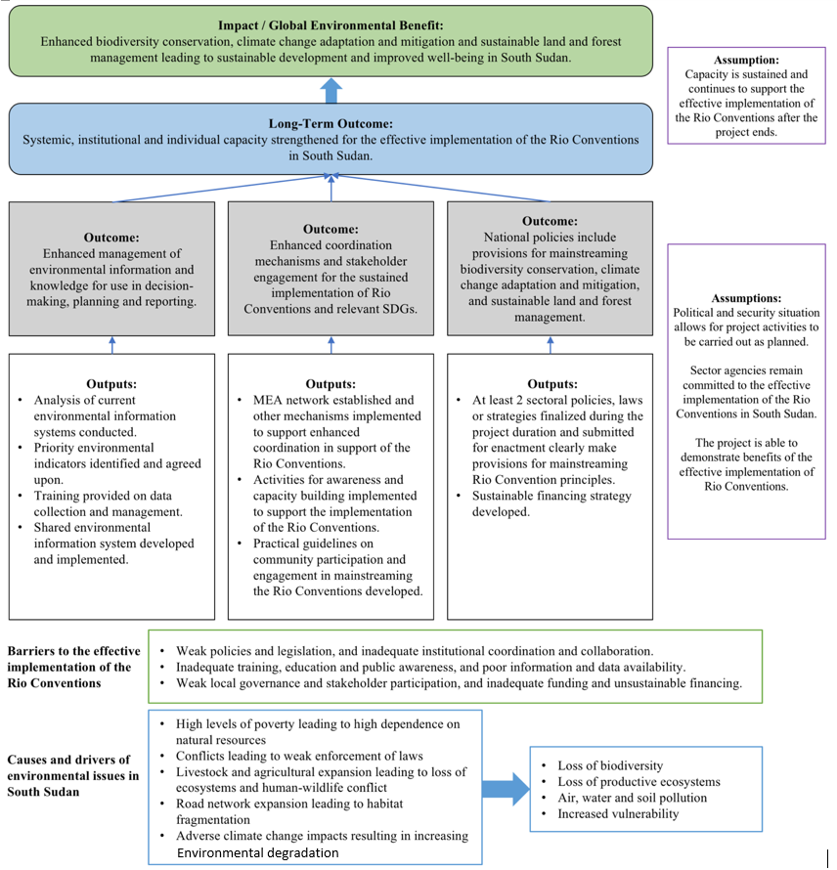
Figure 2: Theory of Change
A brief description of the project outcomes and outputs is provided below. The detailed work plan can be found in Annex I.

Objective: To strengthen systemic, institutional and individual capacity for effective implementation of the Rio Conventions in South Sudan

Component 1: Development of a coordinated environmental knowledge and information management system
Outcome / Outputs | Brief description
Outcome 1  Enhanced management of environmental information and knowledge for use in decision-making, planning and reporting. | This outcome is focused on developing a shared environment information management system.
Output 1.1  Analysis of the current environmental information systems, data flows, environmental statistics and reporting mechanisms related to the Rio Conventions and other MEAs utilized by line ministries and other relevant agencies conducted. | The project will conduct a detailed analysis of existing environmental information systems, data sources and flows, indicators and reporting mechanisms related to the Rio Conventions and other MEAs in South Sudan. This analysis will be conducted by consulting with relevant ministries and agencies, and by using the Environmental Statistics Self-Assessment Tool (ESSAT) as a guideline.
Output 1.2  Priority environmental indicators identified and agreed upon based on MEAs, SDGs, SoEOR, draft Vision 2040 and other sources for use in reporting, monitoring and assessment processes (including gender-disaggregated indicators where relevant). | The project will develop recommendations on improving data availability and on formulating key environmental indicators. An MEA Network meeting (see Output 2.1) will be organised to discuss and agree on priority environmental indicators. The project will then develop standardised definitions for these indicators as well as protocols for data collection, sharing and management, and seek formal endorsement/ agreement of the definitions and protocols from the key agencies. A guidance document will be developed that the sector agencies can use for the compilation and collection of data. The guidance document will also explain how the data in question can be used in decision-making, planning and reporting.  Note: The relevant SDGs are those related to the MEAs. In particular, this includes SDG 1 on Ending Poverty, SDG 2 on Zero Hunger, SDG 3 on Good Health and Well-being, SDG 5 on Gender Equality, SDG 6 on Clean Water and Sanitation, SDG 12 on Responsible Consumption and Production, SDG 13 on Climate Action, and SDG 15 on Life on Land. A mapping of MEA indicators against SDG indicators can be found on Environment Live.
Output 1.3  Training provided to national and state level data custodian agencies (including Rio Convention focal points) on data collection and management methodologies, including use of the Environment Live knowledge platform. | The project will organise a training workshop and on-the-job follow-up activities on data collection and management for the relevant sector agencies and institutions. The main purpose of the training will be to prepare the sector agencies and institutions for the compilation of data for the priority indicators agreed upon under Output 1.2. Champions will be designated in each agency to take these activities forward.
Output 1.4  Shared environmental information system developed and implemented to manage and access environmental data, building on the existing CBD national Clearing House Mechanism. | The project will analyse the requirements and key functionalities of a shared information management system. A Database Expert will then develop the system and provide training for different user groups on its use. A host agency for the system (probably the National Environmental Information Center under MoEF, which could be integrated with the Biodiversity Information Unit) will be identified. Clear responsibilities will be established and budget allocated for the maintenance and update of the system in the medium and long term. The different sector agencies and institutions will make their data available on the shared environmental information system.

Component 2: Strengthening of coordination mechanisms and stakeholder engagement for the Rio Conventions and relevant SDGs
Outcome / Outputs | Brief description
Outcome 2  Enhanced coordination mechanisms and stakeholder engagement for the sustained implementation of Rio Conventions and relevant SDGs. | This outcome will focus on implementing mechanisms for enhanced coordination, on building awareness and capacity of relevant stakeholders, and on developing practical guidelines on community participation and engagement in the implementation of the Rio Conventions.
Output 2.1  MEA Network established and other mechanisms implemented to support enhanced coordination in support of the implementation of the Rio Conventions, other relevant MEAs and related SDGs. | The project will organise a technical workshop with relevant key line ministries and agencies, civil society, development partners, academia and the private sector to discuss common interests in environmental management and the Rio Conventions (building on previous processes such as the SoEOR) and to agree on the establishment of a cross-sector, national MEA Network.  Based on the outcomes of the workshop, the project will prepare the Terms of Reference (TOR) of the network. The network will be formally established through notification or ministerial order by MoEF. Regular meetings of the network will be organised. MoEF as the network secretariat (with support from the PMU) will issue a biannual newsletter to highlight the progress of the network and recognise efforts of the sector agencies with regard to their data and policies. Other incentives/means of recognition can be provided to network members, e.g. through the publication of brief “state of the sector” reports or by sponsoring the participation in regional meetings/trainings.  In addition, the project will support the implementation of other mechanisms for enhanced consultation and coordination in support of the implementation of the Rio Conventions, other relevant MEAs and related SDGs. This will also help to create synergies among the conventions. These mechanisms will likely include:  - Regular working group and consultative meetings during the formulation of policies and project planning and execution. At least one of these meetings will be held at the state level, followed by a field visit, in order to ensure linkages with the state and local level.  - Strengthening of the Department for Multilateral Environmental Agreements within MoEF responsible to coordinate matters related to the Rio Conventions and other relevant MEAs.  - Consultation process in the preparation of national reports and Conference of the Parties (COPs), and briefing sessions with relevant agencies to share outcomes of COPs (in particular, among relevant convention focal points in MoEF and MoAFS).  - Joint progress monitoring of MEA implementation, plans and policies (in particular, the NCSA action plan and the NBSAP).  - Establishment of a stakeholder database (made available on the MoEF website or the CBD Clearing House Mechanism) indicating the focal offices in the agencies that have mandates and information related to the Rio Conventions.  - Conduct a rapid assessment of the current institutional arrangements for MEA implementation (based on the NCSA analysis).
Output 2.2  Activities for awareness and capacity building implemented (e.g., disseminating best practices and fact sheets, organising events, roundtables for decision-makers, and training) to support the implementation of the Rio Conventions and the relevant SDGs. | The project will prepare an awareness and capacity development plan to support the implementation of the Rio Conventions (including Ramsar). It will also conduct a baseline awareness survey among key stakeholders (at national and state/local level). The plan should directly support the needs and priorities identified in existing national plans under the Rio Conventions, notably the NCSA action plan, the NBSAP (for the CBD) and the INC (for UNFCCC), as well as the UNCCD. The project will then start implementing the awareness and capacity development plan. Each agency will lead the activities relevant to their sector, in collaboration with relevant stakeholders and by exploring synergies among the sectors and conventions. Participants will be selected based on predefined criteria such as area of work or expertise, and the project will ensure adequate participation of women. These activities will likely include:  Awareness:  - Compiling and disseminating simple fact sheets on the importance of biodiversity conservation, climate change adaptation and mitigation, and sustainable land and forest management for sustainable development and the well-being of people in South Sudan. These fact sheets should explain the linkages with the Rio Conventions, the SDGs as well as relevant national policies and plans. They can also include best practices of environmental management from South Sudan and other countries in the region. The fact sheets should highlight the importance of gender mainstreaming (and the important role played by women with regard to natural resources management) and indigenous knowledge and practices. Existing channels and mechanisms can be used for awareness building and the dissemination of information, best practices and policies (e.g., the Resilience Exchange Network under the NGO Forum).  - Radio and television bulletins and/or articles in newspapers, magazines, journals, SMS etc.  - Public lectures for university students.  - Organising roundtables for parliamentarians, policy- and decision-makers to sensitise them to the impacts of biodiversity loss, climate change, and land degradation and strategies to address these impacts. It is particularly important to reach decision-makers outside the agencies generally associated with environmental management, as their decisions can have a direct impact on issues related to the Rio Conventions. This also includes the Ministry of Finance and Planning. As an example, awareness needs to be raised on the importance of preserving the Sudd wetlands.  - Organising awareness raising events such as World Environment Day, World Wetlands Day, World Water Day and the International Day of Forests; and organising awareness raising sessions at the state level.  Capacity building:  - Training of Trainers (TOT) for national and state level stakeholders on the Rio Conventions (what do these conventions involve, how are they implemented in South Sudan, and how can South Sudan benefit from them). In particular, this will involve agencies that are less familiar with the Rio Conventions, such as the Ministry of Justice and the Ministry of Finance and Planning, as well as civil society.  - Training for Rio Convention focal points and other relevant technical staff on negotiation skills for the COPs and other technical aspects of the Rio Conventions. The project will seek synergies with the European Capacity Building Initiative (ECBI) junior climate negotiator training. Additional two participants could be sent to attend the ECBI training based on predefined selection criteria. The participants will then support the provision of in-country training to a larger group of participants.  - Training of Trainers (TOT) for representatives of academia/research institutions on the Rio Conventions and the role played by these institutions in their implementation.  - Training on Online Access to Research in the Environment (OARE) – a programme that enables academic, research and government institutions in developing countries to gain access to a large body of research in the environment and related fields. Access to the OARE system will be set up (South Sudan is a “free access” country). Wherever possible, training should be conducted in country in order to reach a larger group of people.  The project will organise an end-of-project awareness survey.
Output 2.3  Practical guidelines on community participation and engagement in mainstreaming and implementation of the Rio Conventions developed. | The project will develop practical guidelines for all levels of government and civil society to facilitate community participation and engagement in mainstreaming and implementation of the Rio Conventions (e.g., through community committees and participatory planning processes). It will organise a stakeholder consultation meeting to discuss the proposed guidelines, and will then disseminate the guidelines through the awareness and training events organised under Output 2.2.

Component 3: Integration of key provisions of Rio Conventions in national policies and legislation
Outcome / Outputs | Brief description
Outcome 3  National policies include provisions for mainstreaming biodiversity conservation, climate change adaptation and mitigation, and sustainable land and forest management. | This outcome is focused on finalizing laws and policies that incorporate Rio Convention principles, and on working towards their adoption. It will also support mainstreaming of the Rio Conventions by developing a sustainable financing strategy.
Output 3.1  At least 2 sectoral policies, laws or strategies finalized during the project duration and submitted for enactment clearly make provisions for mainstreaming Rio Convention principles. | The project will conduct a detailed analysis of existing sectoral policies, laws and strategies to identify gaps in the integration of the Rio Convention principles (based on the analysis conducted in section A1. 2) Baseline scenario). It will also analyse where draft bills and policies are pending, and the steps needed towards their adoption. The project will then draft a working paper outlining opportunities to incorporate Rio Convention principles (on biodiversity, climate change, and land degradation) into existing draft policies, laws and strategies or new policies, in line with the relevant national plans (in particular, the NBSAP, the INC, as well as the UNCCD).  The project will organise an MEA Network meeting and public consultations (including at the state level and with civil society organisations) to gather stakeholder inputs on the priority bills and policies to be supported by the project. It will then support the finalization of the selected priority bills and policies, including their submission to the Ministry of Justice for final drafting. The project will then work towards the adoption of the draft bills and policies by the National Legislative Assembly or the Council of Ministers, respectively.
Output 3.2  Sustainable financing strategy for Rio Conventions and the environmental dimension of SDGs developed. | The project will conduct an analysis of the current funding sources and gaps related to the implementation of the Rio Conventions, the relevant SDGs and national policies and laws. Based on this, it will draft a sustainable financing strategy. The project will organise consultations to discuss the strategy with the sector agencies, including the Ministry of Finance and Planning and state level representation, as well as international development partners and other relevant stakeholders. Once finalized, the progress in implementing the strategy will be regularly monitored at the MEA Network meetings.  To support resource mobilisation from international sources, the project will organise a training for staff of relevant government agencies and NGOs on writing project proposals to access funding for environmental projects.

The changes made in the results framework since the PIF are summarized in the table below. These changes were made based on consultations with key stakeholders during the project design phase.

PIF version | Changes since PIF
Component 1
Component 1:  Development of a coordinated environmental knowledge and information management system.  Outcome 1:  Enhanced management of environmental information and knowledge for use in decision-making, planning and reporting.  Output 1.1:  Analysis of the current environmental information systems, data flows, environmental statistics and reporting mechanisms related to the Rio Conventions and other MEAs utilized by line ministries and other relevant agencies.  Output 1.2:  Agreement among key line ministries and agencies on the streamlining of data collection and sharing to fill data gaps and reduce unnecessary duplication.  Output 1.3:  Formulation of nationally appropriate environmental indicators based on MEAs, SDGs, and other sources for use in different reporting and assessment processes.  Output 1.4:  Training for national and local data custodian agencies on data collection and management methodologies, including use of the UNEP Live knowledge platform.  Output 1.5:  Streamlined indicator-based monitoring and reporting system to MEAs, indicators for the environmental dimension of SDGs, EPI calculation and other relevant mechanisms, including by use of the Indicator Reporting Information System (IRIS). | Component 1:  No changes.  Outcome 1:  No changes.  Output 1.1:  No changes (“conducted” added at the end to harmonise output wording).  This has been incorporated into new Output 1.2 as well as Output 2.1.  Output 1.2:  Changed to “Priority environmental indicators identified and agreed upon based on MEAs, SDGs, SoEOR, draft Vision 2040 and other sources for use in reporting, monitoring and assessment processes (including gender-disaggregated indicators where relevant).”  Output 1.3:  Slightly changed as follows: “Training provided to national and state level data custodian agencies (including Rio Convention focal points) on data collection and management methodologies, including use of the Environment Live knowledge platform.”  Output 1.4:  Changed as follows to make it clearer: “Shared environmental information system developed and implemented to manage and access environmental data, building on the existing CBD national Clearing House Mechanism.”
Component 2
Component 2:  Strengthening of consultative management structures and mechanisms for the Rio Conventions and relevant SDGs.  Outcome 2:  Enhanced institutional capacity and stakeholder participation for the sustained implementation of Rio conventions and relevant SDGs.  Output 2.1:  Enhanced consultative and decision-making processes to coordinate South Sudan’s planning, implementation, and reporting obligations under the Rio Conventions, other relevant MEAs and related SDGs, including shared environmental information systems, collaborative institutional inter-ministerial and decentralized mechanisms, collaborative mechanisms with major groups and stakeholders.  Output 2.2:  Strategy for enhancing capacity of public institutions of learning to teach environmental education, including capacity necessary for research, monitoring, and managing information, formulated and implementation started (technical staff trained).  Output 2.3:  Communications/awareness raising to increase awareness of Rio Conventions and relevant SDGs.  Output 2.4:  Civil society groups provided with capacity to participate in and facilitate communities engagement in mainstreaming and implementation of Rio Conventions.  Output 2.5:  Sustainable financing strategy for Rio Conventions and the environmental dimension of SDGs. | Component 2:  Changed as follows to make it clearer: “Strengthening of coordination mechanisms and stakeholder engagement for the Rio Conventions and relevant SDGs.”  Outcome 2:  Changed as follows to make it more concrete: “Enhanced coordination mechanisms and stakeholder engagement for the sustained implementation of Rio Conventions and relevant SDGs.”  Output 2.1:  Changed to “MEA Network established and other mechanisms implemented to support enhanced coordination in support of the implementation of the Rio Conventions, other relevant MEAs and related SDGs.” The specific mechanisms are outlined in the description of the activities under this output (see Annex I). The shared environmental information system has been moved to Output 1.4.  Output 2.2:  Elements of this output have been incorporated into new Output 1.3 and 2.2, including capacity building of academic institutions. Output 2.2 has been revised as follows: “Activities for awareness and capacity building implemented (e.g., disseminating best practices and fact sheets, organising events, roundtables for decision-makers, and training) to support the implementation of the Rio Conventions and the relevant SDGs.”, which (among others) includes training for academic/research institutions. The concrete activities are outlined in the description of the activities under this output.  This has been incorporated into new Output 2.2.  Output 2.3:  Reworded as follows to make it more tangible and realistic: “Practical guidelines on community participation and engagement in mainstreaming and implementation of the Rio Conventions developed.” Capacity building for civil society (among other stakeholders) is included in new Output 2.2.  This output has been moved to Component 3 due to its linkages with policy and planning to support mainstreaming of the Rio Conventions.
Component 3
Component 3:  Integration of key provisions of Rio Conventions in National Policies and legislation.  Outcome 3:  National policies include provisions for mainstreaming biodiversity conservation, climate change risks and adaptation, sustainable land and forest management.  Output 3.1:  At least 4 policies finalized during the project duration clearly make provisions for mainstreaming Rio Convention principles.  Output 3.2:  At least 3 policies finalized during the project duration have legislation to support implementation submitted to Cabinet for Enactment.  Output 3.3:  Roadblocks to effective enforcement of policies identified and strategies for tackling weak enforcement (e.g. of Environmental Impact Assessments and environmental auditing for the Petroleum and other industries, and infrastructure development) formulated and implementation supported. | Component 3:  No changes.  Outcome 3:  “Climate change risks and adaptation” has been changed to “climate change adaptation and mitigation” to make it clearer.  Output 3.1:  Reworded and combined with Output 3.2 to make it clearer. Target reduced to 2 policies to make it more realistic. “At least 2 sectoral policies, laws or strategies finalized during the project duration and submitted for enactment clearly make provisions for mainstreaming Rio Convention principles.”  Output 3.2:  This has been incorporated into Output 3.1. New Output 3.2 added as follows: “Sustainable financing strategy for Rio Conventions and the environmental dimension of SDGs developed.”  Removed to make the project more realistic and focused on the formulated outcome. The main barriers to effective enforcement in South Sudan are deemed to be 1) the absence of peace and stability, and 2) the fact that the bills have not been enacted, which is addressed by Output 3.1. Another barrier, the lack of awareness and capacity, is addressed under Outcome 2.

4) Incremental/additional cost reasoning and expected contributions from the baseline, the GEFTF, LDCF, SCCF, CBIT and co-financing

The project will build on ongoing efforts at the Ministry of Environment and Forestry, the Ministry of Agriculture and Food Security, the Ministry of Wildlife Conservation and Tourism, the Ministry of Water Resources and Irrigation, and the Ministry of Humanitarian Affairs and Disaster Management, to formulate and implement policies and plans related the Rio Conventions. It will also build on ongoing initiatives at the National Bureau of Statistics to build statistical capacity in South Sudan. It will benefit from the ongoing development of a National Biodiversity Database, as well as environmental education and awareness raising activities. The project will also benefit from best practices of past and ongoing projects implemented by civil society organisations and academia in South Sudan with regard to natural resources management and community engagement.

Without the GEF project, however, South Sudan would not be in a position to build the necessary capacity for the adequate implementation and mainstreaming of the Rio Conventions in the country. In particular, without the necessary coordination mechanisms supporting their enactment, several environmental laws and policies would remain in draft format. In the absence of effective data collection and sharing mechanisms, available environmental data and information to support enhanced decision-making, planning and reporting would remain limited. In addition, there would be limited support by high-level decision makers, agencies that are not generally associated with environmental management and the general public, and thus limited mobilisation of resources, for the implementation of the Rio Conventions. There would also be limited capacity to support public consultation and community engagement.

The GEF incremental support will, therefore, allow for:
- Enhanced management of environmental information and knowledge for use in decision-making, planning and reporting;
- Enhanced coordination mechanisms and stakeholder engagement for the sustained implementation of Rio Conventions and relevant SDGs; and
- National policies that include provisions for mainstreaming biodiversity conservation, climate change adaptation and mitigation, and sustainable land and forest management.

5) Global environmental benefits (GEFTF) and/or adaptation benefits (LDCF/SCCF)

There is a significant opportunity to strengthen South Sudan’s capacity to address global environmental issues such as biodiversity loss, climate change and desertification by enhancing its capacity to implement the obligations under the Rio Conventions and related SDGs. Accordingly, the project will support the mainstreaming of biodiversity conservation, climate change adaptation and mitigation, and sustainable land and forest management, into policy and planning processes in South Sudan. It will also support increased awareness and capacity to implement the Rio Convention principles in the country, and improve the availability of environmental information.

The global benefits arising from these actions include improved habitats for globally significant and threatened wildlife species (such as lions, cheetahs, leopards, elephants), and migratory birds. Reduced deforestation will increase carbon storage with benefits to the global climate regimes, and will lead to sustainable livelihoods for local communities. Addressing land degradation and climate change impacts will lead to improved provision of ecosystem goods and services. By building capacity for implementing the Rio Conventions, the project is, therefore, expected to have multiple global environmental benefits in all GEF focal areas, leading to sustainable development and improved well-being for the people of South Sudan.

6) Innovativeness, sustainability and potential for scaling up

The project’s innovative nature stems from its specific design seeking to align country-level environmental priorities with global environmental concerns at an early stage of the country’s policy development process. This is unlike many more established countries, which involve an extensive process of policy review to mainstream the Rio Conventions. The proposed project will represent a first in the CCCD portfolio at the national level; it will encourage policy makers, scientists and researchers to implement measures in support of the Rio Conventions and relevant SDGs, as well as encourage linkages between researchers in South Sudan and the international research community in fields related to multilateral environmental agreements (MEAs). The socio-economic situation in South Sudan, deforestation, land degradation and loss of biodiversity, and the growing climate challenge combine to create a unique challenge for the GEF and CCCD portfolio.

The project’s innovativeness also lies in introducing locally adopted environmental data management and environmental monitoring systems, utilizing the best international practices, for the integration of data in the local and global environmental management systems, based on the country’s traditional knowledge and experiences. The project will carry out activities that build the needed capacities for harmonizing information management for improved knowledge and monitoring of the global environment in South Sudan, while producing global environmental benefits; this includes a wide variety of activities such establishing a cross-sector, national MEA Network, and a shared information management system.

The project’s strategy of establishing information management and synchronized data entry and management systems within the Government’s responsible authority, is an innovative approach that can be applied to other fields where other governance systems or decentralization processes create tensions over sovereignty and the rights or needs of information sharing. Many lessons in this regard will be drawn from the project and can be utilized for improved implementation in other fields.

UN Environment has built a solid working relationship with the Government of the Republic of South Sudan, which has enabled it to continue undertaking environment management work in a country undergoing humanitarian support. This has enabled it to generate a series of lessons that have informed the formulation of the current project, in particular with regard to the sustainability of the project interventions. These include:
- The critical importance of mainstreaming the principles of the Rio Conventions to safeguard the important natural resources and ecosystems of South Sudan for national development and global environment benefits;
- The critical role of partnerships between government entities, local and national government, civil society and development partners in tackling the very complex and fluid development, environment management and poverty/wealth creation nexus in South Sudan;
- The importance of capacity development for government institutions in managing this nexus; and,
- The importance of knowledge management and information systems in supporting mainstreaming.

By establishing mechanisms for coordination among the different line ministries and agencies, it is anticipated that the capacity built through the project will be sustained after the project ends. In addition, the generation of high quality data and the synergies created by the project should help demonstrate the need for continuation of support after the project ends. Once the mechanisms are in place, there is potential for scaling up the project interventions, in particular by addressing additional laws and policies and environmental indicators.

A.2. Child Project? If this is a child project under a program, describe how the components contribute to the overall program impact.
No

B. Stakeholders. Identify key stakeholders and elaborate on how the key stakeholders engagement is incorporated in the preparation and implementation of the project. Do they include civil society organizations (yes /no )? and indigenous peoples (yes /no )?

A number of government bodies operating at the national, state and local levels are responsible for protecting the environment and natural resources. At the local level, they usually work directly with local communities and community-based organizations to undertake specific activities. In addition, key stakeholders to be involved in the project also include international and regional bodies, academia and research institutions, civil society and the private sector. The main stakeholders are:
- The public sector through the staff of sector ministries, authorities and departments, in particular: the Ministry of Environment and Forestry, Ministry of Agriculture and Food Security, Ministry of Wildlife Conservation and Tourism, Ministry of Livestock and Fisheries, Ministry of Justice, Ministry of Finance and Planning, National Bureau of Statistics, Ministry of Electricity and Dams, Ministry of Petroleum, Ministry of Mining, Ministry of Water Resources and Irrigation, Ministry of Trade, Industry and East Africa Community Affairs, Ministry of Lands, Housing and Physical Planning, Ministry of Humanitarian Affairs and Disaster Management, and the Ministry of Transport.
- Other institutions to be involved in the project implementation are the South Sudan Relief and Rehabilitation Commission, the South Sudan Meteorological Service, the Yei Agricultural Research Centre, the Sudd Institute and Institutions of Higher Learning.
- Community-based organizations and other civil society groups.

A project preparation inception workshop and individual consultations were held in May 2018 with several government ministries, public institutions and civil society in Juba to gather stakeholder inputs for the project document preparation of the GEF-funded project. Over 60 participants from different line ministries, departments, the National Legislative Assembly, academia, the private sector and local NGOs attended the workshop. International development partners were also consulted.

The table below lists the stakeholders that have been identified during the development of this project, and their expected role in the project.

Stakeholder | Description / mandate | Role and involvement in the project
Government
Ministry of Environment and Forestry (MoEF) | In charge of developing the policy and regulatory frameworks on environment, forestry, wetlands and biodiversity management, including capacity building and strengthening of partnerships with stakeholders, acceding to and implementing MEAs and environmental audit and assessment. Focal point for CBD, UNFCCC, Ramsar Convention. Includes the following directorates:  - Directorate of Forestry: Manages Forest Reserves.  - Directorate of Wetlands and Biodiversity: Ensures that the wetlands, biodiversity and any natural features in South Sudan are protected and used sustainably.  - Directorate of Climate Change and Meteorology: Develops and implements programmes to address issues of climate change and coordinates the implementation of South Sudan’s obligations under the UNFCCC.  - Directorate of Environmental Information & Education | The MoEF will be a key partner in the execution of the project, providing support to the UN Environment country office (the Lead Executing Agency).
Ministry of Agriculture and Food Security | Responsible for increasing agricultural productivity to improve food security and contribute to economic growth, environmental sustainability and to facilitate and encourage equitable and sustainable development towards improved livelihood through sensitization, mobilization, capacity building and direct involvement of rural communities in their own development. Responsible for managing invasive alien species, and for maintaining seed genetic diversity.  - Directorate of Agriculture & Extension  - Directorate of Research & Training  Focal point for UNCCD. | Engage in project implementation (all three outcomes), in particular with regard to the UNCCD.
Ministry of Wildlife Conservation and Tourism | Protects, conserves and manages wildlife resources in South Sudan through the Wildlife Service (at the national, state, county, payam, and national park level). All protected areas and the wild animals therein remain the property of government on behalf of the people.  The Wildlife Service is well established in the country with offices in each state and localities where protected areas are located. It coordinates and cooperates with the local communities on the protection and management of wildlife within their areas; manages wildlife outside protected areas; and conserves, manages and administers national parks, wildlife reserves or other protected areas according to law and in a manner consistent with the agricultural and pastoral activities of nearby settled communities. | Engage in project implementation (all three outcomes)
Ministry of Livestock and Fisheries | In charge of livestock and fishery policy development. The Directorate of Veterinary Services is responsible for preparing and enforcing laws governing the control and eradication of livestock diseases and the safety of food of animal origin. This includes safeguarding public health by tracking animal diseases transmissible to humans as well as domestic animal disease control. | Inform and engage (all three outcomes, in particular Outcome 1)
Ministry of Justice | The Ministry of Justice plays a crucial role in reviewing draft laws and ensuring their compatibility with the Transitional Constitution before they are forwarded to the Council of Ministers/Cabinet and Parliament for approval. | Engage in project implementation (in particular, Outcome 3)
Ministry of Finance and Planning | Allocates financial resources to government ministries and agencies. | Inform and engage (in particular in Outcome 3)
National Bureau of Statistics | Responsible for the development of statistics in South Sudan. Hosts the National Directorate of GIS, Remote Sensing and Cartography. | Engage in project implementation (in particular for Outcome 1)
Ministry of Electricity and Dams | Plans and provides power generation, transmission and distribution facilities to industrial and domestic consumers through the South Sudan Electricity Corporation (SSEC), the implementing body of the Ministry whose mandate is to execute the Ministry’s policies, strategies and plans for availability, accessibility and affordability of electricity. | Inform and engage (all three outcomes)
Ministry of Petroleum | In charge of policies related to petroleum exploration. | Inform and engage (all three outcomes)
Ministry of Mining | Ministry in charge of mining policies. | Inform and engage (all three outcomes)
Ministry of Water Resources and Irrigation | Is responsible for managing water resources and developing water policies, strategies and plans, such as the Irrigation Development Master Plan and the Water Resources Utilisation and Development Master Plan. | Inform and engage (all three outcomes)
Ministry of Lands, Housing and Physical Planning | Is responsible for conducting town planning, land registration, and land use planning. | Inform and engage (all three outcomes)
Ministry of Trade, Industry and East Africa Community Affairs | Ministry responsible for trade, industry and the East African Community (EAC). Responsible for the formulation of the South Sudan Trade Policy. South Sudan became a full member of the EAC in 2016, and obtained observer status with the World Trade Organization (WTO) in in 2017. | Inform and engage (all three outcomes)
Ministry of Humanitarian Affairs and Disaster Management (MHADM) | Is responsible for policy making on disaster risk reduction at the national level. Its mandate is to oversee all humanitarian work in South Sudan. It is composed of the Directorate of Administration and Finance; the Directorate of Planning, Coordination, Monitoring and Evaluation; and the Directorate of Disaster and Management. | Inform and engage (all three outcomes)
South Sudan Relief and Rehabilitation Commission (SSRRC) | This is the operational arm of the MHADM, responsible for implementing policies made by the Ministry under the Directorate of Disaster Management at the national level and through SSRRC’s representatives at the levels of states and counties. It is involved in establishing an early warning system at national and state levels. | Inform and engage (all three outcomes)
Ministry of Gender, Child and Social Welfare | Responsible for promoting gender equality and safeguard the rights and welfare of women, children, persons with disabilities and other vulnerable groups. | Inform and engage (all three outcomes)
Ministry of Foreign Affairs and International Cooperation | This ministry is the political focal point for international environmental conventions and treaties. It is also the link between international efforts on climate change and the Government of the Republic of South Sudan. | Inform and engage (all three outcomes)
Ministry of Transport | Responsible for developing the legal framework and implementation strategy for transport. Also hosts the South Sudan Meteorological Service. | Inform and engage (all three outcomes)
South Sudan Meteorological Service (SSMS), Ministry of Transport | The SSMS has re-established climate stations to deliver information on actual weather, forecast weather, seasonal outlook and climate.  The SSMS also acts as the National Meteorological and Hydrological Service for South Sudan under the World Meteorological Organization (WMO). | Inform and engage (in particular Outcome 1)
Ministry of General Education and Instruction | Responsible for formulating the national education curriculum. | Inform and engage (in particular Outcome 2)
Ministry of Information, Telecommunication and Postal Services | Manages, controls and disseminates information guided by policy. | Inform and engage for information dissemination (Outcome 2)
South Sudan Investment Authority (SSIA) | The SSIA is a corporate body established under the Investment Promotion Act 2009 to promote investment in South Sudan. The SSIA is responsible for initiating and supporting measures that will enhance the investment climate for both national and non-national enterprises and persons. | Inform and engage (all three outcomes)
State, County, Payam and Boma Level Governments | Responsible for State, County, Payam, and Boma administration. In particular:  - State Ministries  - State and local level environmental management committees  - Wildlife Departments | Engage in project implementation (all three outcomes)
International and regional institutions
UN Environment | United Nations agency for the environment, plays a leading role in supporting the environmental dimension of the SDGs. It also acts as the secretariat for several MEAs (CBD, chemicals conventions, CITES, Minamata, Montreal). It hosts the Environment Live platform, providing global environmental and socio-economic data, and is developing the Indicator Reporting Information System (IRIS), an online reporting system that can be customised at the national level.  https://environmentlive.unep.org/  UN Environment has a country presence in South Sudan since 2009, under its Post-Conflict and Disaster Management Branch (renamed to Crisis Management Branch). Since then, it has supported the Government of South Sudan in the drafting of environmental bills and policies and in the development of the National Adaptation Programme of Action (NAPA) and the Initial National Communication (INC) under the UNFCCC, the Fifth National Report and the National Biodiversity Strategy and Action Plan (NBSAP) under the CBD, as well as the State of Environment Report (SoEOR). It has also supported the implementation of the Green Climate Fund’s Readiness project in South Sudan. | UN Environment is the GEF Implementing Agency, and will also support MoEF in the execution of this project.
United Nations Mission in South Sudan (UNMISS) | The UNMISS mandate includes:  - Support for peace consolidation and thereby fostering longer-term statebuilding and economic development.  - Support the Government of the Republic of South Sudan in exercising its responsibilities for conflict prevention, mitigation and resolution and protect civilians.  - Support the Government of the Republic of South Sudan in developing its capacity to provide security, to establish rule of law, and to strengthen the security and justice sectors. | Inform
UN-REDD Programme | The United Nations Programme on Reducing Emissions from Deforestation and Forest Degradation (UN-REDD) is a collaborative programme of FAO, UNDP and UN Environment, created in 2008. UN-REDD supports nationally led REDD+ processes and promotes the informed and meaningful involvement of all stakeholders. In South Sudan, it has supported the implementation of a REDD+ Country Needs Assessment. | Inform
Food and Agriculture Organization of the United Nations (FAO) | FAO is a specialized agency of the United Nations that leads international efforts to defeat hunger. FAO works closely with the Government of South Sudan to improve nutrition and eradicate hunger in the country. Provides support in three priority areas described in the Country Programming Framework (CPF) 2016-2017: sustainable increase in production and productivity, agriculture-based economic growth and incomes increased, increased resilience of livelihoods to threats and crisis. | Inform and engage
World Food Programme (WFP) | WFP is the food-assistance branch of the United Nations and the world’s largest humanitarian organization addressing hunger and promoting food security. In South Sudan, WFP provides lifesaving emergency assistance for 1.6 million people directly affected by conflict, and non-emergency food assistance for a further 1.6 million people through its recovery operation. | Inform
United Nations Educational, Scientific and Cultural Organization (UNESCO) | UNESCO seeks to build peace through international cooperation in education, the sciences and culture. UNESCO’s projects and activities in South Sudan aim to contribute to peace building, alleviating poverty and fostering sustainable development in the country. | Inform
United Nations Development Programme (UNDP) | UNDP is the United Nations’ global development network. UNDP’s programmes in South Sudan are focused on democratic governance and stabilization, human development and inclusive growth, as well as gender equality and women’s empowerment. | Inform and engage
BRACED Consortium | The BRACED Consortium is a UKaid-funded project implemented by a consortium of Concern Worldwide, ACTED, FAO and the Sudd Institute. FAO provides data driven decision making inputs and training tools for BRACED activities. | Inform
Intergovernmental Authority on Development (IGAD) | IGAD is an eight-country trade bloc in Africa. It includes governments from the Horn of Africa, Nile Valley, and the African Great Lakes. Its mission is to assist and complement the efforts of its Member States through increased cooperation to achieve:  - Food security and environmental protection;  - Promotion and maintenance of peace and security and humanitarian affairs; and  - Economic cooperation and integration. | Inform
Nile Basin Initiative | The Nile Basin Initiative (NBI) is an intergovernmental partnership of 10 Nile Basin countries (including South Sudan). The NBI provides a forum for consultation and coordination among the Basin States for the sustainable management and development of the shared Nile Basin water and related resources for win-win benefits. | Inform
GIZ | German development agency that provides services in the field of international development cooperation. GIZ’s work in South Sudan focuses on three priority areas:  - Food security and development of agricultural markets,  - Urban water and sanitation, and  - Decentralisation and accountability. | Inform
JICA | The Japan International Cooperation Agency (JICA) is a governmental agency that coordinates official development assistance for the government of Japan. JICA is supporting the Government of South Sudan in implementing programmes that foster peace and development of the country. | Inform
Norwegian People’s Aid | Norwegian People’s Aid (NPA) is a humanitarian organisation for solidarity with a long history of involvement in South Sudan. For example, NPA, in partnership with UN Environment conducted pilot activities on community-based natural resource mapping in 2013 in Lainya and Ifwoto Counties of South Sudan. | Inform
Other development partners (major donors) | The EU, USAID, UKaid, the Canadian International Development Agency (CIDA), the Government of Norway, the World Bank and the African Development Bank represent significant development partners providing technical and financial assistance. | Inform
Wildlife Conservation Society (WCS) | WCS has the mandate to support the administration and management of South Sudan’s protected area network, in partnership with the South Sudan Wildlife Service (SSWS). This includes much of the country’s national park estate and includes law enforcement activities as well. WCS additionally works outside of the formally protected areas in a landscape-based approach with operations and programming over a much larger area than the protected areas alone (UN-REDD, 2016). WCS also works with community-based organisations (CBOs) on livelihood programmes and awareness raising. | Inform and engage
Fauna and Flora International (FFI) | Fauna and Flora International is a long-standing international conservation organization. FFI has been operating in South Sudan for more than a decade and works directly with indigenous forest communities, mainly in Western Equatoria to protect forests and forest biodiversity. FFI has extensive experience in participatory community forest management, law enforcement and training and forest monitoring. FFI is about to launch Zooniverse, a platform using citizen science, for South Sudan in collaboration with Bucknell University, to analyse camera trap images for species identification. | Inform and engage
African Wildlife Foundation | The African Wildlife Foundation (AWF) is an international conservation organization headquartered in Nairobi, Kenya, which focuses on critically important landscapes in Africa. AWF is assisting South Sudan in establishing appropriate policies that will help protect its natural resources. In particular, it has supported South Sudan in developing a management plan for Nimule National Park. | Inform and engage
International Fund for Animal Welfare (IFAW) | IFAW is a global non-profit organization that protects animals and their habitats. It works to rescue individual animals, safeguard populations, preserve habitat, and advocate for greater protection. | Inform
Wetlands International | Wetlands International is a global not-for-profit organisation dedicated to the conservation and restoration of wetlands. Wetlands International previously provided training to civil society organisations (CSOs) that work in the Imatong Mountains Key Biodiversity Area (KBA) under a CEPF grant. | Inform
Catholic Relief Service | Catholic Relief Service (CRS) is the international humanitarian agency of the Catholic community in the United States. In South Sudan, CRS provide emergency food and water, works with community members to improve water and hygiene systems, and collaborates with the Catholic Church and other organizations to support peacebuilding and reconciliation. | Inform
Global Biodiversity Information Facility (GBIF) | International organization that focuses on making scientific data on biodiversity available via the Internet using web services. Members collaborate to advance free and open access to biodiversity data.  https://www.gbif.org | Inform
Academia/research institutions
Universities and other training institutions | Universities of South Sudan include:  - Dr. John Garang Memorial University of Science and Technology  - University of Juba (College of Natural Resources and Environment Studies)  - Upper Nile University (Faculties of Forestry, Range Sciences, Agriculture)  Diploma and certificate training institutions include:  - The Padak Fisheries Training Centre  - The Kagelu Forestry Training Centre. | Inform and engage
University of Juba | College of Natural Resources and Environmental Studies. Includes the Departments of Environment, Agricultural Science, Animal Production, Fisheries, and Wildlife Science.  The University of Juba has existing cooperation with international and national research institutions, including, among others, Indiana University, Dr. John Garang Memorial University of Science and Technology, and Upper Nile University. It has over 10,000 students across 12 colleges and six centres, institutes and schools. | Inform and engage
Sudd Institute | The Sudd Institute is a civil society organization that provides targeted research and commentary on various issues in South Sudan, including environment, climate change, natural resource management, and land tenure/rights. It evaluates policies and provides insight to local de facto arrangements regarding resource governance at grass root level. | Inform and engage
Agricultural research institutes | The key institutes established under the Ministry of Agriculture and Food Security are:  - The Yei Agricultural Research Centre  - Parataka Agricultural Research Centre  - Halina Agricultural Research Centre  They are involved in testing varieties of seeds, including seeds that are drought-resistant. | Inform and engage
Civil society/NGOs
Church groups | Church groups in South Sudan are involved in initiatives for peacebuilding, emergency assistance and food security. | Inform and engage
South Sudan NGO Forum | The South Sudan NGO Forum is a voluntary, independent networking body of national and international NGOs that supports its members to effectively respond to the humanitarian and development needs in South Sudan. | Inform and engage
South Sudan Wildlife Society | Promotes conservation of wildlife in South Sudan. | Inform and engage
Alliance for Environment and Rural Development | Promotes sustainable resource use and improves livelihoods through its activities with communities. | Inform and engage
South Sudan Nature Conservation Organisation | A national NGO whose activities promote conservation of biodiversity and contribute to the reduction of greenhouse gas emissions. | Inform and engage
South Sudan Agriculture Producers’ Union | Groups of men and women who work together to strengthen their capacities in agriculture production and marketing throughout the country. | Inform and engage
Famers’ groups, livestock groups | Farmers organised into groups for easy provision of services, inputs and marketing of their produce. | Inform and engage
Community-based organisations (CBOs) | Under the National Environment Policy, CBOs are expected to play a pivotal role in advocacy on sustainable management of biodiversity and ecosystems through mobilizing and sensitizing local people and ensuring that the concerns of the underprivileged are integrated into the national development plans. | Inform and engage
Village elders, village chiefs | Village elders and village chiefs play an important role in local level management through community mobilisation and sensitisation. They are gate keepers and therefore play an important role in determining the success of a project. | Inform and engage
Local and indigenous communities / ethnic groups | Men, women, the elderly and other categories who share common environmental resources. Their livelihoods depend on environmental resources and are therefore the most affected by changes in the quality of ecosystems. | Inform and engage in awareness activities
Private sector
Nile Petroleum Corporation (Nilepet) | Nilepet is the state-owned oil company of South Sudan. They regulate the import of petro-products into the country. | Inform
National and international businesses | Businesses, both national and international, whose activities have direct or indirect impact on the environment or who are impacted by environmental change. Including tourism enterprises. | Inform and engage
Micro-, small and medium enterprises (SMEs) and community cooperatives | Locally owned businesses and producer cooperatives including women-owned cooperatives groups. | Inform

A.4. Gender Equality and Women’s Empowerment. Elaborate on how gender equality and women’s empowerment issues are mainstreamed into the project implementation and monitoring, taking into account the differences, needs, roles and priorities of women and men. In addition, 1) did the project conduct a gender analysis during project preparation (yes /no )?; 2) did the project incorporate a gender responsive project results framework, including sex-disaggregated indicators (yes /no )?; and 3) what is the share of women and men direct beneficiaries (women X%, men X%)?

As highlighted in the NBSAP (2018):

While degradation of ecosystems in South Sudan has had an impact on communities in general, women have suffered more than their male counterparts. In traditional African households, women are usually the primary food providers for their families. Women fetch forest products such as fire wood, leafy vegetables, fruits, roots, and tubers. Women in South Sudanese societies take a very active role in activities such as fishing, collection of wild fruits and vegetables and ensuring food security at the household level. Despite their critical role in the management of natural resources, women have limited property rights that ensure their access to land and forests. Women have comparatively few employment opportunities in the collection, production, and sale of timber, wood, charcoal, and other forest products. This gender disparity in access to and utilization of natural resources from forests and elsewhere is a major contributor to the rising poverty among women. This is accentuated by the fact that the illiteracy rate of women in South Sudan is significantly higher than that of men. Consequently, the involvement of women in development is very important and women should be encouraged to take a more active role in conservation activities at all levels.

Accordingly, gender will be a cross-cutting theme in the formulation, revision and strengthening of key policies and legislative instruments at all levels during the implementation of this project. Bringing the need for sound environmental management down from the national to the local level will ensure that the requirements of the most vulnerable groups in society, such as women and youth groups, can be incorporated in policy making and programme design from a bottom-up perspective. As part of the project implementation arrangements, directed attention will be paid to ensuring an appropriate gender balance in the training and capacity development activities. A background analysis on gender and ethnicity in South Sudan was prepared during the project design phase and is included as a separate document. Gender-disaggregated indicators have been included in the project results framework, with at least 40% of the targeted project stakeholders and beneficiaries being women. In addition, wherever possible, the environmental indicators to be developed under Outcome 1 of the project will be disaggregated by gender, by age and by socio-economic group.

The project will also seek to build on existing policies and structures with regard to gender mainstreaming. In particular, the National Gender Policy of the Ministry of Gender, Child and Social Welfare has formulated strategies on Gender, Environment and Natural Resources Management (see excerpt below). The Ministry of Gender, Child and Social Welfare has a gender focal point in all institutions, including the Ministry of Environment and Forestry, who are involved in training and other activities related to gender. Additionally, the National Women’s Association has representatives at state and county levels.

South Sudan National Gender Policy

Section 3.8 Gender, Environment and Natural Resources Management
South Sudan is among countries in the region that are susceptible to environmental disasters including prolonged droughts and floods. Women play a critical role in providing food, water, fuel wood and subsistence farming among other vital services and are the most affected by environmental degradation and hazards. Their needs and concerns must, therefore, be an integral part of the process of formulating environment and resource management policies and programs. The following strategies can help to ensure that environmental protection, conservation and management systems are gender-responsive and able to meet the needs of present and future generations.

Objective 1. To mainstream gender equality in the formulation and implementation of regulatory framework for environmental and Natural Resource Management

Strategies
      - Provide women education opportunities and information on environmental and natural resources management in order to take up leadership roles in the sector.
      - Invest in research and training of women in the development, production and utilisation of energy-saving and environment-friendly cooking methods and materials.
      - Make gender analysis obligatory in environmental impact assessments for investment and development projects and programs, including large-scale agriculture, dam building, and within petroleum industry.
      - Collaborate with the private sector, including the petroleum industry, to meet their corporate social responsibility by supporting women-led environment protection and rehabilitation activities.
      - Develop and implement gender-responsive and sustainable environment protection and conservation policies and programs and regulations.
      - Conduct research on effects of environment change related to natural resource management on women and families.
      - Gender dimensions of mismanagement and over-use of natural resources on women and links to conflict management and peace building.

In mainstreaming the Rio Conventions, the project shall also take into account the following provisions in the Transitional Constitution of South Sudan.
- Section 16(3): Women shall have the right to participate equally with men in public life.
- Section 16(4): All levels of government shall (a) promote women participation in public life and their representation in the legislative and executive organs by at least twenty-five per cent as an affirmative action to redress imbalances created by history, customs, and traditions. […]
- Section 16(5): Women shall have right to own property and share in the estates of their deceased husbands together with any surviving legal heir of the deceased.

For the dissemination of best practices, the project can further build on the findings of earlier assessments. Among these, the Technical Guidelines on Gender Mainstreaming in Water Harvesting in South Sudan recommend:

It is important to recognize women’s and men’s rights as water users in their own right and consider the different implications of water harvesting for women, men, boys and girls in any project, programme or policy to assess how they will benefit from different interventions. Such a gender approach to water harvesting interventions would contribute to sustainability and impact on conflict reduction and peace-building.

A USAID report (2015) finds:

Customary law continues to govern the use of land and other natural resources in South Sudan, with each ethnic group applying its own laws relating to land and land rights within its own territory. However, customary rules are not equitable and restrict women’s access to land and property. The current legislation recognizes the importance of customary institutions as well as their inability to protect women’s access, control and ownership of land. While the legal framework provides a solid foundation, efforts need to be made to clarify roles and responsibilities of the government and customary institutions when rights overlap, and to provide guidance on how to bridge the gap between a customary framework that restricts women’s rights, and the new legal framework that puts women on equal footing with men. […] [Support can be provided by] ensuring that women participate in the decision-making process and increasing women’s representation within land administration institutions.

A.5 Risk. Elaborate on indicated risks, including climate change, potential social and environmental risks that might prevent the project objectives from being achieved, and, if possible, the proposed measures that address these risks at the time of project implementation.(table format acceptable):

The following risks have been identified and management measures proposed.

Risk | Level | Management Strategy
- Limited institutional capacities to support project implementation and programme continuity. | Low | CCCD interventions are institutionally complex and require effective coordination and collaboration mechanisms. A ministerial order is planned to be issued by the Ministry of Environment and Forestry to form a high-level inter-ministerial committee on the implementation of environmental projects. This committee, in conjunction with other coordination mechanisms to be established under the project, is expected to strengthen institutional capacity.
- Lack of horizontal coordination across ministries and agencies. | Medium | Same as 1)
- Inadequate government and other stakeholder commitment to the process, including reluctance to share information and data. | Medium | South Sudan is still a new country fully engaged in many processes of establishing a functioning country, having faced frequent conflict and civil war. It therefore has many socio-economic priorities, and commitment to the global environment may decline in the face of other, short-term, socio-economic challenges. The project has a focus on building the needed capacity and raising awareness on the linkages between the Rio Conventions and sustainable development, which are designed to promote and generate high-level support. This, and the focus on generating good information, should ensure that the needed commitment is maintained. The project will build on existing mechanisms under which the agencies share data with NBS, and between MWCT and MoEF. The project will also aim to address priorities of the different agencies with regard to their data in order to ensure their commitment. In addition, South Sudan’s Information Act regulates information sharing.
- Instability and insecurity in certain parts of the country. | Medium | Most of the project activities will be based in Juba which is comparatively safe and secure as head offices of over 20 UN agencies are based there. In case of travelling to other parts of the country, the project will follow appropriate instructions and applicable protocols from the UN Department of Safety and Security (UNDSS). Prior to any deployment, project staff, consultants and collaborators will undergo security training.
- Inability to mobilise adequate co-financing for the implementation of project activities and outputs. | Medium | The project depends on GEF and co-financing from several sources for sustaining the operations during the project. During the project preparation phase, the commitment and co-financing of the key agencies has been confirmed. Also, the project activities have been designed to be realistic under the current circumstances. Nevertheless, there is a risk that the needed co-financing may not be available in time due to external factors. The high-level support described above should facilitate access to co-financing.
- Inability to maintain the finances required for a sustained continuation of project activities and outputs after the project ends, including to maintain IT infrastructure and internet access. | High | The synergies created through the project, in particular with regard to environmental information management and reporting, are expected to help to mobilise support. In addition, the generation of high quality data should help demonstrate the need for continuation of support after the project ends, including continued funding for maintainance of IT infrastructure and internet access. The project will explore synergies with other projects under development, in order to ensure long-term sustainability.

A.6. Institutional Arrangement and Coordination. Describe the institutional arrangement for project implementation. Elaborate on the planned coordination with other relevant GEF-financed projects and other initiatives.

South Sudan is gradually building capacity for accessing funding from the global funds such as GEF and its associated funds (such as the LDCF), the Green Climate Fund and REDD+. The UNFCCC NAPA has been concluded, and several proposals for GEF and LDCF funding are under formulation.

The project will be implemented over a period of three years (36 months) starting in 2019. UN Environment’s Science Division will act as the GEF Implementing Agency (IA) and will be responsible for overseeing the project implementation, monitoring its progress and impact, and ensuring the proper use of GEF funds. The UN Environment Crisis Management Branch within the Policy and Programme Division – through its South Sudan Country Office – will be the Executing Agency (EA) and will be responsible for project coordination and management, monitoring adherence to the work plan, and administering the project funds. The Crisis Management Branch (EA) will be accountable to the Science Division (IA) for project delivery and use of funds. The EA will collaborate closely with the Ministry of Environment and Forestry (MoEF) on the project execution. The necessary planning and coordination mechanisms will be set up by the project, in line with established Government of the Republic of South Sudan and UN Environment procedures in South Sudan.

A Project Steering Committee (PSC) will be constituted to serve as the oversight, advisory and support body for the project. The PSC will be chaired by MoEF and will be composed of key partners of the project, including the Ministry of Agriculture and Food Security, Ministry of Wildlife Conservation and Tourism, Ministry of Justice, Ministry of Finance and Planning, the National Bureau of Statistics, the University of Juba, and UN Environment’s Crisis Management Branch.

The EA will establish a Project Management Unit (PMU), composed of 1) a Project Coordinator who will be responsible for the overall coordination and who will lead the technical implementation of the project, as well as 2) Administrative and Finance support staff.

Both the PSC and the PMU shall ensure adequate representation of women.

The project’s organisational structure is shown in Figure 3 below.

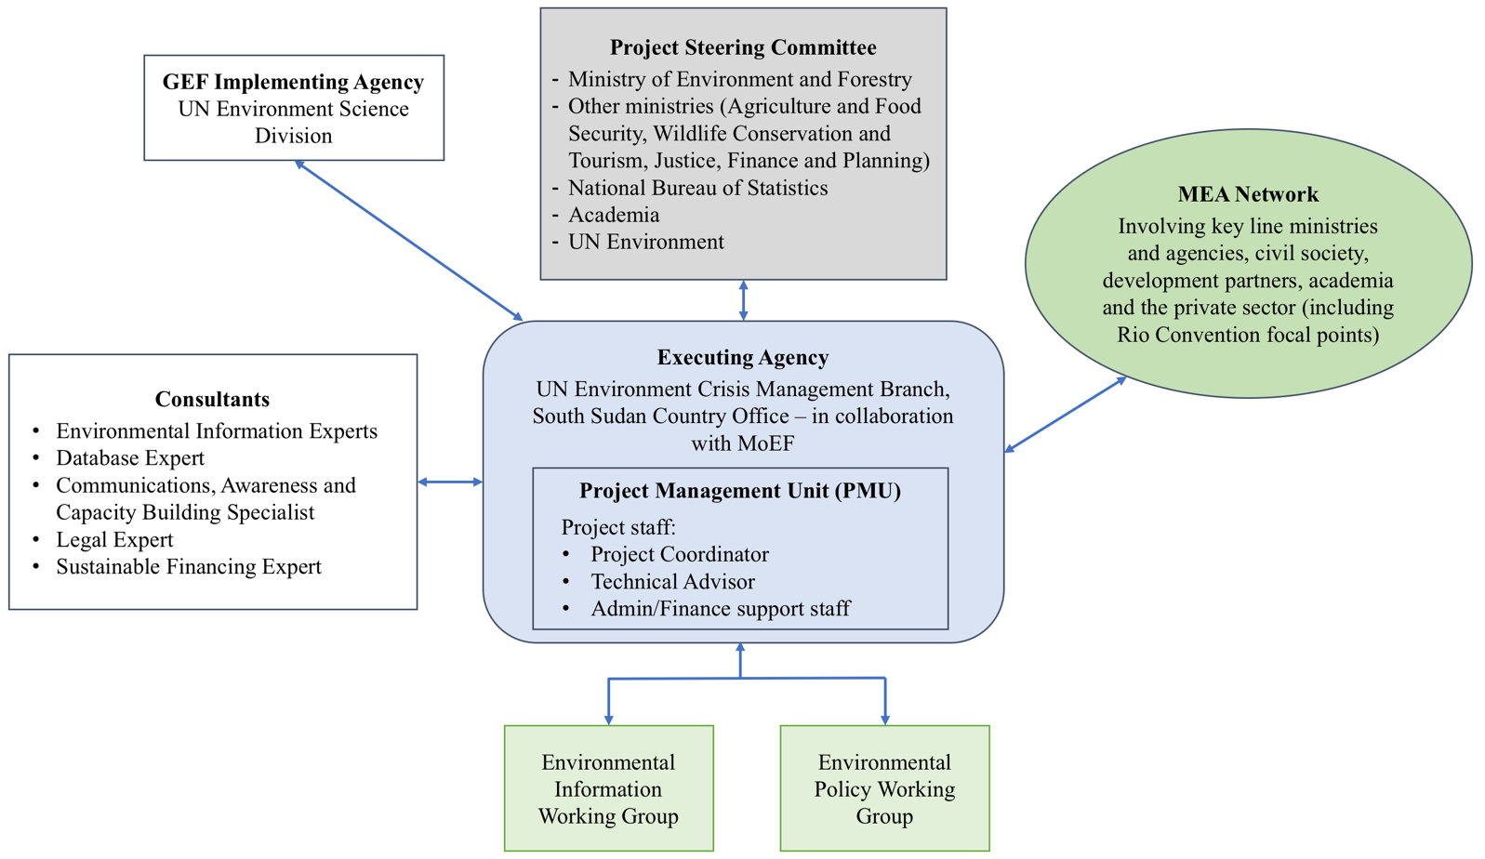
Figure 3: Project organisational structure

The detailed responsibilities of the main entities involved are described in Annex H. The Terms of Reference (TOR) of the project staff and consultants are included in Annex O.

Coordination of the project with other initiatives

The Ministry of Environment and Forestry will take the lead in ensuring coordination of the project with relevant government agencies and their ongoing initiatives. Additionally, the Rio Convention focal points will be supported to build and utilise their capacity to ensure the proper coordination with other agencies. The project will build on the consultations and linkages established during the NCSA process, where broad consultations strengthened the linkages and relationships among many major initiatives.

Coordination between this project and ongoing baseline projects will be strengthened through the high-level inter-ministerial committee on the implementation of environmental projects (in particular, GCF) currently being established by MoEF, as well as the MEA Network to be established under this project. In addition, the National GEF Steering Committee will provide oversight on the complementarities between the different GEF-financed projects, notably the climate change adaptation and the wildlife and protected areas projects.

Additional Information not well elaborated at PIF Stage:

A.7 Benefits. Describe the socioeconomic benefits to be delivered by the project at the national and local levels. How do these benefits translate in supporting the achievement of global environment benefits (GEF Trust Fund) or adaptation benefits (LDCF/SCCF)?

The project’s objective is to strengthen systemic, institutional and individual capacity for the effective implementation of the Rio Conventions in South Sudan. Consequently, it is anticipated that the project will increase South Sudan’s capacity to address global environmental issues through its national plans and policies. The project will lay the foundations for South Sudan to be able to realise global environmental benefits, including socio-economic benefits, in the implementation of the MEAs and the related SDGs. These socio-economic benefits include, among others, access to clean water, poverty reduction, reduced impacts of desertification and drought, reduced exposure to air, water and soil pollution, and increased resilience of ecosystems and livelihoods to climate change.

Under Component 1, the project will establish indicators that will enable the relevant institutions in South Sudan to measure not only the state of the environment itself, but also its linkages with human wellbeing and sustainable development.

A.8 Knowledge Management. Elaborate on the knowledge management approach for the project, including, if any, plans for the project to learn from other relevant projects and initiatives (e.g. participate in trainings, conferences, stakeholder exchanges, virtual networks, project twinning) and plans for the project to assess and document in a user-friendly form (e.g. lessons learned briefs, engaging websites, guidebooks based on experience) and share these experiences and expertise (e.g. participate in community of practices, organize seminars, trainings and conferences) with relevant stakeholders.

South Sudan has limited systems for generating, capturing and sharing lessons. The CCCD activities are also relatively new initiatives, and much knowledge needs to be acquired, assessed, stored and shared. In recognition of these facts, the project will establish systems for generating, collating and sharing lessons at the local, national and international levels. Component 1 of the project is directly related to information and knowledge management, as it aims to establish a coordinated environmental knowledge and information management system as well as an MEA Network. In addition, Component 2 of the project will support the compilation and dissemination of best practices of environmental management.

At the national level, through the implementation of Output 2.2, the project will build technical capacity of communications staff at the sector ministries and authorities to share knowledge and raise awareness on the Rio Conventions and the SDGs. The concerned staff are to be mandated with promoting synergies among the three conventions into the future. This will involve many technical agencies, including the relevant ministries and national authorities. Hence, by building the institutional and individual capacity, and working with concerned staff, the project directly contributes to knowledge management at the national level.

At the state level, all concerned ministries and departments will be involved in the project. Notably, the knowledge generated by the project will be disseminated through the project-supported awareness and capacity development plan for the implementation of the Rio Conventions. UN Environment, as an active member of many national development partner and government committees and networks, will ensure that all knowledge is appropriately disseminated at the national, state and local level and ensure linkages with global knowledge platforms such as Environment Live and InforMEA.

Moreover, UN Environment, as the leading agency responsible for environment management within the United Nations, plays a key role in organising South-to-South learning exchanges and disseminating knowledge products regionally and globally. This is achieved through technical publications, seminars and workshops as well as through side events at the Conference of the Parties (COPs) for the various conventions. Lessons generated through the proposed project will feed into these knowledge dissemination initiatives and benefit from them.

B. Description of the consistency of the project with:
B.1 Consistency with National Priorities. Describe the consistency of the project with national strategies and plans or reports and assessments under relevant conventions such as NAPAs, NAPs, ASGM NAPs, MIAs, NBSAPs, NCs, TNAs, NCSAs, NIPs, PRSPs, NPFE, BURs, INDCs, etc.:

Rio Conventions and related national plans

As mentioned earlier, South Sudan is party to the three Rio Conventions on biodiversity conservation, climate change and desertification, among other multilateral environmental agreements (MEAs). The country has formulated a National Adaptation Programme of Action (NAPA) and an Initial National Communication (INC) under the UNFCCC, and has developed a National Biodiversity Strategy and Action Plan (NBSAP) under the CBD. It also plans to initiate the work on the National Action Plan (NAP) for the implementation of the work programme of the UNCCD. This CCCD project is directly aligned with and supports the implementation of these conventions and related national plans.

South Sudan’s NBSAP (2018) sets out seven strategic objectives as follows, to be implemented over a period of 10 years (2018-2027). The CCCD project directly contributes to strategic objectives (i), (ii), (iii), (vi) and (vii).
    - Developing a stakeholder coordination framework for national and sub-national biodiversity management in South Sudan;
    - Strengthening policy, legislative and institutional capacity for biodiversity conservation and management for all actors in the country;
    - Reducing negative impacts and enhancing positive impacts on biodiversity through facilitation, design and capacity enhancement for enforcement and compliance, for biodiversity regulations and incentive mechanisms;
    - Strengthening capacity for and conducting resource assessments, spatial, ecological and land use planning and benchmarking of the value of biodiversity in South Sudan to support sustainable use and management of biodiversity in South Sudan;
    - Restoring degraded ecosystems and promoting access and benefit sharing of biodiversity and ecosystem services, including for protected areas and non-protected areas of South Sudan;
    - Developing and implementing a resource mobilization strategy for biodiversity conservation and management in South Sudan;
    - Establishing knowledge and information management systems and awareness creation for biodiversity conservation in South Sudan.

The country’s National Adaptation Programme of Action (NAPA) prioritised the following priority adaptation activities, which are also in line with this project.
- Environment: Promotion of reforestation and agroforestry to reduce vulnerability to droughts and floods.
- Water Resources: Sustainable management and conservation of wetlands in South Sudan.
- Agriculture: Promotion of climate-smart agricultural techniques to improve livelihoods and food security under changing climatic patterns.
- Disaster Risk Reduction: Establish improved drought and flood Early Warning Systems in South Sudan through an improved hydro-meteorological monitoring network.
- Policy and Institutional Framework: Strengthening the institutional capacity of the Government of South Sudan to integrate climate change into national policies and planning processes.

National Capacity Self-Assessment (NCSA)

With support from GEF, a National Capacity Self-Assessment (NCSA) was conducted through a participatory process that took place between November 2015 and February 2017. The objective of the NCSA was to generate an action plan for implementation of capacity building activities for meeting South Sudan’s commitments under the Rio Conventions and Ramsar (the Rio+ Conventions), by identifying gaps, priorities and potential for enhancing synergies among the conventions. The NCSA action plan defines specific actions under the following six intervention areas. The activities and outputs under the CCCD project directly support the implementation of these actions.
- Policy and legislation;
- Institutional coordination and collaboration;
- Information and data availability;
- Training, education, and public awareness;
- Local governance and stakeholder participation; and
- Resource mobilization and sustainable financing.

National laws and policies

The project is consistent with South Sudan’s national laws and policies. Although the country is young, several policies have been established, which create a basis for building the national capacity to implement the Rio Conventions. First and foremost, the project is in line with the Transitional Constitution, which addresses the need to protect and manage natural resources. Section 41 of the Transitional Constitution guarantees people’s right to a clean and healthy environment. It calls for proper legislative measures that: “(a) prevent pollution and ecological degradation; (b) promote conservation; and (c) secure ecologically sustainable development and use of natural resources while promoting rational economic and social development so as to protect genetic stability and bio-diversity.” Furthermore, the project is in line with South Sudan’s Environment Protection Bill, the National Environmental Policy and the recently developed Disaster Management Policy and its accompanying Master Plan 2015-2030, as well as the Land Act, the Draft Forest Policy and the Comprehensive Agricultural Development Master Plan (CAMP). It is also in line with the South Sudan Vision 2040, which calls on the Government to adopt appropriate measures to limit pollution that may result from rapid industrialisation and to foster sustainable environmental management. The South Sudan Vision 2040 further notes:

The key resources and assets of the country will be equitably distributed between its people. Communities will be involved in the use and preservation of their environmental assets and will benefit directly from their exploitation. The attitude towards natural resources will pay attention to fair distribution between present and future generations. The eradication of poverty will have created a situation where no one will be compelled to damage the environment in order to obtain their basic needs.

The project also addresses priorities identified in the South Sudan Development Plan (SSDP) 2011-2013, now extended to 2018. The SSSD, in addition to mainstreaming environmental protection within multiple sectors, specifically calls for natural resources to be protected from significant adverse environmental impacts (SoEOR, 2018). The SSDP is South Sudan’s main development policy document. It commits the Government to work towards key goals and allocate resources accordingly.
United Nations Cooperation Framework (UNCF)

The United Nations Cooperation Framework (UNCF) 2019-2021 replaces the 2016-2018 Interim Cooperation Framework (ICF) that was a bridging programme due to the absence of a national development strategy. The UNCF aspires to promote the following priority areas:

- Building peace and strengthening governance;
- Improving food security and recovering local economies;
- Strengthening social services;
- Empowering women and youth.

The CCCD project will contribute to priority areas I and II by improving environmental governance and by strengthening resilience of the communities of South Sudan through enhanced implementation of the Rio Conventions and related SDGs.

State of Environment and Outlook Report (SoEOR)

The CCCD project addresses some of the recommendations made in the State of Environment and Outlook Report (SoEOR, 2018). These recommendations include, in particular:
- Supporting the finalisation, approval and implementation of the South Sudan Vision 2040 as well as environmental policies in South Sudan.
- Adopting a set of key environmental indicators to monitor South Sudan’s sustainable development and the implementation of the SDGs, and improving data and indicators for environmental management.
- Strengthening environmental awareness and education.
- Mainstreaming gender in environment and development activities.
- Providing technical support in institution building and mobilising financial resources from international sources.

In addition, the SoEOR calls for Building a National Strategy for the Development of Statistics (NSDS) for South Sudan:

The Government of South Sudan, with its partners in UNDP and UN Environment, can take immediate steps toward building a NSDS network based on the results from this report’s national inception workshop held in Juba in November/December 2016. The Government of South Sudan and UN Environment could reconvene workshop participants to create a cross-sector community sharing a common interest in environmental data and information. Their task-driven agenda should be as follows:
  - Identifying priority environmental information objectives that link to policy needs and that support reporting requirements to SDGs, draft Vision 2040, INCDs, REDD+, etc.
  - Identifying status and needs for national standards, including documentation and metadata, quality, periodicity and accessibility for core data sets, etc.
  - Agreeing on roles and responsibilities within the network.
  - Developing a medium-term plan for improving the role that environmental information will play in the implementation of the draft Vision 2040.

The SoEOR also highlights the linkages between effective natural resources management and peace building. By improving resource governance, resolving land tenure issues and by providing stronger mechanisms for dispute resolution and reduced competition for resources, South Sudan is expected to greatly improve its prospects for peace and stability.

C. Describe the budgeted m&e plan
The monitoring and evaluation process is expected to be a key component of each outcome area within the project, based on a three-year implementation plan. Monitoring and Evaluation (M&E) will be conducted utilising the results based management approach. The Results Framework provides performance and impact indicators for project implementation along with corresponding means of verification, including use of a Capacity Development Scorecard. M&E will be an ongoing process and is based on the following strategic directions:
  - An effective coordinating mechanism with roles and responsibilities clearly defined and under the lead of the UN Environment country office, which has overall responsibility for project execution.
  - The monitoring and evaluation process is participatory, consultative and aimed at ensuring delivery of project outputs and achievement of associated defined targets. Evaluation will be based on the status of implementation, through identification of gaps, and the measurement of impacts and level of success in the application of best practices.

UN Environment will be responsible for managing the Mid-Term Review (MTR) and the Terminal Evaluation (TE). The Project Coordinator and partners will participate actively in the process. The project will be reviewed at mid-term. The purpose of the MTR is to provide an independent assessment of project performance at mid-term, to analyse whether the project is on track, what problems and challenges the project is encountering, and which corrective actions are required so that the project can achieve its intended outcomes by project completion in the most efficient and sustainable way. In addition, it will verify information gathered through the Capacity Development Scorecard. The MTR is managed by the UN Environment Task Manager. The Project Steering Committee will participate in the MTR and develop a management response to the review recommendations along with an implementation plan. It is the responsibility of the Task Manager to monitor whether the agreed recommendations are being implemented.

In line with UN Environment Evaluation Policy and the GEF’s Monitoring and Evaluation Policy, the project will be subject to a Terminal Evaluation (TE). The Evaluation Office will be responsible for the TE and will liaise with the Task Manager and Executing Agency(ies) throughout the process. The TE will provide an independent assessment of project performance (in terms of relevance, effectiveness and efficiency), and determine the likelihood of impact and sustainability. It will have two primary purposes: (i) to provide evidence of results to meet accountability requirements, and (ii) to promote learning, feedback, and knowledge sharing through results and lessons learned among UN Environment, the GEF, executing partners and other stakeholders. The direct costs of the evaluation will be charged against the project evaluation budget. The TE will be initiated no earlier than six months prior to the operational completion of project activities and, if a follow-on phase of the project is envisaged, should be completed prior to the submission of the follow-on proposal. TEs must be initiated no later than six months after operational completion.

The draft TE report will be sent by the Evaluation Office to project stakeholders for comment. Formal comments on the report will be shared by the Evaluation Office in an open and transparent manner. The project performance will be assessed against standard evaluation criteria using a six point rating scheme. The final determination of project ratings will be made by the Evaluation Office when the report is finalised and further reviewed by the GEF Independent Evaluation Office upon submission. The evaluation report will be publically disclosed and may be followed by a recommendation compliance process.

While a TE should review the use of project funds against budget, it would be the role of a financial audit to assess probity (i.e. correctness, integrity etc.) of expenditure and transactions.

The indicative Monitoring and Evaluation Budget and Work Plan is provided in Annex G.

PART iII: certification by gef partner agency(ies)

- GEF Agency(ies) certification

This request has been prepared in accordance with GEF policies and procedures and meets the GEF criteria for CEO endorsement under GEF-6.

Agency Coordinator, Agency Name | Signature | Date  (mm/dd/yyyy) | Project Contact Person | Telephone | Email Address
Kelly West,  Senior Programme Manager & Global Environment Facility Coordinator Corporate Services Division, UN Environment |  | 07 November 2018 | Jochem Zoetelief  Senior Programme Officer,  Science Division, UNEP | +254 20 762386 | jochem.zoetelief@un.org

LIST OF ANNEXES

Annex A: Project Results Framework
Annex B: Responses to Project Reviews
Annex C: Status of Implementation of Project Preparation Activities and the Use of Funds
Annex D: Calendar of Expected Reflows
Annex E: Consultants to be Hired for the Project Using GEF/LDCF/SCCF Resources
Annex F-1: Detailed GEF Budget
Annex F-2: Detailed Co-finance Budget
Annex G: Monitoring and Evaluation Budget and Workplan
Annex H: Project Implementation Arrangements
Annex I: Key Deliverables and Benchmarks + Work Plan
Annex J: Capacity Development Scorecard
Annex K: OFP Endorsement Letter
Annex L: Co-finance Letters
Annex M: UNEP Environmental, Social and Economic Review Note (ESERN)
Annex N: Acronyms and Abbreviations
Appendix 5: Supervision Plan
Appendix 6: Procurement Plan
Appendix 7: Terms of Reference of Key Personnel

Annex A: Project Results Framework
Project Objective | Objective level Indicator | Baseline | Target | Means of Verification | Assumptions & Risks
To strengthen systemic, institutional and individual capacity for effective implementation of the Rio Conventions in South Sudan | Increased capacity for Rio Convention implementation as shown in the capacity development scorecard. | See capacity development scorecard (Annex J). Baseline total score is 18 out of 45 possible maximum. | Mid-term:  (a) Increase of 2 points at a minimum in the total score.  End of project:  (a) Increase of 6 points at a minimum in the total score. | Annual project implementation reports and final project report  Capacity development scorecard | Assumptions:  Sector agencies remain committed to the effective implementation of the Rio Conventions in South Sudan.  Risks:  Project is not given sufficient priority for external reasons.

Outcome | Indicators | Baseline | Targets | Means of Verification | Assumptions & Risks
Component 1: Development of a coordinated environmental knowledge and information management system
Outcome 1: Enhanced management of environmental information and knowledge for use in decision-making, planning and reporting. | (a) MEA Network operational and facilitating access, sharing and management of environmental data and information for MEA/SDG reporting, monitoring and decision makingNumber.  (b) Technical system functional to manage and access environmental data, with defined roles and responsibilities and protocols for data collection and sharing. | CBD national Clearing House Mechanism and MoEF website currently being developed. National biodiversity database being established at MoEF and MWCT. | Mid-term:  (a) MEA Network operational with at-least 30 stakeholders (of which at least 40% women).  (b) n/a  End of project:  (a) MEA Network operational with at-least 40 stakeholders (of which at least 40% women).  (b) A functional, shared environmental information system with defined roles and responsibilities and protocols for data collection and sharing is in place. | Annual project implementation reports and final project report  Minutes of MEA Network meetings | Assumptions:  There is sufficient common interest in environmental data management among relevant agencies and stakeholders.  Risks:  Delays in implementation for political or security reasons.

Outcome | Indicators | Baseline | Targets | Means of Verification | Assumptions & Risks
Component 2: Strengthening of coordination mechanisms and stakeholder engagement for the Rio Conventions and relevant SDGs
Outcome 2: Enhanced coordination mechanisms and stakeholder engagement for the sustained implementation of Rio Conventions and relevant SDGs. | Number of mechanisms implemented by the government of South Sudan under the lead of MoEF to support the sustained implementation of the Rio Conventions and relevant SDGs (e.g., regular network/ working group/consultative meetings) | No specific mechanisms, although some existing ad hoc committees have been established. | Mid-term:  At least 1 mechanism.  End of project:  At least 3 mechanisms. | Annual project implementation reports and final project report  Minutes of consultation meetings | Assumptions:  There is sufficient interest and commitment from relevant agencies and stakeholders.  Risks:  Delays in implementation for political or security reasons.

Outcome | Indicators | Baseline | Targets | Means of Verification | Assumptions & Risks
Component 3: Integration of key provisions of Rio Conventions in national policies and legislation
Outcome 3: National policies include provisions for mainstreaming biodiversity conservation, climate change adaptation and mitigation, and sustainable land and forest management. | Number of policies, laws or strategies finalized for enactment during the project duration and submitted for enactment that include provisions for mainstreaming Rio Convention principles. | Some existing laws and policies; many exist only in draft format. | Mid-term:  (a) n/a  End of project:  At least 2. | Annual project implementation reports and final project report  Minutes of consultation meetings  Draft policies/bills | Assumptions:  There is sufficient interest and commitment from relevant agencies and stakeholders.  Risks:  Delays in implementation for political or security reasons.

UNEP MTS reference
Sub-programme 7: Environment under review
SP7 EA(a): Governments and other stakeholders use quality open environmental data, analyses and participatory processes that strengthen the science-policy interface to generate evidence-based environmental assessments, identify emerging issues and foster policy action
716. National and regional reporting systems based on shared environmental information system principles generating open access to information

Annex B: Responses to Project Reviews (from GEF Secretariat and GEF Agencies, and Responses to Comments from Council at work program inclusion and the Convention Secretariat and STAP at PIF).

The GEF Secretariat comments that were not addressed at the PIF stage are elaborated in the table below.

GEF Secretariat comment | Agency response at PPG stage
Question 5  The components in table B are somewhat clear, and are expected to be refined after stakeholder consultation. However there is no mention of how the project will contribute to the GEBs.  Please provide some information on this. | - The project components, outcomes and outputs have been refined based on consultations with key stakeholders during the project design phase. The changes are explained in Section A.1. 3) Proposed alternative scenario. A detailed work plan and budget have also been prepared.  - The global environmental benefits are described in Section A.7. The project will lay the foundations for South Sudan to be able to realise global environmental benefits, including socio-economic benefits, in the implementation of the MEAs and the related SDGs. These socio-economic benefits include, among others, access to clean water, poverty reduction, reduced impacts of desertification and drought, reduced exposure to air, water and soil pollution, and increased resilience of ecosystems and livelihoods to climate change. Under Component 1, the project will establish indicators that will enable the relevant institutions in South Sudan to measure not only the state of the environment itself, but also its linkages with human wellbeing and sustainable development.
Question 6  CSOs and other NGO details will be provided at CEO endorsement - please ensure that they are consulted. | - Civil society organisations/national and international NGOs were consulted during the project preparation phase. Details are included in the stakeholder analysis in Section A.3. Civil society organisations will be an important stakeholder group for the implementation of all three project components, as shown in the results framework and work plan.

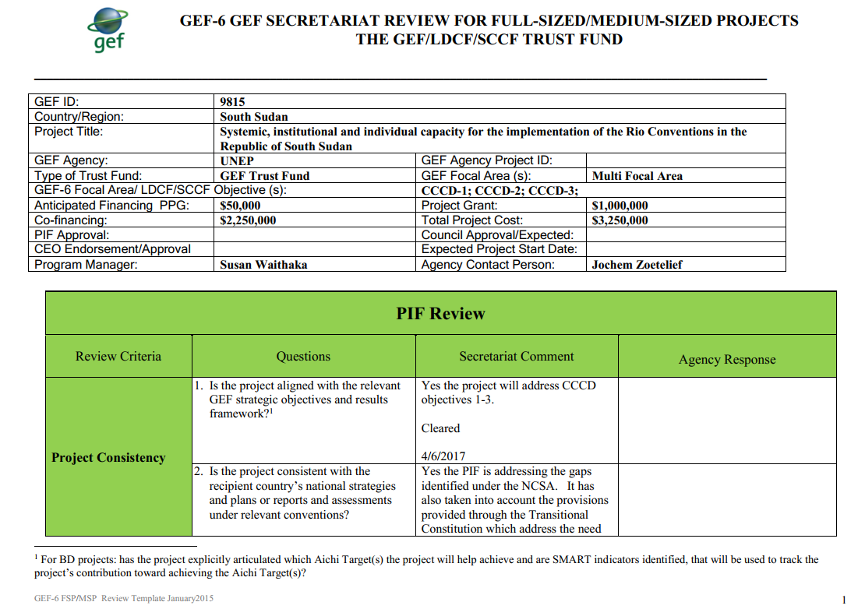
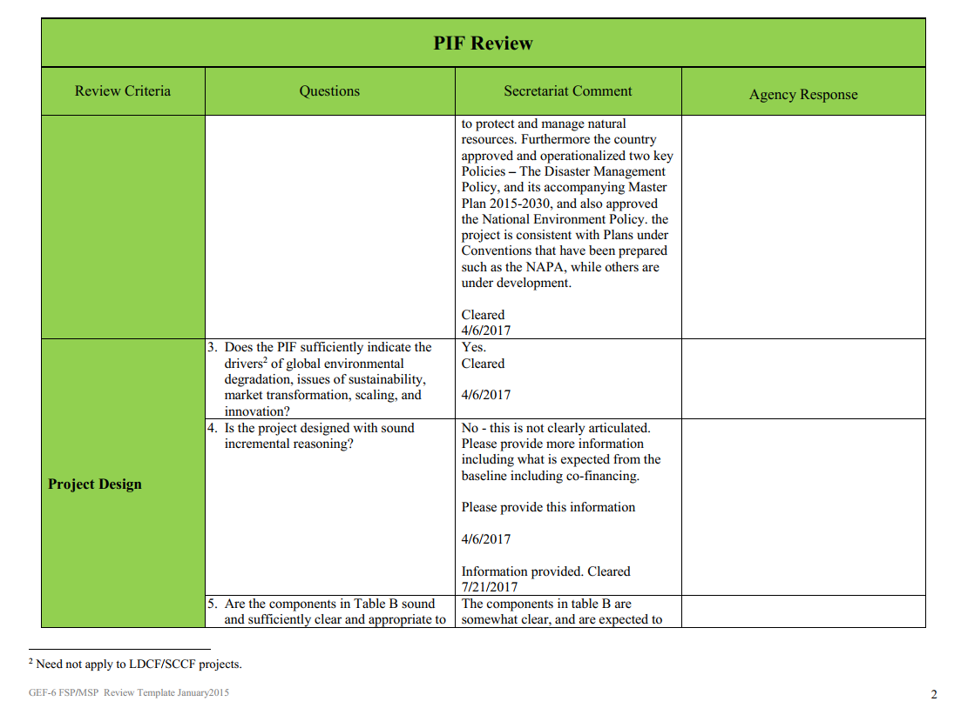
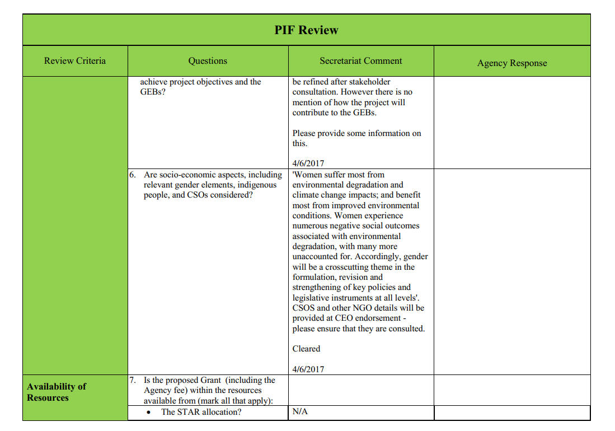
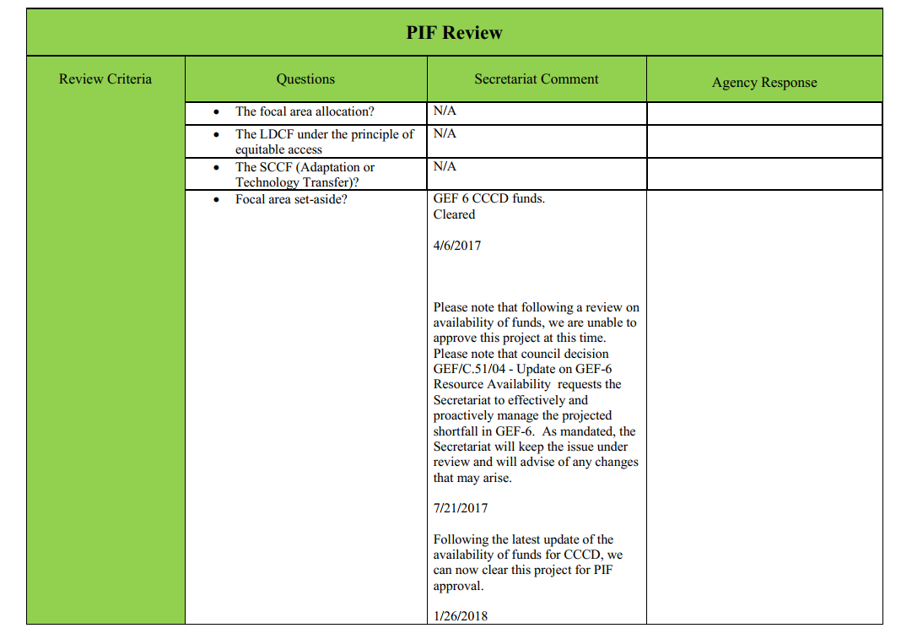
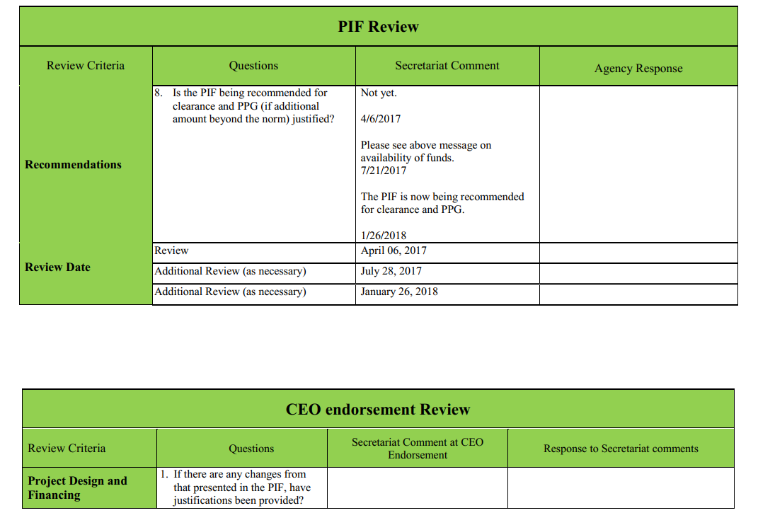
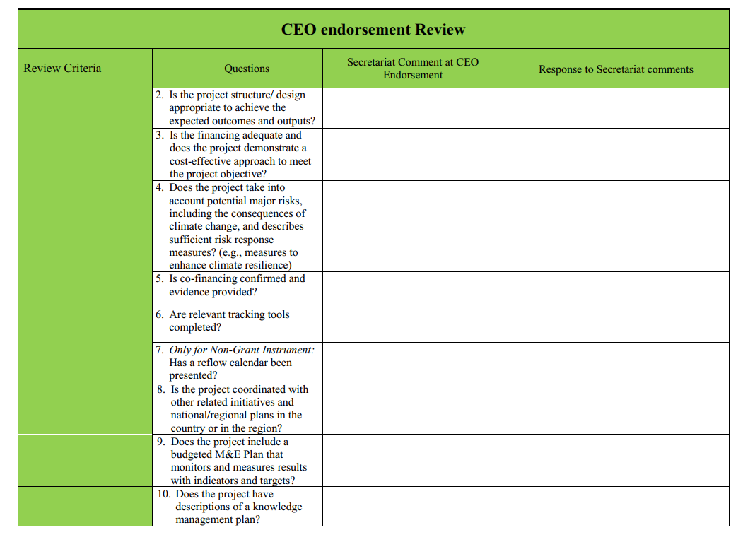
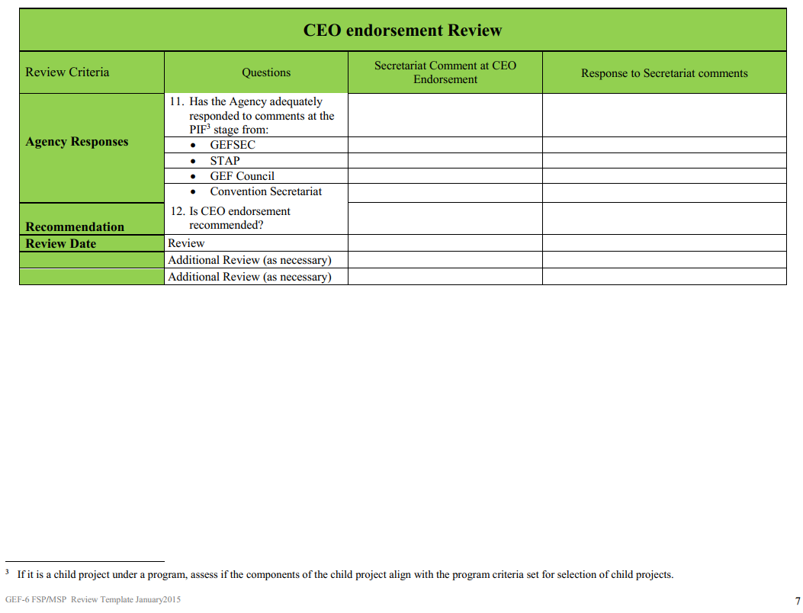
Annex C: Status of Implementation of Project Preparation Activities and the Use of Funds
- Provide detailed funding amount of the PPG activities financing status in the table below:

PPG Grant Approved at PIF: $ 50,000
Project Preparation Activities Implemented | GETF/LDCF/SCCF/CBIT Amount ($)
Project Preparation Activities Implemented | Budgeted Amount | Amount Spent To date | Amount Committed
Consultants  {International (including travel) and national project development consultancy fees} | 35,000 | 27,567 | 12,664
PPG Workshops and related Travel  { National scoping, stakeholders consultation mission + project preparation inception/ validation workshops } | 15,000 | 3,584 | 5,166
Other project operational costs | 0 | 1,019 | 0
Total | 50,000 | 32,170 | 17,830

Annex D: Calendar of Expected Reflows (if non-grant instrument is used)

Provide a calendar of expected reflows to the GEF/LDCF/SCCF/CBIT Trust Funds or to your Agency (and/or revolving fund that will be set up)

N/A

Annex E: Consultants to be Hired for the Project Using GEF/LDCF/SCCF Resources
Excel spreadsheet attached as a separate file.

Annex F-1: Detailed GEF Budget
Excel spreadsheet attached as a separate file.

Annex F-2: Detailed Co-finance Budget
Excel spreadsheet attached as a separate file.

Annex G: Monitoring and Evaluation Budget and Workplan
Excel spreadsheet attached as a separate file.

Annex H: Project Implementation Arrangements
The project will be implemented over a period of three years (36 months) starting in 2019. UN Environment’s Science Division will act as the GEF Implementing Agency (IA) and will be responsible for overseeing the project implementation, monitoring its progress and impact, and ensuring the proper use of GEF funds. The UN Environment Crisis Management Branch within the Policy and Programme Division – through its South Sudan Country Office – will be the Executing Agency (EA) and will be responsible for project coordination and management, monitoring adherence to the work plan, and administering the project funds. The Crisis Management Branch (EA) will be accountable to the Science Division (IA) for project delivery and use of funds. The EA will collaborate closely with the Ministry of Environment and Forestry (MoEF) on the project execution. The necessary planning and coordination mechanisms will be set up by the project, in line with established Government of the Republic of South Sudan and UN Environment procedures in South Sudan.

A Project Steering Committee (PSC) will be constituted to serve as the oversight, advisory and support body for the project. The PSC will be chaired by MoEF and will be composed of key partners of the project, including the Ministry of Agriculture and Food Security, Ministry of Wildlife Conservation and Tourism, Ministry of Justice, Ministry of Finance and Planning, the National Bureau of Statistics, the University of Juba, and UN Environment’s Crisis Management Branch.

The EA will establish a Project Management Unit (PMU), composed of 1) a Project Coordinator who will be responsible for the overall coordination and who will lead the technical implementation of the project, as well as 2) Administrative and Finance support staff.

Both the PSC and the PMU shall ensure adequate representation of women.

The project’s organisational structure is shown in Figure 4 below.

Figure 4: Project organisational structure

The section below describes the responsibilities of the main entities involved.

GEF Implementing Agency (IA)

The UN Environment Science Division will be directly responsible for:
  - Providing consistent and regular project oversight to ensure the achievement of the project objective and outcomes.
  - Providing support to the Executing Agency in ensuring the technical quality of products, outputs and deliverables produced by the project, including adherence to international best practices.
  - Liaising between the project and the GEF Secretariat.
  - Ensuring that both GEF and UN Environment policy requirements and standards are applied and met (i.e. reporting obligations, technical, fiduciary, M&E).
  - Approving budget revisions, certifying fund availability and transferring funds.
  - Organizing mid- and end-term evaluations and reviewing project audits.
  - Providing technical, legal and administrative guidance if requested.
  - Certifying project operational completion.

Executing Agency (EA) – UN Environment Crisis Management Branch within the Policy and Programme Division

The UN Environment Crisis Management Branch within the Policy and Programme Division – through its South Sudan Country Office – will be accountable to the IA for the disbursement of funds and the achievement of the project objective and outcomes, according to the approved work plan. The EA will be ultimately responsible for:
  - Leading the project execution in accordance with the project results framework and budget, the agreed work plan and reporting tasks.
  - Closely coordinating project activities with MoEF and other project partners, with a particular focus on building their capacity for project execution.
  - Ensuring full participation of stakeholders in project activities.
  - Providing technical expertise to the project through its personnel and networks.
  - Ensuring technical quality of products, outputs and deliverables produced by the project.
  - Establishing project sub-contracts and monitor the performance of the sub-contractors.
  - Compiling and submitting progress, financial and audit reporting to the IA.
  - Supporting logistical project-related issues (e.g. organization of meetings), as required.

A Project Management Unit (PMU) will be established within UN Environment’s country office to lead the day-to-day management of the project activities. The project staff and consultants will regularly visit the MoEF offices to allow for greater coordination and capacity building.

Ministry of Environment and Forestry

The Ministry of Environment and Forestry (MoEF) as a key partner in the execution of the project will be responsible for:
  - Supporting the EA in the execution of the project in accordance with the project objectives, activities and budget.
  - Organising and chairing the Project Steering Committee meetings (with support from the PMU).
  - Supporting the compilation of reports to be submitted to the IA.
  - Ensuring coordination with relevant government agencies at the national, state and local levels.

Project Steering Committee (PSC)

The PSC will formally meet once a year for the annual project progress and performance assessment. It can, however, meet more frequently on an informal basis to ensure regular project updates and coordination.

The PSC provides overall guidance and policy direction to the implementation of the project, and provides advice on appropriate strategies for project sustainability. The PSC will play a critical role in project monitoring and evaluation by assuring the quality of the project processes and products. The detailed responsibilities of the PSC include:
  - Overseeing project implementation and performance based on reports provided by the Project Management Unit (PMU).
  - Approving annual project work plans and budgets for submission to the IA.
  - Approving any major changes in project implementation arrangements for submission to the IA for endorsement.
  - Providing technical input and advice.
  - Reviewing the quality of major project deliverables.
  - Ensuring commitment of co-funding resources to support project implementation.
  - Advising on any conflicts within the project and/or negotiating solutions between the project and any parties beyond the scope of the project.
  - Ensuring coordination amongst member agencies.
  - Requesting amendments to the project plan if required.
  - Requesting the temporary suspension of the project in accordance with any findings of M&E missions.

Working Groups

Two working groups will be established to provide support to the project team and consultants. The working groups are small, technical groups established for the purpose of the project, to provide technical support to the implementation of its outcomes. They are also a mechanism to ensure the continuous involvement of key agencies and, thus, the sustainability of the project interventions. Working group members will be officially nominated by the relevant agencies based on criteria such as relevant experience and responsibilities, and adequate gender balance. The working group members will be responsible for regularly updating their supervisors and colleagues on the activities of the working group, and for seeking their inputs.
  - Environmental Information Working Group: This working group will be established to support Outcome 1. It will involve the PMU and relevant technical staff of agencies such as MoEF, NBS, MWCT, MoAFS, MWRI, Ministry of Humanitarian Affairs and Disaster Management and academia (around 8-X representatives, including the Rio Convention focal points).
  - Environmental Policy Working Group: This working group will be established to support Outcome 3. It will involve the PMU and relevant technical/legal staff of agencies such as MoEF, MWCT, MoAFS, MWRI, Ministry of Justice, Ministry of Finance and Planning, Ministry of Humanitarian Affairs and Disaster Management, the National Legislative Assembly and academia (around 8-X representatives, including the Rio Convention focal points).

MEA Network

The MEA Network is a larger technical body established for the long term, with the purpose of sharing data and information as well as providing policy advice in the field of environment. It will involve key line ministries and agencies, civil society, development partners, academia and the private sector. The network will act as the link between relevant ministries in terms of ensuring integration of cross-cutting biodiversity, climate and land degradation issues into policies, laws, regulations and plans in respective ministries. The network is expected to have around ≥ 30 members, and to last after the project ends. It will provide guidance on biodiversity, climate change, and land degradation issues in South Sudan, and on the implementation of the Rio Conventions and relevant SDGs. The network will meet quarterly or semi-annually, as required.

Annex I: Key Deliverables and Benchmarks + Work Plan
Excel spreadsheet with detailed Work Plan and Timetable attached as a separate file.

Key Deliverables and Benchmarks:

Component / Outcome / Outputs | Activities | Deliverables | Benchmarks
Component 1: Development of a coordinated environmental knowledge and information management system
Outcome 1: Enhanced management of environmental information and knowledge for use in decision-making, planning and reporting.
Output 1.1 Analysis of the current environmental information systems | 1.1.1 Recruit project staff and consultants | - | -
 | 1.1.2 Organise a project inception workshop | (See under Project Management below) | -
 | 1.1.3 Establish an Environmental Information Working Group | - | -
 | 1.1.4 Conduct a detailed analysis of existing environmental information systems | Deliverable 1.1.4 Working paper with analysis | Year 2, Q1
Output 1.2 Priority environmental indicators identified and agreed upon | 1.2.1 Develop recommendations on improving data availability and on formulating key environmental indicators | Deliverable 1.2.1 Working paper with recommendations | Year 2, Q1
 | 1.2.2 Organise an MEA Network meeting (see Output 2.1) to discuss and agree on priority environmental indicators | Deliverable 1.2.2 Meeting report | Year 2, Q2
 | 1.2.3 Develop and agree on standardised definitions for these indicators and protocols for data collection, sharing and management. | Deliverable 1.2.3 Endorsement/ agreement by key agencies on indicator definitions and protocols for data sharing. | Year 2, Q4
 | 1.2.4 Develop a guidance document, including on the use of data in decision-making, planning and reporting. | Deliverable 1.2.4 Guidance document with agreed priority environmental indicators and definitions/protocols | Year 2, Q4
Output 1.3 Training provided on data collection and management methodologies | 1.3.1 Prepare a training on data collection and management | - | -
 | 1.3.2 Organise training workshop and designate champions | Deliverable 1.3.2 Training material and report, including on the designation of champions | Year 3, Q3
 | 1.3.3 Organise on-the-job follow-up activities per sector to apply the acquired knowledge and compile data for the priority indicators identified | (Information on follow-up activities and data compilation included in Final Project Report) | -
Output 1.4 Shared environmental information system developed and implemented | 1.4.1 Analyse the requirements and key functionalities of a shared information management system | Deliverable 1.4.1 Working paper with analysis | Year 2, Q3
 | 1.4.2 Organise an MEA Network meeting to discuss and agree on the requirements of the system, identify a host agency and establish clear responsibilities | Deliverable 1.4.2 Meeting report | Year 2, Q4
 | 1.4.3 Develop and implement the system based on the identified requirements | (Information on system implementation included in Final Project Report) | -
 | 1.4.4 Provide training for different user groups on the use of the information management system. Make data available on the shared environmental information system. | Deliverable 1.4.4 Training material and report | Year 3, Q4
Component 2: Strengthening of coordination mechanisms and stakeholder engagement for the Rio Conventions and relevant SDGs
Outcome 2: Enhanced coordination mechanisms and stakeholder engagement for the sustained implementation of Rio Conventions and relevant SDGs.
Output 2.1 MEA Network established and other mechanisms implemented to support enhanced coordination | 2.1.1 Organise a technical workshop to discuss and agree on the establishment of an MEA Network. | Deliverable 2.1.1 Workshop report | Year 2, Q1
 | 2.1.2 Prepare the Terms of Reference (TOR) of the network, and formally establish it through notification or ministerial order by MoEF. Organise regular meetings of the network. | Deliverable 2.1.2 Notification or ministerial order, including TOR | Year 2, Q2
 | 2.1.3 Issue a biannual newsletter, publish brief “state of the sector” reports, and/or sponsor the participation in regional meetings/trainings | Deliverable 2.1.3 Newsletters and state of the sector reports (if any) | Year 3, Q4
 | 2.1.4 Implement other mechanisms to support enhanced consultation and coordination in support of the Rio Conventions. This will likely include:  - Regular working group and consultative meetings during the formulation of policies and project planning and execution. At least one of these meetings will be held at the state level, followed by a field visit, in order to ensure linkages with the state and local level.  - Strengthening of the Department for Multilateral Environmental Agreements within MoEF.  - Consultation process in the preparation of national reports and Conference of the Parties (COPs).  - Joint progress monitoring of MEA implementation (as part of regular MEA Network meetings).  - Establishment of a stakeholder database.  - Conduct rapid assessment of the current institutional arrangements for MEA implementation. | (Information on the coordination mechanisms included in Final Project Report) | -
Output 2.2 Activities for awareness and capacity building implemented | 2.2.1 Prepare an awareness and capacity development plan to support the implementation of the Rio Conventions (including Ramsar) | Deliverable 2.2.1 Awareness and capacity development plan | Year 2, Q1
 | 2.2.2 Conduct a baseline awareness survey among key stakeholders (at national and state/local level) | Deliverable 2.2.2 Baseline awareness survey results | Year 2, Q2
 | 2.2.3 Implement the awareness and capacity development plan. This will likely include:  Awareness:  - Compiling and disseminating simple fact sheets on the Rio Conventions.  - Radio and television bulletins, newspaper articles, etc.  - Public lectures for university students.  - Organising roundtables for parliamentarians, policy- and decision-makers.  - Organising awareness raising events such as World Environment Day, World Wetlands Day, World Water Day and the International Day of Forests; and organising awareness raising sessions at the state level.  Capacity building:  - Training of Trainers (TOT) for national and state level stakeholders on the Rio Conventions.  - Training for Rio Convention focal points and other relevant technical staff on negotiation skills for the COPs.  - Training of Trainers (TOT) for representatives of academia/research institutions.  - Training on Online Access to Research in the Environment (OARE). | Deliverable 2.2.3 Report on awareness and capacity building activities (including training reports) | Year 3, Q4
 | 2.2.4 Conduct an end-of-project awareness survey among key stakeholders (at national and state/local level) | Deliverable 2.2.4 End-of-project awareness survey results | Year 3, Q4
Output 2.3 Practical guidelines on community participation and engagement developed | 2.3.1 Develop practical guidelines to facilitate community participation and engagement | - | -
 | 2.3.2 Organise a stakeholder consultation meeting to discuss the proposed guidelines | Deliverable 2.3.2 Consultation meeting report | Year 3, Q1
 | 2.3.3 Disseminate these guidelines through the awareness and training events organised under Output 2.2 | Deliverable 2.3.3 Guidelines (final version) | Year 3, Q1
Component 3: Integration of key provisions of Rio Conventions in national policies and legislation
Outcome 3: National policies include provisions for mainstreaming biodiversity conservation, climate change adaptation and mitigation, and sustainable land and forest management.
Output 3.1 At least 2 sectoral policies, laws or strategies clearly make provisions for mainstreaming Rio Convention principles | 3.1.1 Establish an Environmental Policy Working Group | - | -
 | 3.1.2 Conduct a detailed analysis of existing sectoral policies, laws and strategies to identify gaps | (Incorporated into 3.1.3) | -
 | 3.1.3 Draft a working paper outlining opportunities to incorporate Rio Convention principles into existing draft policies, laws and strategies | Deliverable 3.1.3 Working paper outlining opportunities | Year 2, Q3
 | 3.1.4 Organise an MEA Network meeting and public consultations (including at the state level and with civil society organisations) to discuss the outcomes of the analysis and decide on the priority bills and policies to be supported by the project | Deliverable 3.1.4 Meeting report | Year 2, Q4
 | 3.1.5 Support the finalization of the selected priority bills and policies, including their submission to the Ministry of Justice for final drafting. Work towards the adoption of the draft bills and policies. | Deliverable 3.1.5 Finalised draft policies and bills | Year 3, Q4
Output 3.2 Sustainable financing strategy developed | 3.2.1 Conduct an analysis of the current funding sources and gaps related to the implementation of the Rio Conventions, the relevant SDGs and national policies and laws | Deliverable 3.2.1 Working paper with analysis | Year 2, Q4
Output 3.2 Sustainable financing strategy developed | 3.2.2 Draft a sustainable financing strategy | - | -
Output 3.2 Sustainable financing strategy developed | 3.2.3 Organise consultations to discuss the strategy with the sector agencies and other relevant stakeholders. Once finalized, the progress in implementing the strategy will be regularly monitored at the MEA Network meetings. | Deliverable 3.2.3 Sustainable financing strategy document | Year 3, Q2
Output 3.2 Sustainable financing strategy developed | 3.2.4 Organise a training for staff of relevant government agencies and NGOs on writing project proposals to access funding for environmental projects | Deliverable 3.2.4 Training report | Year 3, Q4
Project Management
Project Management | Project Inception | Inception Report | Year 1, Q1
Project Management | Project Steering Committee (PSC) meetings | PSC Meeting Report | Annually
Project Management | Project Mid-Term Review (MTR) | MTR Report | Year 2, Q3
Project Management | Project Terminal Evaluation (TE) | TE Report | Year 4, Q1
Project Management | Semi-Annual Expense Reports | Semi-Annual Expense Report | Semi-annually
Project Management | Semi-Annual Progress Review | Semi-Annual Progress Report | Semi-annually
Project Management | Annual Progress Review | Project Implementation Report (PIR) | Annually
Project Management | Final Reporting | Final Report | Year 4, Q1

NB: Descriptive workplan included in a separate spreadsheet.

Annex J: Capacity Development Scorecard
Project Name: Systemic, institutional and individual capacity for the implementation of the Rio Conventions in the Republic of South Sudan
Date: June 2018

Capacity Result / Indicator | Staged Indicators | Rating | Score | Comments | Next Steps | Contribution to which Outcome
CR 1: Capacities for engagement
Indicator 1 – Degree of legitimacy / mandate of lead environmental organizations | Institutional responsibilities for environmental management are not clearly defined | 0 | Baseline: 2 | Mandates of Ministry of Environment and Forestry, Ministry of Agriculture and Food Security, Ministry of Wildlife Conservation and Tourism and other relevant ministries are defined in relevant laws/bills and policies. Some overlapping institutional mandates and some bills are still pending approval. |  | Outcome 2:  Enhanced coordination mechanisms and stakeholder engagement for the sustained implementation of Rio Conventions and relevant SDGs.
 | Institutional responsibilities for environmental management are identified | 1
 | Authority and legitimacy of all lead organizations responsible for environmental management are partially recognized by stakeholders | 2
 | Authority and legitimacy of all lead organizations responsible for environmental management recognized by stakeholders | 3
Indicator 2 – Existence of operational co-management mechanisms | No co-management mechanisms are in place | 0 | Baseline: 1 | There exists operational co-management in the Ministry of Environment and Forestry, Ministry of Wildlife Conservation and other line ministries. There is however limited implementation of the mechanisms due to low level of coordination. |  | Outcome 2:  Enhanced coordination mechanisms and stakeholder engagement for the sustained implementation of Rio Conventions and relevant SDGs.
 | Some co-management mechanisms are in place and operational | 1
 | Some co-management mechanisms are formally established through agreements, MOUs, etc. | 2
 | Comprehensive co-management mechanisms are formally established and are operational/functional | 3
Indicator 3 – Existence of cooperation with stakeholder | Identification of stakeholders and their participation/involvement in decision-making is poor | 0 | Baseline: 1 | Cooperation exists between the Ministry of Environment and Forestry, Ministry of Wildlife Conservation and Tourism, academic institutions, other ministries and stakeholders that needs to be strengthened. |  | Outcome 2:  Enhanced coordination mechanisms and stakeholder engagement for the sustained implementation of Rio Conventions and relevant SDGs.
Indicator 3 – Existence of cooperation with stakeholder | Stakeholders are identified but their participation in decision-making is limited | 1
Indicator 3 – Existence of cooperation with stakeholder | Stakeholders are identified and regular consultations mechanisms are established | 2
Indicator 3 – Existence of cooperation with stakeholder | Stakeholders are identified and they actively contribute to established participative decision-making processes | 3
CR 2: Capacities to generate, access, and use information and knowledge
Indicator 4 – Degree of environmental awareness of stakeholders | Stakeholders are not aware about global environmental issues and their related possible solutions (MEAs) | 0 | Baseline: 1 | The Ministry of Environment and Forestry, the Ministry of Wildlife Conservation and Tourism, the Ministry of Agriculture and Forestry, and other line ministries are aware of MEAs. However, there is a low level of participation which is attributed to limited financial capacity. In addition, awareness by state and local stakeholders and the public is still limited. |  | Outcome 1:  Enhanced management of environmental information and knowledge for use in decision-making, planning and reporting.  Outcome 2:  Enhanced coordination mechanisms and stakeholder engagement for the sustained implementation of Rio Conventions and relevant SDGs.
 | Stakeholders are aware about global environmental issues but not about the possible solutions (MEAs) | 1
 | Stakeholders are aware about global environmental issues and the possible solutions but do not know how to participate | 2
 | Stakeholders are aware about global environmental issues and are actively participating in the implementation of related solutions | 3
Indicator 5 – Access and sharing of environmental information by stakeholders | The environmental information needs are not identified and the information management infrastructure is inadequate | 0 | Baseline: 2 | The Ministry of Environment and Forestry, the Ministry of Wildlife Conservation and Tourism and other line ministries have initiated access to and sharing of environmental information. This is implemented in the statistics unit at the Directorate of Wetlands and Biodiversity at the Ministry of Environment and Forestry and the Ministry of Wildlife Conservation and Tourism. These units need to be supported and further strengthened for sustainability as the on-going project supporting them is coming to an end. A State of Environment and Outlook Report has been published. |  | Outcome 1:  Enhanced management of environmental information and knowledge for use in decision-making, planning and reporting.
 | The environmental information needs are identified but the information management infrastructure is inadequate | 1
 | The environmental information is partially available and shared among stakeholders but is not covering all focal areas and/or the information management infrastructure to manage and give information access to the public is limited | 2
 | Comprehensive environmental information is available and shared through an adequate information management infrastructure | 3
Indicator 6 – Existence of environmental education programmes | No environmental education programmes are in place | 0 | Baseline: 1 | The Ministry of Environment and Forestry, the Ministry of Wildlife Conservation and Tourism and other line ministries have partially developed environmental education programmes, sometimes overlapping. However, most of them are not delivered due to a lack of resources. |  | Outcome 2:  Enhanced coordination mechanisms and stakeholder engagement for the sustained implementation of Rio Conventions and relevant SDGs.
 | Environmental education programmes are partially developed and partially delivered | 1
 | Environmental education programmes are fully developed but partially delivered | 2
 | Comprehensive environmental education programmes exist and are being delivered | 3
Indicator 7 – Extent of the linkage between environmental research/science and policy development | No linkage exists between environmental policy development and science/research strategies and programmes | 0 | Baseline: 1 | The Ministry of Environment and Forestry, the Ministry of Wildlife Conservation and Tourism, and other line ministries as well as academic institutions have environmental research and policy department/units, but research is not fully responding to policy needs. |  | Outcome 1:  Enhanced management of environmental information and knowledge for use in decision-making, planning and reporting.  Outcome 2:  Enhanced coordination mechanisms and stakeholder engagement for the sustained implementation of Rio Conventions and relevant SDGs.
 | Research needs for environmental policy development are identified but are not translated into relevant research strategies and programmes | 1
 | Relevant research strategies and programmes for environmental policy development exist but the research information is not responding fully to the policy research needs | 2
 | Relevant research results are available for environmental policy development | 3
Indicator 8-Extend of inclusion/use of traditional knowledge in environmental decision-making | Traditional knowledge is ignored and not taken into account into relevant participative decision-making processes | 0 | Baseline: 1 | Inclusion and use of traditional knowledge in the Ministry of Environment and Forestry and other line ministries is identified and recognised (included in the legal framework) but is rarely used in decision making. |  | Outcome 1:  Enhanced management of environmental information and knowledge for use in decision-making, planning and reporting  Outcome 3:  National policies include provisions for mainstreaming biodiversity conservation, climate change adaptation and mitigation, and sustainable land and forest management.
 | Traditional knowledge is identified and recognized as important but is not collected and used in relevant participative decision-making processes | 1
 | Traditional knowledge is collected but is not used systematically into relevant participative decision-making processes | 2
 | Traditional knowledge is collected, used and shared for effective participative decision-making processes | 3
CR 3: Capacities for strategy, policy and legislation development
Indicator 9 – Extent of the environmental planning and strategy development process | The environmental planning and strategy development process is not coordinated and does not produce adequate environmental plans and strategies | 0 | Baseline: 2 | The Ministry of Environment and Forestry, the Ministry of Wildlife Conservation and Tourism and other line ministries have their environmental plans and strategies developed but implementation is slow due to numerous challenges including lack of funds. |  | Outcome 1:  Enhanced management of environmental information and knowledge for use in decision-making, planning and reporting.  Outcome 2:  Enhanced coordination mechanisms and stakeholder engagement for the sustained implementation of Rio Conventions and relevant SDGs.  Outcome 3:  National policies include provisions for mainstreaming biodiversity conservation, climate change adaptation and mitigation, and sustainable land and forest management.
 | The environmental planning and strategy development process does produce adequate environmental plans and strategies but they are not implemented/used | 1
 | Adequate environmental plans and strategies are produced but they are only partially implemented because of funding constraints and/or other problems | 2
 | The environmental planning and strategy development process is well coordinated by the lead environmental organizations and produces the required environmental plans and strategies; which are being implemented | 3
Indicator 10 – Existence of an adequate environmental policy and regulatory frameworks | The environmental policy and regulatory frameworks are insufficient; they do not provide an enabling environment | 0 | Baseline: 1 | Adequate environmental policies and regulatory frameworks were developed by the Ministry of Environment and Forestry the Ministry of Wildlife Conservation and Tourism and other line ministries. Some of them passed while others (mainly bills) are in draft. The lack of enactment and the poor implementation of these policies and legal frameworks is the key challenge. |  | Outcome 3:  National policies include provisions for mainstreaming biodiversity conservation, climate change adaptation and mitigation, and sustainable land and forest management.
 | Some relevant environmental policies and laws exist but few are implemented and enforced | 1
 | Adequate environmental policy and legislation frameworks exist but there are problems in implementing and enforcing them | 2
 | Adequate policy and legislation frameworks are implemented and provide an adequate enabling environment; a compliance and enforcement mechanism is established and functions | 3
Indicator 11 – Adequacy of the environmental information available for decision-making | The availability of environmental information for decision-making is lacking | 0 | Baseline: 1 | The Ministry of Environment and Forestry, the Ministry of Wildlife Conservation and Tourism and other line ministries have limited to environmental information for decision making. Data and information centres were established in MoEF and MWCT to streamline data. This requires support for sustainability. |  | Outcome 1:  Enhanced management of environmental information and knowledge for use in decision-making, planning and reporting.
 | Some environmental information exists but it is not sufficient to support environmental decision-making processes | 1
 | Relevant environmental information is made available to environmental decision-makers but the process to update this information is not functioning properly | 2
 | Political and administrative decision-makers obtain and use updated environmental information to make environmental decisions | 3
CR 4: Capacities for management and implementation
Indicator 12 – Existence and mobilization of resources | The environmental organizations don’t have adequate resources for their programmes and projects and the requirements have not been assessed | 0 | Baseline: 2 | The Ministry of Environment and Forestry, the Ministry of Wildlife Conservation and Tourism and other line ministries, as well as civil society organisations have partially identified required resources. |  | Outcome 3:  National policies include provisions for mainstreaming biodiversity conservation, climate change adaptation and mitigation, and sustainable land and forest management.
 | The resource requirements are known but are not being addressed | 1
 | The funding sources for these resource requirements are partially identified and the resource requirements are partially addressed | 2
 | Adequate resources are mobilized and available for the functioning of the lead environmental organizations | 3
Indicator 13 – Availability of required technical skills and technology transfer | The necessary required skills and technology are not available and the needs are not identified | 0 | Baseline: 1 | Technical skills and technologies available in the Ministry of Environment and Forestry, the Ministry of Wildlife Conservation and Tourism and other line ministries are identified but resources are inadequate for proper utilisation of the available skills. |  | Outcome 1:  Enhanced management of environmental information and knowledge for use in decision-making, planning and reporting.
 | The required skills and technologies needs are identified as well as their sources | 1
 | The required skills and technologies are obtained but their access depend on foreign sources | 2
 | The required skills and technologies are available and there is a national-based mechanism for updating the required skills and for upgrading the technologies | 3
CR 5: Capacities to monitor and evaluate
Indicator 14 – Adequacy of the project/programme monitoring process | Irregular project monitoring is being done without an adequate monitoring framework detailing what and how to monitor the particular project or programme | 0 | Baseline: 1 | The Ministry of Environment and Forestry and the Ministry of Wildlife Conservation and Tourism and other line ministries have some monitoring frameworks in place, however, implementation is not systematic, and outcomes are not adequately used to inform projects. |  | Outcome 1:  Enhanced management of environmental information and knowledge for use in decision-making, planning and reporting.  Outcome 2:  Enhanced coordination mechanisms and stakeholder engagement for the sustained implementation of Rio Conventions and relevant SDGs.
 | An adequate resourced monitoring framework is in place but project monitoring is irregularly conducted | 1
 | Regular participative monitoring of results in being conducted but this information is only partially used by the project/programme implementation team | 2
 | Monitoring information is produced timely and accurately and is used by the implementation team to learn and possibly to change the course of action | 3
Indicator 15 – Adequacy of the project/programme monitoring and evaluation process | None or ineffective evaluations are being conducted without an adequate evaluation plan; including the necessary resources | 0 | Baseline: 0 | Evaluations are currently not being carried out. |  | Outcome 1:  Enhanced management of environmental information and knowledge for use in decision-making, planning and reporting.  Outcome 2:  Enhanced coordination mechanisms and stakeholder engagement for the sustained implementation of Rio Conventions and relevant SDGs.
 | An adequate evaluation plan is in place but evaluation activities are irregularly conducted | 1
 | Evaluations are being conducted as per an adequate evaluation plan but the evaluation results are only partially used by the project/programme implementation team | 2
 | Effective evaluations are conducted timely and accurately and are used by the implementation team and the Agencies and GEF Staff to correct the course of action if needed and to learn for further planning activities | 3
Total score | Indicators 1-15 | 0-3 | Baseline = 0.4 (18/45)

Annex K: OFP Endorsement Letter
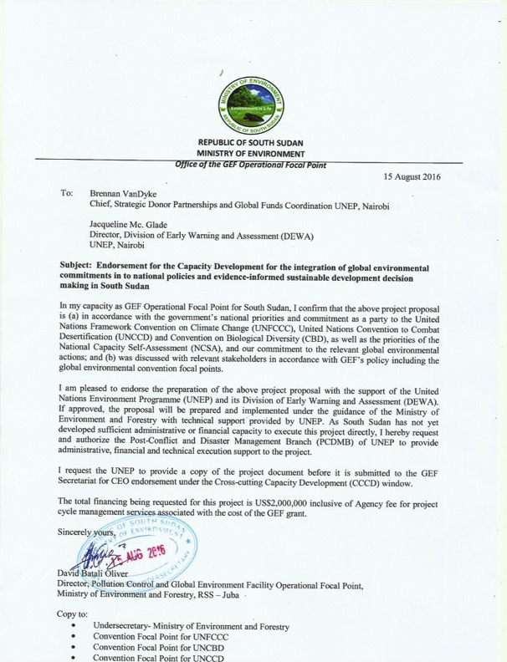

Annex L: Co-finance Letters
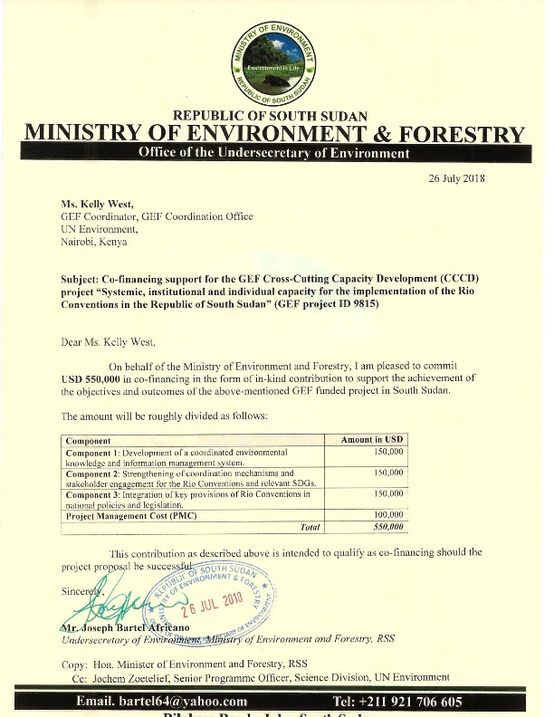

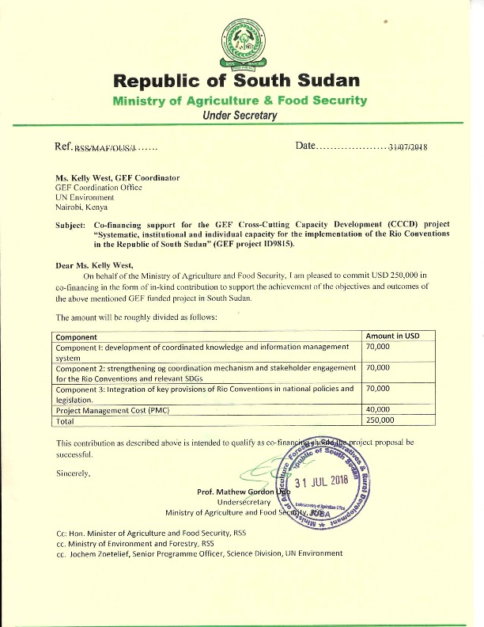

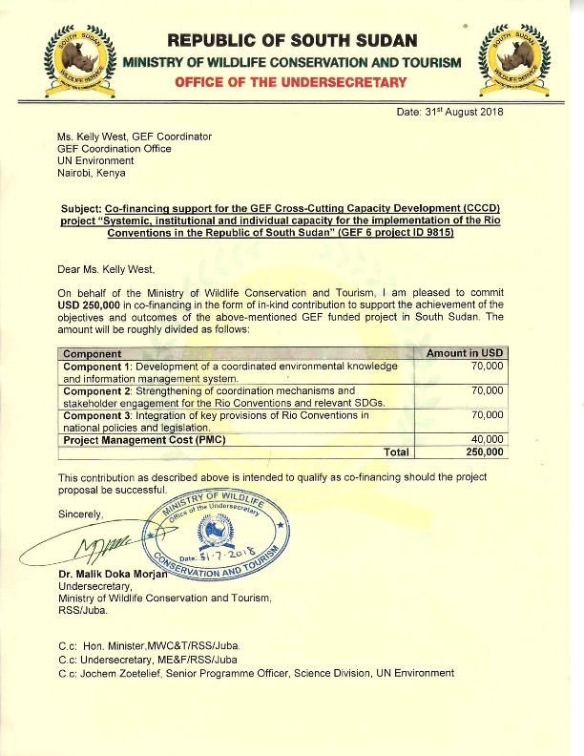

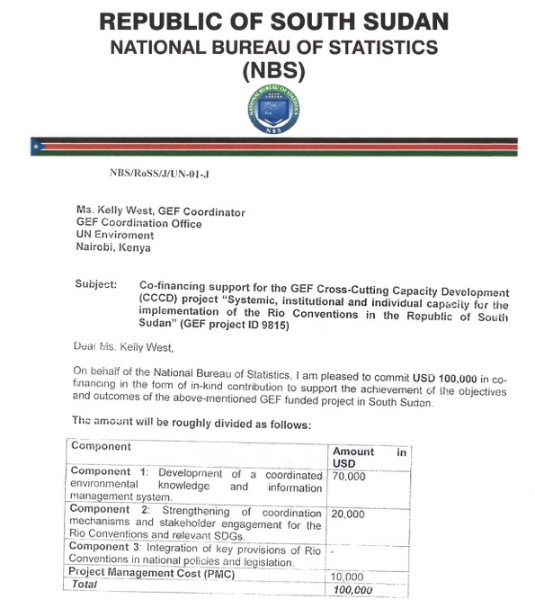
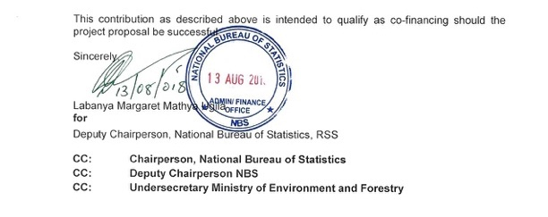

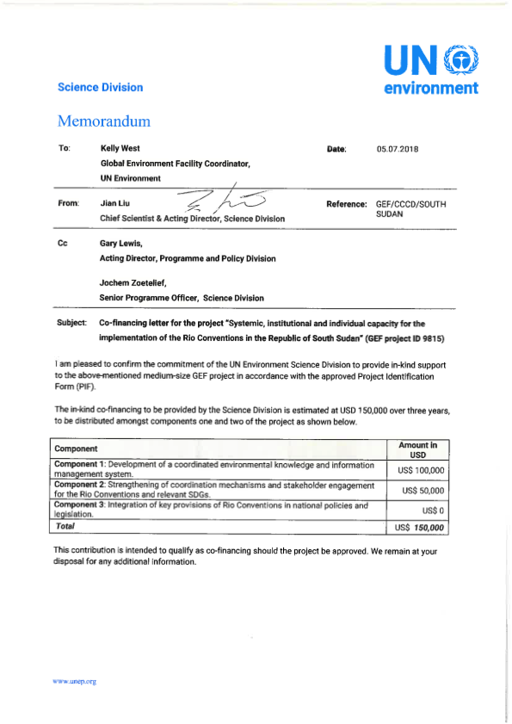

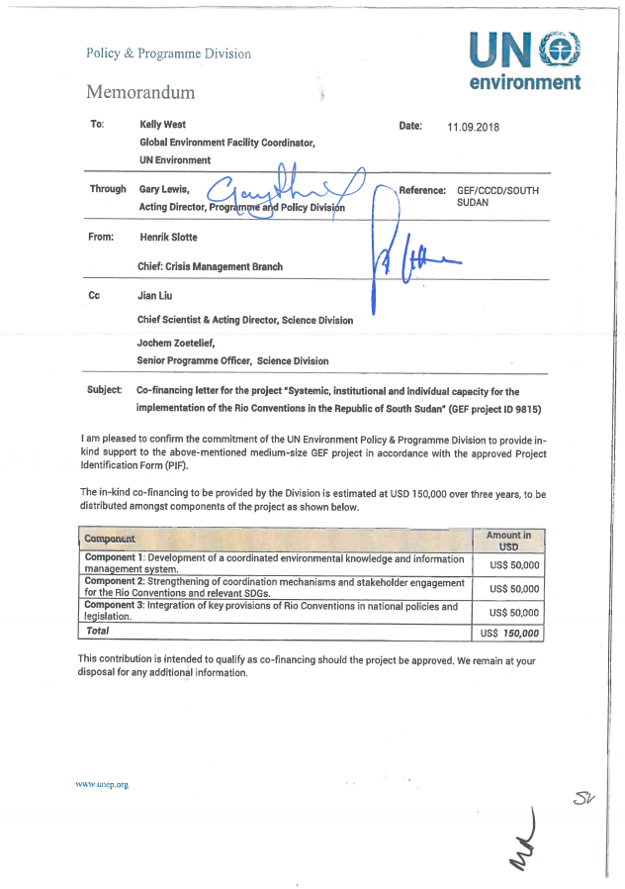

Annex M: UNEP Environmental, Social and Economic Review Note (ESERN)
I. Project Overview

Identification | GEF project ID: 9815  Agency project ID: 01566
Project Title | Systemic, institutional and individual capacity for the implementation of the Rio Conventions in the Republic of South Sudan
Managing Division | Science Division
Type/Location | National
Region | Africa
List Countries | South Sudan
Project Description | The objective of this Cross-Cutting Capacity Development (CCCD) project is to strengthen systemic, institutional and individual capacity for effective implementation of the Rio Conventions in South Sudan.  The project will have three components:  - Enhanced management of environmental information and knowledge for use in decision-making, planning and reporting.  - Enhanced coordination mechanisms and stakeholder engagement for the sustained implementation of Rio Conventions and relevant SDGs.  - National policies include provisions for mainstreaming biodiversity conservation, climate change adaptation and mitigation, and sustainable land and forest management.
Estimated duration of project: | 36 months (2019-2021)
Estimated cost of the project: | USD 1,000,000 from GEF plus USD 1,450,000 in co-financing

II. Environmental Social and Economic Screening Determination

A. Summary of the Safeguard Risks Triggered
Safeguard Standard Triggered by the Project | Impact of Risk (1-5) | Probability of Risk (1-5) | Significance of Risk (L, M, H)
SS 1: Biodiversity, natural habitat and Sustainable Management of Living Resources | 1 | 1 | L
SS 2: Resource Efficiency, Pollution Prevention and Management of Chemicals and Wastes | 1 | 1 | L
SS 3: Safety of Dams | 1 | 1 | L
SS 4: Involuntary resettlement | 2 | 1 | L
SS 5: Indigenous peoples | 2 | 1 | L
SS 6: Labor and working conditions | 1 | 1 | L
SS 7: Cultural Heritage | 1 | 1 | L
SS 8: Gender equity | 1 | 1 | L
SS 9: Economic Sustainability | 1 | 1 | L
Additional Safeguard questions for projects seeking GCF-funding (Section IV)

B. ESE Screening Decision (Refer to the UNEP ESES Framework (Chapter 2) and the UNEP’s ESES Guidelines.)

Low risk X Moderate risk High risk Additional information required

C. Development of ESE Review Note and Screening Decision:

Prepared by: Name: Jochem Zoetelief Date: 17 June 2018

Safeguard Advisor: Name: _Yunae Yi Date: 28 Sept. 2018

Task Manager: Name: ______________________ Date: __________

D. Recommended further action from the Safeguard Advisor:

III. ESES Principle and Safeguard checklist
(Section III and IV should be retained in UNEP)

Precautionary Approach
The project will take precautionary measures even if some cause and effect relationships are not fully established scientifically and there is risk of causing harm to the people or to the environment.
Human Rights Principle
The project will make an effort to include any potentially affected stakeholders, in particular vulnerable and marginalized groups; from the decision making process that may affect them.
The project will respond to any significant concerns or disputes raised during the stakeholder engagement process.
The project will make an effort to avoid inequitable or discriminatory negative impacts on the quality of and access to resources or basic services, on affected populations, particularly people living in poverty or marginalized or excluded individuals or groups.

Screening checklist | Y/N/  Maybe | Comment
Safeguard Standard 1: Biodiversity, natural habitat and Sustainable Management of Living Resources
Will the proposed project support directly or indirectly any activities that significantly convert or degrade biodiversity and habitat including modified habitat, natural habitat and critical natural habitat? | N | Not anticipated. On the contrary, the project will contribute to enhancing biodiversity and habitats through improved environmental information management.
Will the proposed project likely convert or degrade habitats that are legally protected? | N | Not anticipated.
Will the proposed project likely convert or degrade habitats that are officially proposed for protection? (e.g.; National Park, Nature Conservancy, Indigenous Community Conserved Area, (ICCA); etc.) | N | No negative impacts are anticipated.
Will the proposed project likely convert or degrade habitats that are identified by authoritative sources for their high conservation and biodiversity value? | N | Not anticipated.
Will the proposed project likely convert or degrade habitats that are recognized- including by authoritative sources and /or the national and local government entity, as protected and conserved by traditional local communities? | N | Not anticipated.
Will the proposed project approach possibly not be legally permitted or inconsistent with any officially recognized management plans for the area? | N | Project is aligned with national policies and legislation.
Will the proposed project activities result in soils deterioration and land degradation? | N | On the contrary, the project will contribute to addressing land degradation through improved environmental information management.
Will the proposed project interventions cause any changes to the quality or quantity of water in rivers, ponds, lakes or other wetlands? | Maybe | Indirectly, positive changes are expected from the improved implementation of MEAs.
Will the proposed project possibly introduce or utilize any invasive alien species of flora and fauna, whether accidental or intentional? | N | Not anticipated.
Safeguard Standard 2: Resource Efficiency, Pollution Prevention and Management of Chemicals and Wastes
Will the proposed project likely result in the significant release of pollutants to air, water or soil? | N | Not anticipated. On the contrary, the project will contribute to addressing pollution through improved environmental information management.
Will the proposed project likely consume or cause significant consumption of water, energy or other resources through its own footprint or through the boundary of influence of the activity? | N | Not anticipated.
Will the proposed project likely cause significant generation of Green House Gas (GHG) emissions during and/or after the project? | N | Not anticipated.
Will the proposed project likely generate wastes, including hazardous waste that cannot be reused, recycled or disposed in an environmentally sound and safe manner? | N | Not anticipated.
Will the proposed project use, cause the use of, or manage the use of, storage and disposal of hazardous chemicals, including pesticides? | N | Not anticipated.
Will the proposed project involve the manufacturing, trade, release and/or use of hazardous materials subject to international action bans or phase-outs, such as DDT, PCBs and other chemicals listed in international conventions such as the Stockholm Convention on Persistent Organic Pollutants or the Montreal Protocol? | N | Not anticipated.
Will the proposed project require the procurement of chemical pesticides that is not a component of integrated pest management (IPM) or integrated vector management (IVM) approaches? | N | Not anticipated.
Will the proposed project require inclusion of chemical pesticides that are included in IPM or IVM but high in human toxicity? | N | Not anticipated.
Will the proposed project have difficulty in abiding to FAO’s International Code of Conduct in terms of handling, storage, application and disposal of pesticides? | N | Not anticipated.
Will the proposed project potentially expose the public to hazardous materials and substances and pose potentially serious risk to human health and the environment? | N | Not anticipated.
Safeguard Standard 3: Safety of Dams
Will the proposed project involve constructing a new dam(s)? | N | Not anticipated.
Will the proposed project involve rehabilitating an existing dam(s)? | N | Not anticipated.
Will the proposed project activities involve dam safety operations? | N | Not anticipated.
Safeguard Standard 4: Involuntary resettlement
Will the proposed project likely involve full or partial physical displacement or relocation of people? | N | Not anticipated.
Will the proposed project involve involuntary restrictions on land use that deny a community the use of resources to which they have traditional or recognizable use rights? | N | Not anticipated. The MEAs and related national plans emphasize the need for safeguarding traditional/human rights.
Will the proposed project likely cause restrictions on access to land or use of resources that are sources of livelihood? | Maybe | Potentially indirectly, through enhanced protection of ecosystems based on the implementation of the conventions.
Will the proposed project likely cause or involve temporary/permanent loss of land? | N | Not anticipated.
Will the proposed project likely cause or involve economic displacements affecting their crops, businesses, income generation sources and assets? | N | Not anticipated.
Will the proposed project likely cause or involve forced eviction? | N | Not anticipated.
Will the proposed project likely affect land tenure arrangements, including communal and/or customary/traditional land tenure patterns negatively? | N | Not anticipated.
Safeguard Standard 5: Indigenous peoples
Will indigenous peoples be present in the proposed project area or area of influence? | N | Not anticipated.
Will the proposed project be located on lands and territories claimed by indigenous peoples? | N | Not anticipated.
Will the proposed project likely affect livelihoods of indigenous peoples negatively through affecting the rights, lands and territories claimed by them? | Maybe | Potentially indirectly, through increased protection of ecosystems. However, the MEAs and related national plans emphasize the need for safeguarding indigenous/human rights.
Will the proposed project involve the utilization and/or commercial development of natural resources on lands and territories claimed by indigenous peoples? | N | Not anticipated.
Will the project negatively affect the development priorities of indigenous peoples defined by them? | N | Not anticipated.
Will the project potentially affect the traditional livelihoods, physical and cultural survival of indigenous peoples? | N | Not anticipated.
Will the project potentially affect the Cultural Heritage of indigenous peoples, including through the commercialization or use of their traditional knowledge and practices? | N | Not anticipated.
Safeguard Standard 6: Labor and working conditions
Will the proposed project involve the use of forced labor and child labor? | N | Not anticipated.
Will the proposed project cause the increase of local or regional un-employment? | N | Not anticipated.
Safeguard Standard 7: Cultural Heritage
Will the proposed project potentially have negative impact on objects with historical, cultural, artistic, traditional or religious values and archeological sites that are internationally recognized or legally protected? | N | Not anticipated.
Will the proposed project rely on or profit from tangible cultural heritage (e.g., tourism)? | N | Not anticipated.
Will the proposed project involve land clearing or excavation with the possibility of encountering previously undetected tangible cultural heritage? | N | Not anticipated.
Will the proposed project involve in land clearing or excavation? | N | Not anticipated.
Safeguard Standard 8: Gender equity
Will the proposed project likely have inequitable negative impacts on gender equality and/or the situation of women and girls? | N | Not anticipated. On the contrary, the project aims to support gender mainstreaming targets of the conventions through gender-sensitive environmental indicators.
Will the proposed project potentially discriminate against women or other groups based on gender, especially regarding participation in the design and implementation or access to opportunities and benefits? | N | Not anticipated.
Will the proposed project have impacts that could negatively affect women’s and men’s ability to use, develop and protect natural resources, taking into account different roles and positions of women and men in accessing environmental goods and services? | N | Not anticipated.
Safeguard Standard 9: Economic Sustainability
Will the proposed project likely bring immediate or short-term net gain to the local communities or countries at the risk of generating long-term economic burden (e.g., agriculture for food vs. biofuel; mangrove vs. commercial shrimp farm in terms of fishing, forest products and protection, etc.)? | N | Not anticipated.
Will the proposed project likely bring unequal economic benefits to a limited subset of the target group? | N | Not anticipated.

Annex N: Acronyms and Abbreviations

AWF African Wildlife Foundation
CAMP Comprehensive Agricultural Development Master Plan
CBD Convention on Biological Diversity
CBOs Community-Based Organizations
CCCD Cross-Cutting Capacity Development
CHM Clearing House Mechanism
CITES Convention on International Trade in Endangered Species of Wild Fauna and Flora
CMS Convention on the Conservation of Migratory Species of Wild Animals
COP Conference of the Parties
CSOs Civil Society Organizations
EA Executing Agency
FFI Fauna and Flora International
GEF Global Environment Facility
GRSS Government of the Republic of South Sudan
IA Implementing Agency
ICT Information and communication technology
IGAD Inter-Governmental Authority on Development
INC Initial National Communication to UNFCCC
IPPC International Plant Protection Convention
IRIS Indicator Reporting Information System
M&E Monitoring and Evaluation
MEAs Multilateral Environmental Agreements
MoAFS Ministry of Agriculture and Food Security
MoEF Ministry of Environment and Forestry
MHADM Ministry of Humanitarian Affairs and Disaster Management
MTR Mid Term Review
MWCT Ministry of Wildlife Conservation and Tourism
MWRI Ministry of Water Resources and Irrigation
NAP National Action Plan to Combat Desertification
NAPA National Adaptation Programme of Action
NBS National Bureau of Statistics
NBSAP National Biodiversity Strategy and Action Plan
NCSA National Capacity Self-Assessment
NDCs Nationally Determined Contributions
NEMA National Environmental Management Authority
NGO Non-Governmental Organization
OFP Operational Focal Point
PA Protected Area
PIR Project Implementation Report
PMC Project Management Cost
PMU Project Management Unit
PSC Project Steering Committee
SDGs Sustainable Development Goals
SEIA Social and Environmental Impact Assessment
SoEOR State of Environment and Outlook Report
SSMS South Sudan Meteorological Service
SSWS South Sudan Wildlife Service
TE Terminal Evaluation
TOR Terms of Reference
UNCCD United Nations Convention to Combat Desertification
UN Environment United Nations Environment Programme
UNFCCC United Nations Framework Convention on Climate Change
WCS Wildlife Conservation Society
WHC World Heritage Convention
WHO World Health Organization

Appendix 5: Supervision plan
Excel spreadsheet attached as a separate file.

Appendix 6: Procurement plan
Excel spreadsheet attached as a separate file.

Appendix 7: Terms of Reference of key personnel
  - Project Management Unit (PMU) staff
Project Coordinator
- Title of Position: Project Coordinator
- Position Location: UN Environment country office, Juba (with frequent visits to MoEF offices)
- Reports to: Country Programme Manager
- Date of TOR: Year 1 – Year 3
- Supervises: Administrative and Finance support staff; consultants
- Major Functions
- Overall responsibility for the direction of the project, and the timely delivery and quality of outputs including reports.
- Lead the Project Management Unit (PMU) and project on a day-to-day basis, including detailed work planning, financial management, signing off on all formal project reports, budgets, expense reports and audits; and forging/facilitating national partnerships.
- Supervise the work of the consultants and coordinate the working groups.
- Context and Tasks
- Provide technical coordination for the implementation of the project in accordance with the project document, with a particular focus on building the capacity of MoEF and other project partners.
- Coordinate the activities of the project with relevant project partners including MoEF and other sector agencies, civil society, academia and research institutions and other stakeholders, as well as consultants and working groups.
- Ensure that the project coordination, management and reporting by the PMU is timely and of high quality; as well as meeting GEF and UN Environment requirements.
- Lead the project technical and administrative staff.
- Lead on the selection and procurement of the consultants and sub-contractors.
- Draft and approve terms of reference and selection of sub-contractors, consultants and conduct procedures for initiating sub-contracts.
- Be responsible for and/or prepare the financial and technical reports such as Quarterly Expense Reports, Quarterly Advance Statements, Audits, Semi-Annual Progress Reports, Annual Project Implementation Reports (PIR) Reports, Draft Final Project Report and any other required reports.
- Be responsible for project M&E, including the risk mitigation plan and gender integration; participate in M&E missions.
- Prepare drafts for proposed budget reallocations or revisions, and obtain approval by the PSC as well as UN Environment to formalise these annually as part of the GEF budget reconciliation.
- Coordinate provision of committed in-kind and in-cash co-finance contributions for the project.
- Report to the IA and the PSC any irregularities in project execution, misuse of funds or procedures, or problems in project execution at a timely basis.
- In collaboration with MoEF, organise and participate in the PSC meetings.
- Identify any additional partnerships for enhanced project implementation, strengthening sustainability, or its replication, including through new co-financing contributions from international, national or local sources to finance project components of the project as these evolve.
- Support the Communications, Awareness and Capacity Building Specialist in the preparation and implementation of the awareness and capacity building activities/trainings (Output 2.2).
- Support the implementation of the training on data collection and management (Output 1.3).
- Qualifications
- Advanced university degree (Masters’ or equivalent) in environmental sciences, development studies or a related field. A first university degree in combination with qualifying experience may be accepted in lieu of the advanced degree.
- A minimum of 7 years of relevant and progressive leadership experience in international environmental projects, with some experience in implementing field projects. Experience with different aspects of project management including development, planning, implementation, evaluation, supervision of environmental experts and donor relations.
- Familiarity with institutional, planning and regulatory structures, and rural livelihoods in South Sudan.
- Experience in collaborating with governmental institutions in South Sudan.
- Demonstrable knowledge of the environmental issues and policies in South Sudan.
- Familiarity with GEF and UN Environment procedures is an advantage.
- Excellent communications skills.
- Fluency in oral and written English is required. Working knowledge of Arabic is an asset.
- Good computer skills.

Administrative and Finance support staff
- Title of Position: Administrative and Finance support staff
- Position Location: United Nations offices, Juba
- Reports to: Project Coordinator
- Date of TOR: Year 1 – Year 3 (part-time)
- Context and Tasks
- Oversee the planning, coordination and implementation of administrative policies, procedures and systems, and ensure that these are efficient and effective.
- Provide administrative and logistic support to the PMU.
- Oversee the planning, coordination and implementation of financial policies, procedures and systems, (including anti-fraud policies) and ensure these are efficient and effective.
- Prepare detailed budgets.
- Maintain accounts and financial records.
- Manage the project’s assets (e.g. equipment) and asset register.
- Prepare monthly, quarterly and annual financial reports.
- Prepare relevant documents for internal and external financial audits.
- Participate in financial audits.
- Qualifications
- B.Sc. degree in Finance, Economy, Business administration, or a closely related field.
- A minimum of 4 years relevant work experience, of which at least 2 years should be in project finance and fund management in a relevant sector.
- Experience in working and collaborating within governments is an asset, as well as experience in GEF projects.
- Excellent communications and organizational skills.
- Very good computer literacy.

  - Key Experts (Consultants)
Lead and Assistant Environmental Information Experts (consultants)
- Title of Position: Lead/Assistant Environmental Information Expert
- Position Location: Juba
- Reports to: Project Coordinator
- Date of TOR: Year 1 and 2 (6.5 weeks / 11 weeks)
- Context and Tasks
- With technical support from the working group, conduct a detailed analysis of existing environmental information systems, data sources and flows, indicators and reporting mechanisms related to the Rio Conventions and other MEAs In South Sudan. This analysis will be conducted by consulting with relevant ministries and agencies, and by using the Environmental Statistics Self-Assessment Tool (ESSAT) as a guideline. Previous work conducted under the World Bank’s Statistical Capacity Building Project, the SDGs, the national biodiversity database and data collected by civil society organisations shall be taken into account. The analysis shall also assess the validity of existing data. It shall identify data gaps and potential areas of duplication, and assess environmental data needs and priorities (including gender-sensitive data). It shall also assess technical capacity gaps on data collection and management. Furthermore, it shall take into account the role of traditional knowledge.
- Develop recommendations on improving data availability and on formulating key environmental indicators, with a focus on building the capacity of national stakeholders.
- Support the preparation of draft Terms of Reference (TOR) for establishing an MEA Network in South Sudan.
- Develop standardised definitions for the selected priority indicators and protocols for data collection and management. Develop a guidance document that the sector agencies can use for the compilation and collection of data (including the verification and validation of existing data). The guidance document will also explain how the data in question can be used in decision-making, planning and reporting. The indicators shall be disaggregated by gender and other social characteristics where relevant (e.g., women’s access to water). Traditional knowledge shall be taken into account.
- Support the preparation of a training on data collection and management.
- Provide general advice on the development of an environment information system.
- Qualifications
Lead consultant
- Advanced university degree (Masters’ or equivalent) in statistics, environmental or related sciences with emphasis on applied quantitative skills is required. A first-level university degree in combination with two additional years of qualifying experience may be accepted in lieu of the advanced university degree. Ph.D. in a relevant field is an advantage.
- A minimum of 7 years of work experience in the collection, dissemination and analysis of environment statistics; and experience with standards for environment and integrated statistics, their production, dissemination and use is required. Experience in working in a national statistical office or in other parts of a national statistical system is an asset.
- Demonstrable knowledge of the Rio Conventions as well as environmental issues and policies in the Africa region.
- Excellent communications skills.
- Fluency in oral and written English is required. Working knowledge of Arabic is an asset.
- Good computer skills.
Assistant consultant
- B.Sc. degree in Business administration, statistics, environmental or related sciences with emphasis on applied quantitative skills is required.
- A minimum of 5 years of work experience in the collection, dissemination and analysis of environmental data and/or in implementing international environmental projects. Experience in working in a national statistical office or in other parts of a national statistical system is an asset.
- Familiarity with institutional, planning and regulatory structures, and rural livelihoods in South Sudan.
- Experience in collaborating with governmental institutions in South Sudan.
- Demonstrable knowledge of the Rio Conventions as well as environmental issues and policies in South Sudan.
- Excellent communications skills.
- Fluency in oral and written English is required. Working knowledge of Arabic is an asset.
- Good computer skills.

Database Expert (consultant)
- Title of Position: Database Expert
- Position Location: Juba
- Reports to: Project Coordinator
- Date of TOR: Year 2 and 3 (14 weeks)
- Context and Tasks
- Analyse the requirements and key functionalities of a shared information management system, in close collaboration with the working group. This will include an analysis of the potential user groups, the legal requirements and relevant intellectual property regulations, and access/security protocols. It will also include an inventory of available ICT infrastructure/hardware within the relevant key agencies, and an assessment of their capacity building needs with regard to ICT infrastructure. Due to the limited basic IT infrastructure and resources available in the different line ministries and institutions in South Sudan, it is recommended that the project focus on establishing only a basic website or database, building on the existing MoEF website and CBD national Clearing House Mechanism. Nevertheless, the project will also analyse the potential usability of the Indicator Reporting Information System (IRIS) and other similar systems as a tool for reporting using the data/information generated by the network. User groups of available and potential future databases should be consulted throughout the process to ensure that the system corresponds to their needs.
- Formulate recommendations for the design of a shared environment information system.
- Develop the system based on requirements (including setting up of servers, cloud, database and website).
- Ensure adequate implementation of the legal requirements and relevant intellectual property regulations, and access/security protocols.
- Support the provision of training for different user groups on the use of the information management system.
- Qualifications
- Advanced university degree (Masters’ or equivalent) in Computing or Information Technologies or equivalent. A first-level university degree in combination with two additional years of qualifying experience may be accepted in lieu of the advanced university degree.
- A minimum of 5 years of experience in data processing, database and web design.
- Participation in data management projects in international environmental projects is an asset.
- Knowledge of the Rio Conventions as well as environmental data management in the Africa region is an asset.
- Excellent communications skills.
- Fluency in oral and written English is required. Working knowledge of Arabic is an asset.
- Good computer skills.

Communications, Awareness and Capacity Building Specialist
- Title of Position: Communications and Awareness Specialist
- Position Location: UN Environment country office, Juba (with frequent visits to MoEF offices)
- Reports to: Project Coordinator
- Date of TOR: Year 1 – Year 3 (29 weeks)
- Context and Tasks
- In close collaboration with MoEF’s Directorate of Environmental Information and Education, MWCT’s Wildlife Education Unit and relevant MoAFS staff, prepare an awareness and capacity development plan to support the implementation of the Rio Conventions (including Ramsar). The plan should directly support the needs and priorities identified in existing national plans under the Rio Conventions, notably the NCSA action plan, the NBSAP (for the CBD) and the INC (for UNFCCC). It should also specifically focus on awareness and capacity building needs under the UNCCD, which has received less attention in South Sudan thus far. The target audience should include stakeholders from different levels of government, the National Legislative Assembly, civil society, development partners, academia, media, the private sector and communities in South Sudan (including women, vulnerable groups and youth). The plan should be coordinated with any awareness and capacity building activities planned under the UN Environment/GEF projects on wildlife and climate change adaptation.
- In collaboration with the relevant agencies, lead the implementation of the awareness activities, by focusing on building the capacity of the agencies involved and by exploring synergies among the sectors and conventions. Lead the compilation and dissemination of fact sheets and other communications material, and the development practical guidelines to facilitate community participation and engagement.
- In collaboration with the relevant agencies, prepare and conduct an end-of-project awareness survey among key stakeholders (at national and state/local level).
- Support communications activities related to the revision and finalization of environmental bills and policies.
- Support knowledge management of the project.
- In collaboration with the relevant agencies, lead the preparation and implementation of the capacity building activities/trainings. This will likely include:
  - Training of Trainers (TOT) for national and state level stakeholders on the Rio Conventions.
  - Training for Rio Convention focal points and other relevant technical staff on negotiation skills for the COPs.
  - Training of Trainers (TOT) for representatives of academia/research institutions.
  - Training on Online Access to Research in the Environment (OARE).
- Liaise with UN Environment Science Division for the organisation of these trainings.
- Qualifications
- B.Sc. degree in Communications, Development studies or related field.
- A minimum of 5 years of work experience in international environmental and/or development projects, in particular in awareness and capacity building.
- Experience working with CSOs, government officials and traditional institutions.
- Familiarity with institutional, planning and regulatory structures, and rural livelihoods in South Sudan and/or in the region.
- Knowledge of the Rio Conventions as well as environmental issues and policies in South Sudan is an asset.
- Good interpersonal and networking skills, as well as the ability to conduct professional working relationships.
- Excellent communications, writing and documentation skills.
- Fluency in oral and written English is required. Working knowledge of Arabic is an asset.
- Good computer skills.

Legal Expert (consultant)
- Title of Position: Legal Expert
- Position Location: Juba
- Reports to: Project Coordinator
- Date of TOR: Year 1 and 2 (15 weeks)
- Context and Tasks
- In close collaboration with the working group, conduct a detailed analysis of existing sectoral policies, laws and strategies to identify gaps in the integration of the Rio Convention principles (including with regard to gender mainstreaming and traditional knowledge and practices, and the involvement of the state/local level). The consultant will also analyse where draft bills and policies are pending, and the steps needed towards their adoption. This task will be coordinated with the analysis conducted under Output 1.1.
- Draft a working paper outlining opportunities to incorporate Rio Convention principles (on biodiversity, climate change, and land degradation) into existing draft policies, laws and strategies. The consultant will also identify opportunities to harmonise laws and sector plans to ensure clarity and avoid contradictions. The working paper will highlight priority bills and policies for which the project should support the approval process.
- Based on the outcomes of the MEA Network meeting and public consultations, lead the finalization of the priority bills and policies, in line with the principles of the Rio Conventions and the relevant national plans (in particular, the NBSAP, the INC, as well as the UNCCD). This also includes the recognition of indigenous knowledge and practices, as well as the integration of gender aspects, where relevant.
- Qualifications
- Masters or Advanced Diploma in law with experience in legislative drafting.
- A minimum of 7 years of work experience in legislative and policy matters in South Sudan and/or the region.
- Demonstrable knowledge of the Rio Conventions as well as environmental issues and policies in the Africa region.
- Familiarity with institutional, planning and regulatory structures in South Sudan and/or in the region.
- Excellent communications skills.
- Fluency in oral and written English is required. Working knowledge of Arabic is an asset.
- Good computer skills.

Sustainable Financing Expert (consultant)
- Title of Position: Sustainable Financing Expert
- Position Location: Juba
- Reports to: Project Coordinator
- Date of TOR: Year 2 and 3 (4 weeks)
- Context and Tasks
- In close collaboration with the working group, conduct an analysis of the current funding sources and gaps related to the implementation of the Rio Conventions, the relevant SDGs and national policies and laws. This will take into account, in particular, previous analyses conducted in the NBSAP and the INC.
- Based on the analysis, formulate a sustainable financing strategy. This will include recommendations on how to strengthen institutions financially and materially, including academic institutions. It will also include recommendations on mainstreaming the Rio Conventions and the environmental dimension of SDGs into existing sector plans and budgets, such as the integration of biodiversity/climate change/land degradation financing mechanisms into financial policies and budgeting processes. In addition, the strategy will also address resource mobilisation from international sources.
- Provide training on resource mobilisation / proposal writing (possibly this can be a separate resource person).
- Qualifications
- Advanced university degree (Masters’ or equivalent) in Public policy, Public administration, Development studies or related field. A first-level university degree in combination with two additional years of qualifying experience may be accepted in lieu of the advanced university degree.
- A minimum of 5 years of work experience in international development projects and financing of sustainable development.
- Familiarity with institutional, planning and regulatory structures, and rural livelihoods in South Sudan and/or in the region.
- Knowledge of the Rio Conventions as well as environmental issues and policies in South Sudan.
- Good interpersonal and networking skills, as well as the ability to conduct professional working relationships.
- Excellent communications, writing and documentation skills.
- Fluency in oral and written English is required. Working knowledge of Arabic is an asset.
- Good computer skills.

Project ID number remains the same as the assigned PIF number.
When completing Table A, refer to the excerpts on GEF 6 Results Frameworks for GETF, LDCF and SCCF and CBIT programming directions.
Financing type can be either investment or technical assistance.
Multilateral environmental agreements.
https://chm.mef-ssd.org.
The relevant SDGs are those related to the MEAs. See note under Output 1.2 on page 21 for more details.
To the Council of Ministers if it is a policy, to the National Legislative Assembly if it is a bill.
For GEF Project Financing up to $2 million, PMC could be up to 10% of the subtotal; above $2 million, PMC could be up to 5% of the subtotal. PMC should be charged proportionately to focal areas based on focal area project financing amount in Table D below.
Update the applicable indicators provided at PIF stage. Progress in programming against these targets for the projects per the Corporate Results Framework in the GEF-6 Programming Directions, will be aggregated and reported during mid-term and at the conclusion of the replenishment period.
For questions A.1 –A.7 in Part II, if there are no changes since PIF , no need to respond, please enter “NA” after the respective question.
For biodiversity projects, in addition to explaining the project’s consistency with the biodiversity focal area strategy, objectives and programs, please also describe which Aichi Target(s) the project will directly contribute to achieving..
South Sudan: First State of Environment and Outlook Report (SoEOR), 2018.
http://datazone.birdlife.org/country/south-sudan
N. Tiitmamer, A. Ting Mayai, N. Hoth Mai (2018). Climate Change and Conflicts in South Sudan: Special Report. The Sudd Institute.
South Sudan: REDD+ Stakeholder Mapping and Capacity Needs Assessment, UN-REDD Programme, 2015.
In addition, in accordance with the NBSAP (2018), South Sudan is also preparing the accession to the Cartagena Protocol as well as to other biodiversity-related conventions such as the Convention on International Trade in Endangered Species of Wild Fauna and Flora (CITES), the Convention on the Conservation of Migratory Species of Wild Animals (CMS), the World Heritage Convention (WHC), and the International Treaty on Plant Genetic Resources for Food and Agriculture (ITPGRFA). The target set out in the NBSAP is that South Sudan is party to these treaties and conventions by 2022. South Sudan is not yet signatory to the Kyoto Protocol.
Several ministries and institutions lack basic infrastructure such as access to internet, adequate computer equipment and stable power supply. Most households and government institutions depend on diesel generators for their electricity supply.
Original source: UNDP. Synergies in National Implementation: The Rio Agreements.
See also N. Tiitmamer (2015). Assessment of Policy and Institutional Responses to Climate Change and Environmental Disaster Risks in South Sudan, The Sudd Institute.
N. Tiitmamer, A. Ting Mayai, N. Hoth Mai (2017). Land Tenure in South Sudan: Does it Promote Climate Change Resilience? The Sudd Institute.
USAID (2014). South Sudan Tropical Forests and Biological Diversity Assessment - Phase 1: Pre-field FAA 118/119 Desk Assessment. Washington, DC: United States Agency for International Development (USAID).
With the financial support of the European Union.
https://www.southsudanpeaceportal.com/repository-grid/
For a detailed overview of existing food and nutrition information systems in South Sudan, see WFP (2014). Capacity Assessment of South Sudan Food Security and Nutrition Information Systems. Food Security Information Network.
Civil Society capacity needs assessment in South Sudan and Eritrea, Final report, 17 March 2015.
Critical Ecosystem Partnership Fund (CEPF), Ecosystem Profile, Eastern Afromontane Biodiversity Hotspot, 24 January 2012.
See also Ives, K. and Buchner, M. (2011) Implementing CSR in South Sudan: Challenges faced by the oil sector in implementing international human rights. Integrity/Norwegian People’s Aid.
Norwegian Peacebuilding Resource Centre (NOREF). Triangular co-operation for government capacity development in South Sudan. Policy Brief. April 2013.
The Environmental Statistics Self-Assessment Tool (ESSAT) is based on the Framework for the Development of Environment Statistics (FDES 2013) developed by the United Nations Statistics Division. It serves as a tool to assess the national relevance, importance, availability and sources of the individual statistics contained in the Basic Set of Environment Statistics. It also helps to identify relevant quantitative and qualitative data gaps and develop a plan for filling in the gaps and strengthening environment statistics according to national priorities, needs and available resources. See also https://unstats.un.org/unsd/environment/fdes/Introduction_ESSAT.docx, https://unstats.un.org/unsd/environment/fdes/PartI_ESSAT.docx and https://unstats.un.org/unsd/environment/fdes/PartII_ESSAT.xlsm.
https://environmentlive.unep.org/portal#global_synergies.
https://chm.mef-ssd.org.
To the Council of Ministers if it is a policy, to the National Legislative Assembly if it is a bill.
To be confirmed during PPG or inception period but may include land use policy, wetlands policy, climate change policy, etc.
As per the GEF-6 Corporate Results Framework in the GEF Programming Directions and GEF-6 Gender Core Indicators in the Gender Equality Action Plan, provide information on these specific indicators on stakeholders (including civil society organization and indigenous peoples) and gender.
Sources: SoEOR (2018), NCSA (2017) and consultations during project preparation phase.
Same as footnote 34 above.
Cited in UNDP and Human Rights Initiative (2017), Legal Provisions Relating to Gender Equality and Sexual and Gender-Based Violence in South Sudan.
UNEP; FAO; Ministry of Electricity, Dams, Irrigation and Water Resources (2015), Gender Mainstreaming in Water Harvesting in South Sudan: Technical Guidelines.
USAID (2015). South Sudan: Land Tenure and Property Rights Profile.
South Sudan Vision 2040: Towards Freedom, Equality, Justice, Peace and Prosperity for All. 2011.
South Sudan Development Plan 2011-2013. http://www.grss-mof.org/wp-content/uploads/2013/08/RSS_SSDP.pdf
South Sudan: First State of Environment and Outlook Report (SoEOR), 2018.
GEF policies encompass all managed trust funds, namely: GEFTF, LDCF, SCCF and CBIT
If at CEO Endorsement, the PPG activities have not been completed and there is a balance of unspent fund, Agencies can continue to undertake the activities up to one year of project start. No later than one year from start of project implementation, Agencies should report this table to the GEF Secretariat on the completion of PPG activities and the amount spent for the activities. Agencies should also report closing of PPG to Trustee in its Quarterly Report.
Possibly, the MEA Network could be linked with the inter-ministerial committee currently being established under the lead of MoEF and/or the National Biodiversity Committee.
Refer to UNEP Environment, Social and Economic Sustainability (ESES): Implementation Guidance Note to assign values to the Impact of Risk and the Probability of Risk to determine the overall significance of Risk (Low, Moderate or High).
Low risk: Negative impacts negligible: no further study or impact management required. Moderate risk: Potential negative impacts, but less significant; few if any impacts irreversible; impact amenable to management using standard mitigation measures; limited environmental or social analysis may be required to develop a ESEMP. Straightforward application of good practice may be sufficient without additional study. High risk: Potential for significant negative impacts, possibly irreversible, ESEA including a full impact assessment may be required, followed by an effective safeguard management plan.
Prohibited grounds of discrimination include race, ethnicity, gender, age, language, disability, sexual orientation, religion, political or other opinion, national or social or geographical origin, property, birth or other status including as an indigenous person or as a member of a minority. References to “women and men” or similar is understood to include women and men, boys and girls, and other groups discriminated against based on their gender identities, such as transgender people and transsexuals.
“Integrated Pest Management (IPM) means the careful consideration of all available pest control techniques and subsequent integration of appropriate measures that discourage the development of pest populations and keep pesticides and other interventions to levels that are economically justified and reduce or minimize risks to human health and the environment. IPM emphasizes the growth of a healthy crop with the least possible disruption to agro-ecosystems and encourages natural pest control mechanisms http://www.fao.org/agriculture/crops/thematic-sitemap/theme/pests/ipm/en/
“IVM is a rational decision-making process for the optimal use of resources for vector control. The approach seeks to improve the efficacy, cost-effectiveness, ecological soundness and sustainability of disease-vector control. The ultimate goal is to prevent the transmission of vector-borne diseases such as malaria, dengue, Japanese encephalitis, leishmaniasis, schistosomiasis and Chagas disease.” (http://www.who.int/neglected_diseases/vector_ecology/ivm_concept/en/)
Find more information from http://www.fao.org/fileadmin/templates/agphome/documents/Pests_Pesticides/Code/CODE_2014Sep_ENG.pdf
Refer to the Toolkit for the application of the UNEP Indigenous Peoples Policy Guidance for further information.
Information and communication technology.

